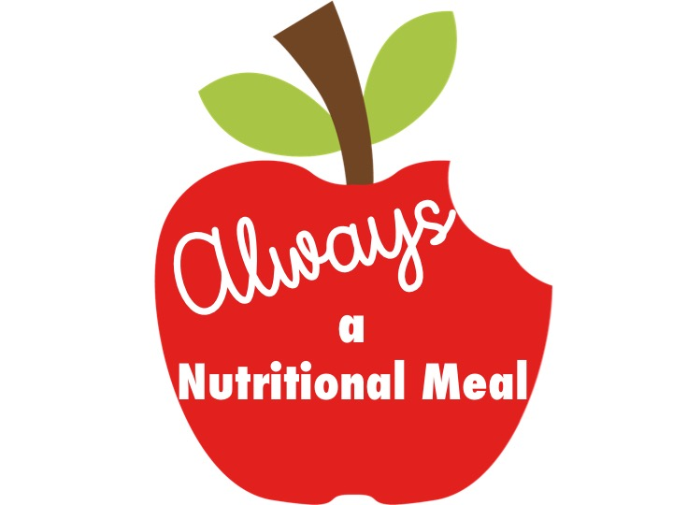Dear Parent/Guardian:

##### ***This letter is intended for parents or guardians of children enrolled in a child care center.*** *[Name of Center]* ***offers healthy meals to all enrolled children as part of our participation in the U.S. Department of Agriculture’s (USDA) Child and Adult Care Food Program (CACFP). The CACFP provides reimbursements for healthy meals and snacks served to children enrolled in child care. Please help us comply with the requirements of the CACFP by completing the attached Meal Benefit Income Eligibility Form. In addition, by filling out this form, we will be able to determine if your child(ren) qualifies for free or reduced-price meals.***

**1. Do I need to fill out a Meal Benefit Form for each of my children in day care?** You may complete and submit one CACFP Meal Benefit Income Eligibility Form for all children enrolled in child care in your household **only** if the children in child care are enrolled in the same center. We cannot approve a form that is not complete, so be sure to read the instructions carefully and fill out all required information. **Return the completed form to:**

**Name of Center: ________________________________________________**

**2. Who can get free meals without providing income information?** Children in households getting Supplemental Nutrition Assistance Program (SNAP) (formerly Food Stamps), Temporary Assistance for Needy Families (TANF), or Food Distribution Program on Indian Reservations (FDPIR) can get free meals. Foster children (reference question #8 for more information on foster children) and children enrolled in a Head Start Program (HSP), Early Head Start Program (EHSP), or Even Start Program (ESP) and have not entered kindergarten) are also eligible for free meals. Households with children enrolled in a HSP, EHSP or ESP can provide a certification letter from the program of the child’s enrollment and do not need to complete the CACFP Meal Benefit Income Eligibility Form.

**3. Who can get reduced price meals?** Your children can get low-cost meals if your household income is within the reduced-price limits on the Income Chart, sent with this application. Children in households participating in WIC may be eligible for reduced price meals.

**4. May I fill out a form if someone in my household is not a U.S. citizen?** Yes. You or your children do not have to be U.S. citizens to qualify for meal benefits offered at the child care center.

**5. Who should I include as members of my household?** You must include everyone in your household (such as grandparents, other relatives, or friends who live with you) who shares income and expenses. You must include yourself and all children who live with you. You also may include foster children who live with you.

**6. How do I report income information and changes in employment status?** The income you report must be the total gross income listed by source for each household member received last month. If last month’s income does not accurately reflect your circumstances, you may provide a projection of your monthly income. If no significant change has occurred, you may use last month’s income as a basis to make this projection. If your household’s income is equal to or less than the amounts indicated for your household’s size on the attached Income Chart, the center will receive a higher level of reimbursement. Once properly approved for free or reduced-price benefits, whether through income or by providing a current SNAP, TANF, FDPIR case number, you will remain eligible for those benefits for 12 months. You should notify us, however, if you or someone in your household becomes unemployed and the loss of income causes your household income to be within the eligibility standards.

**7. What if my income is not always the same?** List the amount that you normally get. For example, if you normally get $1000 each month, but you missed some work last month and only got $900, put down that you get $1000 per month. If you normally get overtime, include it, but not if you only get it sometimes.

**8. What if I have foster children?** Foster children that are under the legal responsibility of a foster care agency or court are eligible for free meals. Any foster child in the household is eligible for free meals regardless of income. Households may include foster children on the Meal Benefit Form but are not required to include payments received for the foster child as income. Households wishing to apply for such benefits for foster children can provide the Texas Department of Family and Protective Services Form 2085FC, *Placement Authorization Foster Care/Residential Care*, to their child’s caregiver and do not need to complete the CACFP Meal Benefit Income Eligibility Form**.**

**9. We are in the military; do we include our housing and supplemental allowances as income?** If your housing is part of the Military Housing Privatization Initiative and you receive the Family Subsistence Supplemental Allowance, do not include these allowances as income. Also, in regard to deployed service members, only that portion of a deployed service member’s income made available by them or on their behalf to the household will be counted as income to the household. Combat Pay, including Deployment Extension Incentive Pay (DEIP) is also excluded and will not be counted as income to the household. All other allowances must be included in your gross income.

**10. *(Pricing program only)* Will the information I give be verified?** Maybe. We may ask you to send written proof to verify the information you submitted on the form. **What if I disagree with the decision about the information I complete on this form?** You can talk to **Paula Griffin**, either in person or by telephone at **281-883-3554**. You may ask for a hearing by calling or writing to: **Same as above.**

In the operation of child feeding programs, no person will be discriminated against because of race, color, national origin, sex, age or disability.

If you have other questions or need help, call 281-883-3554**.**

Sincerely,