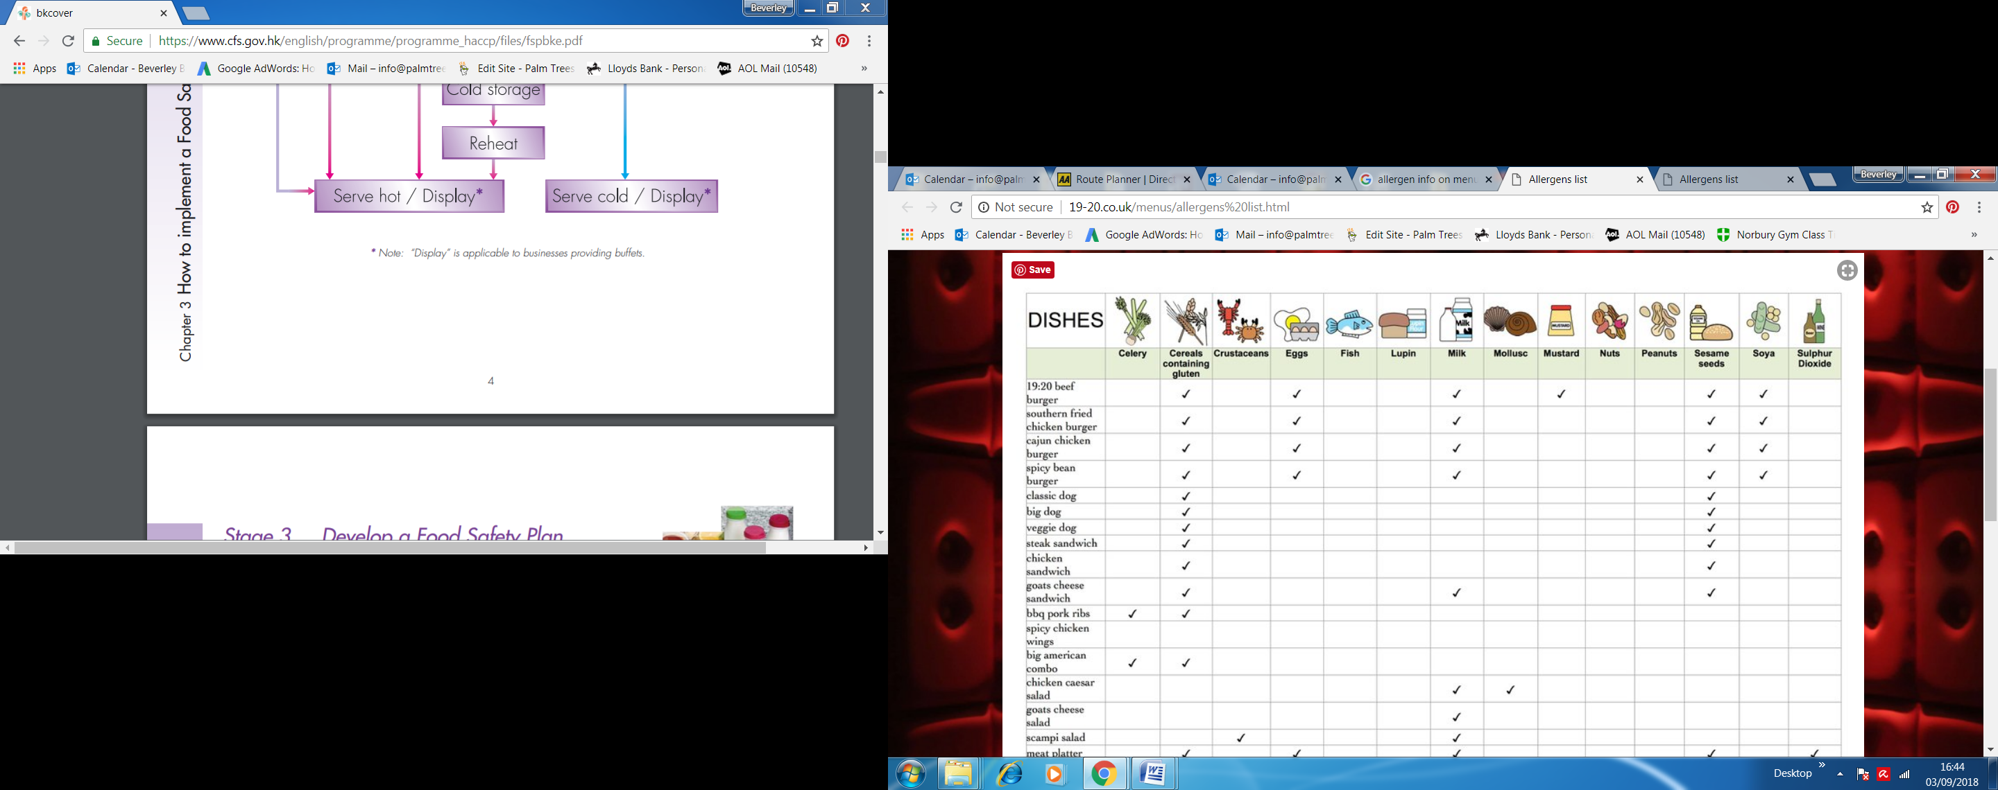**Soups**

|  |  |  |  |  |  |  |  |  |  |  |  |  |  |  |
| --- | --- | --- | --- | --- | --- | --- | --- | --- | --- | --- | --- | --- | --- | --- |
| **Pumpkin** |  |  |  |  |  |  |  |  |  |  |  |  |  |  |
| **Roasted butternut squash** |  |  |  |  |  |  |  |  |  |  |  |  |  |  |
| **Cream of mushroom with chervil** |  |  |  |  |  |  |  |  |  |  |  |  |  |  |
| **Cream of asparagus** |  |  |  |  |  |  |  |  |  |  |  |  |  |  |
| **Carrot and coriander** |  |  |  |  |  |  |  |  |  |  |  |  |  |  |
| **Potato & leek** |  |  |  |  |  |  |  |  |  |  |  |  |  |  |
|  |  |  |  |  |  |  |  |  |  |  |  |  |  |  |
|  |  |  |  |  |  |  |  |  |  |  |  |  |  |  |
|  |  |  |  |  |  |  |  |  |  |  |  |  |  |  |
|  |  |  |  |  |  |  |  |  |  |  |  |  |  |  |
|  |  |  |  |  |  |  |  |  |  |  |  |  |  |  |