Holiday greetings from SS&H! Here’s what’s new….

Butterfly Ridge Food Bag Project Last month, our team packed 1100 weekend food bags for Butterfly Ridge students. Thanks again to Grace Community Church for providing the space and several pairs of hands (big and small!) to help our team fill bags with weekend provisions for students. Thanks also to our First Baptist volunteers, and thank you donors! Your generosity helped us fill enough bags to meet the needs of 275 students for one month. We have committed to providing the bags every other month of the school year so we’ll be packing again at the end of December.

Living Through Loss Last fall, we completed our first round of the Living Through Loss 8-week support group. This is a therapist-led grief group for parents who’ve lost a child to overdose and Second Street & Hope covers all fees and expenses. We work with 2 local Frederick therapists to provide this service to any parent who is in need of this support. The group is free to participants. This was a time of healing, connection, and growth. It was also a time of developing the courage to have hope for life after loss. We had such a positive response, that we offered a Grief and the Holidays Workshop this November, and are planning to run the Living Through Loss support group again beginning in the new year on January 22nd. If you or someone you know could benefit from this group, contact Kacey Hughes at 301-730-3212. Also, be sure to check out Living Through Loss’s Facebook page, where you’ll find helpful resources for supporting friends and loved ones who are grieving this loss.

I Believe In Me SS&H is proud to work alongside IBM, a mentorship program in downtown Frederick. We’re just getting to know these folks, and we enjoyed sharing a meal together last month. We were also happy to provide a matching donation to the organization to purchase a van. Here’s a note from the CEO and lead mentor, Aje Hill: I Believe In Me would like to thank Second Street and Hope for the gracious donation toward the purchase of a 15-passenger van. Because of you, we will be able to have a more effective transportation service that will allow our mentors the opportunity to meet with our youth longer during program hours. This will give us the opportunity to inspire and challenge our youth through mental, physical, and social activities that will foster self respect and respect for the world around them. We look forward to our partnership and continuing to serve the Frederick community together. Truly appreciate all the lives you have impacted by making this investment into our youth. You are truly Hope Dealers!!!
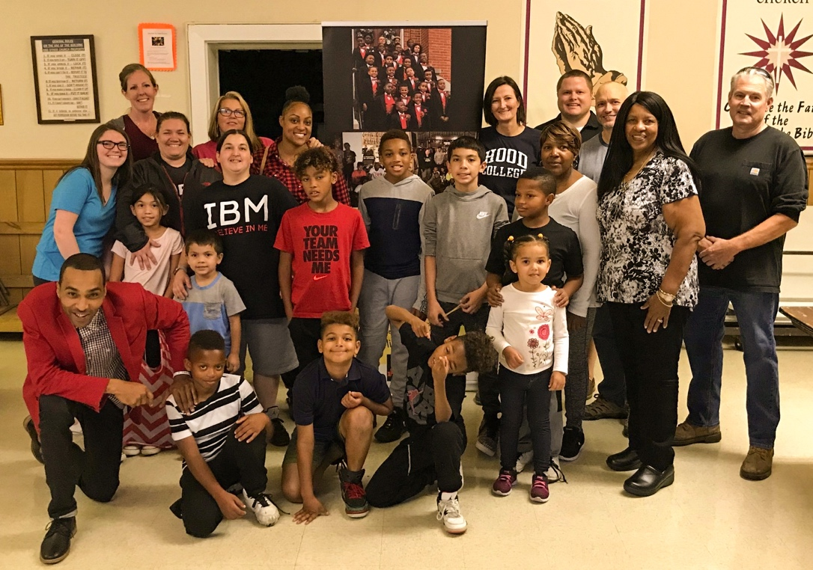

Online Donations We have updated our website to receive online donations! If you’d like to make an online donation, visit our website at secondstreetandhope.org. SS&H has no administrative expenses so all donations go directly to food for weekend bags, expenses for Living Through Loss, and support to IBM.

November 13 2019
Dear Second Street and Hope Donors,
I would like to take this opportunity to thank you for your faithful support of this ministry through your generous gifts. Your commitment to helping SS&H serve the needs of our community is genuinely appreciated.
Each year SS&H continues to advance its mission of alleviating the pain of personal poverty in the Frederick community by reaching out to those in need. Through our programs we have seen many lives changed.
The goal of SS&H is to continue to make a positive difference in the lives of those in our community. With the help of donations from supporters such as you we will continue to see God bless our community.
Thanks again for your generous support of our efforts toward helping our community.
God Bless You All,
Frank Clements
Chairman, Second Street and Hope

Also, be sure to like us on Facebook to stay caught up on all that’s happening and to hear of events and other opportunities to be a part of our efforts!

