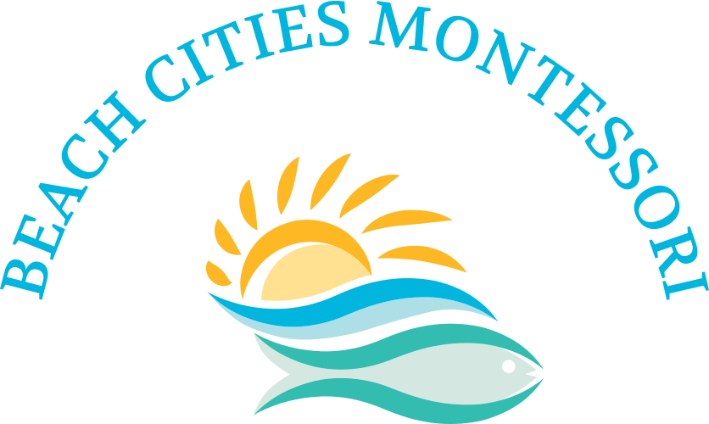

2025-2026 School Calendar

First Day of School September 2nd

Halloween Festival October 31st (Closing at 5PM)

Veteran’s Day November 11th (Closed)

Thanksgiving Break November 24th-28th (Closed)

Winter Break December 22nd-January 2nd (Closed)

Martin Luther King January 19th (Closed)

Presidents Day February 16th (Closed)

Spring Break April 6th-10th (Closed)

Memorial Day May 25th (Closed)

Last Day of School June 18th

Juneteenth June 19th (Closed)

1st Summer Session June 29th-July 24th

4th of July July 3rd (Closed)

2nd Summer Session July 27th-August 21st

\*Calendar Subject to Change