SCHOOLCRAFT COUNTY TRANSIT AUTHORITY

REQUEST FOR QUALIFICATIONS (RFQ)

FOR ARCHITECTURAL AND ENGINEERING SERVICES

**SCTA *Solicitation Number:2017-0125/P6***



**Release Date:**

**July 26th, 2021**

**Deadline for Qualifications:**

**August 29th, 2021**

**Executive Director, John Stapleton**

**Contact Information:**

**John Stapleton –** [**director@sctransit.org**](mailto:director@sctransit.org)

**Eric Perrollaz –** [**deputy@sctransit.org**](mailto:cherieg@databus.org)

***No phone calls will be accepted. Vendors may submit their questions or clarifications about this RFQ to the email addresses above by the date specified in the RFQ.***

Scope of Service:

Schoolcraft County Transit Authority, 335N East Rd., Manistique, Michigan, (hereafter referred to as SCTA), is seeking architectural and engineering services to complete a building expansion for our facility.

This project is funded with federal and state grants so the A&E services must be procured according to the Brooks Act on a qualifications basis

Timely completion of this project is important. Subcontracting is allowed.

Proposed project activities on the subject property include adding on to a steel structure building that was build in 2005, a 60x60ft garage bay expansion with work bay/wash bay, restroom, office, storage on North end of building. Reconfiguring existing conference room to an office, adding conference room, break room in existing work bay. Also adding extending the parking lot on the South side of the building. Existing septic system needs to be removed and sewer system needs to be run to the city sewer.

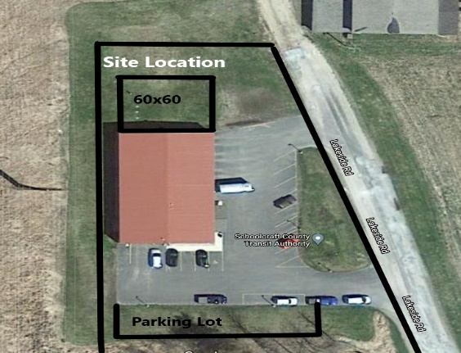

Proposal Content:

Submissions must include a cover letter signed in ink by an authorized official of the submitting firm binding the firm to the conditions of the RFQ. No copies will be accepted.

Submission must include a description of the business organization, the firm’s experience with architectural and engineering projects, the qualifications of individuals performing the work, and three references with the references’ contact information. The description of experience must describe the firm’s experience with design, project management and construction management, although not all of these services may be procured.

**DO NOT** send price information with the qualifications. The agency will negotiate price with the top scoring firm and the firm must provide a derivation of cost at that time. If the agency is unable to successfully negotiate price with the top scoring firm, the agency will end negotiations and negotiate price with the next highest scoring firm.

Qualifications Submission:

Firms must email one copy of their qualifications to John Stapleton at [**director@sctransit.org**](mailto:director@sctransit.org) and submit the original plus two copies of their qualifications to the Schoolcraft County Transit Authority, 335N East Rd., Manistique, Michigan 49854.

Printed proposals may be submitted by mail or hand delivery in an envelope marked “A&E Services”. All qualifications must be received by 4:00 P.M. on August 29th, 2021. Hand delivered qualifications must be delivered between 8:00 am and 4:00 pm. Late submissions will **not be accepted**. Qualifications may be withdrawn by written request prior to the due date.

Conditions for Qualifications:

Submitted qualifications become SCTA’s property. The contents of qualifications are considered valid for one hundred and twenty (120) days after the submission deadline. SCTA reserves the right to waive any informalities or minor defects and to accept or reject any or all of the submitted qualifications or postpone the qualifications due date for sound, documentable, business reasons. Conditional qualifications will be considered non-responsive and may be rejected unless SCTA gives specific approval to a written request received at least ten (10) working days prior to the due date. This RFQ does not commit SCTA to award a contract, to pay any cost incurred in the preparation of qualifications, or to preclude SCTA from canceling, in part or in its entirety, this RFQ for sound, documentable, business reasons.

This solicitation will result in a firm fixed price contract.

Questions about this RFQ must be submitted in writing by email to John Stapleton at [**director@sctransit.org**](mailto:director@sctransit.org)or to [deputy@sctransit.org.](mailto:cherieg@databus.org) Phone calls involving the RFQ or related questions will not be accepted. All questions and answers related to this RFQ, and any addendums, will be sent to vendors who were sent an RFQ or who have submitted questions or proposals, and will be posted on SCTA’s website at www.sctransit.org. All questions and/or comments must be received at least ten (10) working days prior to the proposal due date. Verbal comments are not part of this solicitation.

Any contact or attempt to contact any other employees not specified in this RFQ will result in the immediate disqualification of the vendor.

A site visit is scheduled for Friday, August 6th, 2021, at 10:00 AM at our facility located at 335N East Rd., Manistique, Michigan. Direct questions on the site visit to John Stapleton, Executive Director.

Terms and Conditions:

This project is funded by the Federal Transit Administration (FTA) and the Michigan Department of Transportation (MDOT). It is subject to federal and state guidelines. The federal requirements for this project are the Federal Contract Clauses Professional A&E Less Than $150,000, as attached as Attachment A and available on the internet. Page 1 of the clauses must be signed and included with the submitted qualifications. The selected firm may need to have a 3rd party subcontract approved by MDOT.

The selected vendor will receive a written Notice to Proceed from SCTA. SCTA reserves the right to cancel the contract with thirty (30) days by written notice. All applicable laws, ordinances, and the rules and regulations of all authorities having jurisdiction over construction of the project shall apply to the contract.

The firm agrees to indemnify and hold SCTA, its officers, agents, employees and/or trustees, harmless from and against any and all claims or causes of action brought against SCTA and from any and all damages, losses, expenses, attorney fees, costs and liabilities sustained by SCTA arising out of any claimed defect in the goods and services provided by the firm. The firm’s obligation under this paragraph shall include the obligation to indemnify and hold SCTA harmless for negligence, whether active, passive or concurrent, in the performance of SCTA’s duties and obligations pursuant to this project and agreement.

Evaluation Criteria:

The evaluation criteria for this solicitation are listed below:

They are ranked in order of importance although the first two criteria are equally weighted.

* Documented ability to provide A&E services, including design, project management and construction management. (Up to 40 Points)
* Staff qualifications (Up to 40 Points)
* Three (3) Past References (Up to 20 Points) SEE Evaluation Criteria sheet added with this email attachment highlighted in

The selection panel members are the agency’s Executive Director, Deputy Director.

Any submitter falling within a competitive range as determined by the selection panel may be asked to give a presentation to the selection panel about the submitter’s abilities and qualifications, and to answer any SCTA questions about the submitted qualifications. The original scoring of evaluation criteria may be modified, based on the results of the interview. The agency reserves the right to award A&E Services to the qualifications providing the “best value” to the agency. The award will only be made to a responsive and responsible firm.

Protests of the solicitation documents must be received 10 business days before the proposal due date. Protests of the award decision must be received within five days of the award.

Attachments:

Attachment A – Professional A&E Less Than $150,000

Evaluation Criteria & Point Percentages