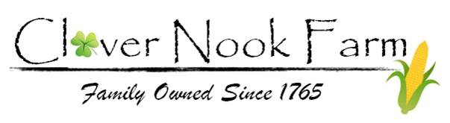
Employee Application 2023
Complete & email to clovernookfarm@gmail.com along with a résumé (if applicable)
Basic Information
Name:
Address:
Date of Birth:
Email:
Phone:

Questions:
- Which position are you interested in? (indicate choice)
- Farm Store Associate (seasonal position)
- Farm Hand Worker (seasonal position)

- Current and previous employment (if any)

- Why would you like to work at Clover Nook Farm?

- What qualifications or special skills can you offer Clover Nook Farm?

- How do you make sure you understand how to complete tasks and assigned projects?

- Are you currently a student? ( Yes / No )

- How many hours a week are you able to work?

- What days and hours would you be available?

- Additional availability information (vacations, sports/ special occasions, etc.) (if necessary)

- Do you have reliable transportation to and from work? ( Yes / No / Unsure)
- Are you able to stand on your feet for 6 hours straight? ( Yes / No / Unsure)
- Are you able to lift 50lbs easily? ( Yes / No / Unsure)
- Are you legally eligible for employment in the United States? ( Yes / No)

Signed: ________________________________

