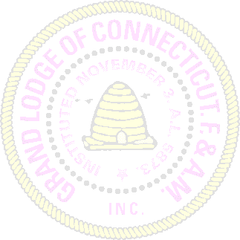
MOST WORSHIPFUL PRINCE HALL GRAND LODGE
F & A.M STATE OF CONNECTICUT, INC.

SURVIVORS BENEFITS COMMISSION

NOTIFICATION OF DEATH AND APPLICATION FOR SUVIVORS BENEFITS

DECEASED BROTHER: _____________________________________________

ADDRESS: ________________________________________________________

DATE OF DEATH: _________________________________________________

PLACE OF DEATH: ________________________________________________
(CITY AND STATE)
BENEFICIARY: ____________________________________________________

WE THE UNDERSIGNED DO HEREBY CERTIFY THAT THE ABOVE INFORMATION IS TRUE AND CORRECT IN ALL RESPECTS AND PURSUANT TO THE SURVIVORS BENEFITS PLAN OF THE MOST WORSHIPFUL PRINCE HALL GRAND LODGE OF THE STATE OF CONNECTICUT, DULY ADOPTED AND ALL BY THE LAWS OF PROVISIONS THERE UNDER:

________________________________LODGE#_________HEREBY MAKES APPLICATION FOR SAID BENEFITS IN THE AMOUNT OF FOUR HUNDRED ($400.00) DOLLARS BY DRAFT OR CHECK PAYABLE TO:

(NAME OF BENEFICIARY)

SIGNED and DATED at ___________________________LODGE#____THIS____DAY of______________________20____

_____________________________
Worshipful Master

_____________________________
Secretary

PLACE SEAL HERE

A CERTIFIED COPY OF THE DEATH CERTIFICATE MUST ACCOMPANY THIS APPLICATION IN ORDER TO HAVE BENEFITS PAID.

