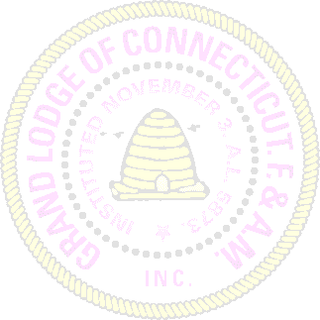
MOST WORSHIPFUL PRINCE HALL GRAND LODGE
F. & A. M. STATE OF CONNECTICUT
SURVIVORS BENEFIT FUND
QUARTERLY REPORT

LODGE NAME | LODGE # | DATE

Members on roll last report ________________________

ADDITIONS

Members Raised ________________________

Members Admitted by Demit ________________________

Misc. ________________________

LOSSES

Members Dropped ________________________

Members Suspended ________________________

Members Expelled ________________________

Members Deceased ________________________

Misc. ________________________

PAYMENTS FOR QUARTER TOTAL PAID

- October, 20 $_____________________

- January, 20 $_____________________

- April, 20 $_____________________

- July, 20 $_____________________

Place Lodge Seal Here

Signed_______________________________
Secretary

Signed_______________________________
Worshipful Master

