Tuscola County Pumpkin Festival
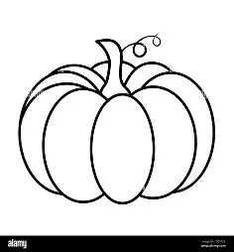
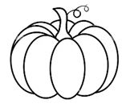
PO BOX 329 Caro, MI 48723
989.325.5323
tcpumpkinfestival@gmail.com

It’s the 45th Annual Tuscola County Pumpkin Festival
This year’s theme is “Rooted in Tradition, Growing from Seed to Celebration”
We are Celebrating 45 years of Fantastic Family Fun!!!

The Pumpkin Festival Board is busy planning the 2026 Festival, which is set to take place Wednesday, September 30th to Sunday, October 4th, 2026.
Many exciting events are being planned again for this year. We are bringing back the FREE Monster Truck Rides, Crowning of the Prince and Princess, Baby Contest, Tailgate party, and so much more.
There will also be food vendors and of course, pumpkin pies, the popular FREE Car and Motorcycle Show, and FREE Children’s Activities which will include a magic show, wagon rides, inflatables, face painting, glo party, and more!!!
On Sunday, it will end with “THE GRAND PARADE”!
To help offset the many expenses incurred for all the activities and the making of the pies, we still rely upon your continued support to offer FREE family-filled activities and events for all to enjoy!!
Enclosed you will find the Sponsorship Commitment Form. We are hoping for your support and ask that the form and your payment be returned to us no later than Aug. 1st, 2026, so that we may proceed with further planning and advertising for the events.
If you have any further questions, please feel free to contact us at (989) 325-5323 or email us at tcpumpkinfestival@gmail.com

ON BEHALF OF THE 2026 PUMPKIN FESTIVAL BOARD, WE THANK YOU FOR YOUR GENEROUS SUPPORT AND ARE LOOKING FORWARD TO A WONDERFUL 2026 FALL FESTIVAL.

