Windmark Beach • AirDNA High-Performers
Data pulled on 4.03.2026 for informational purposes only.
This is not a guarantee (or a limit) of income.
CRITERIA: 270+ days on rental market and 20+ reviews unless otherwise noted.

4 BR, 2 BA
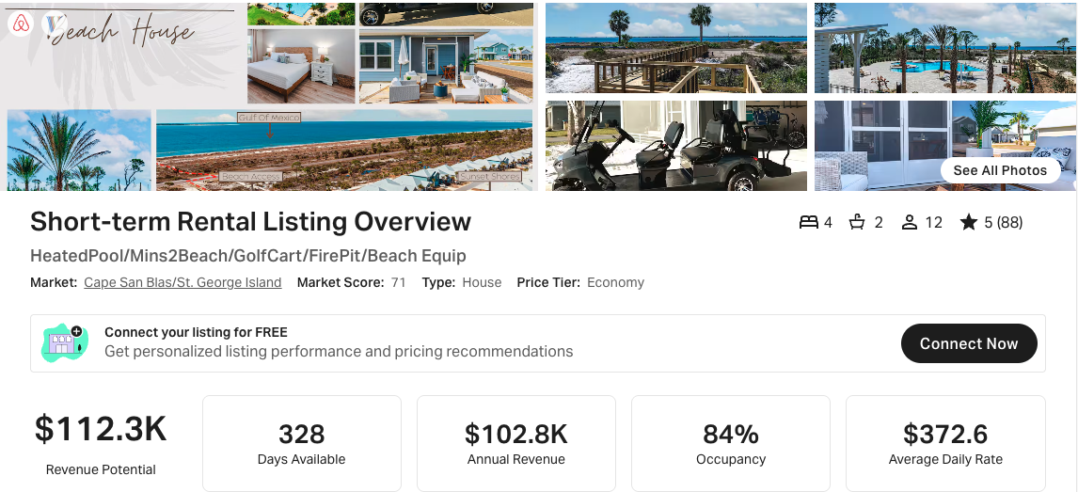
https://www.airbnb.com/rooms/1094184571722265378
https://www.vrbo.com/3906293

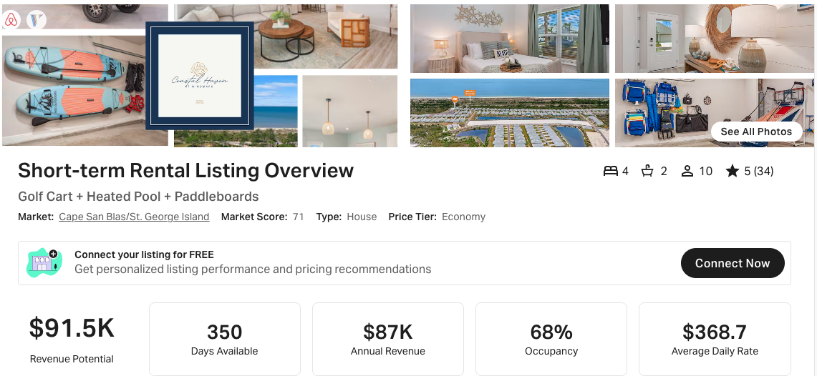
https://www.airbnb.com/rooms/1253787717148112563
https://www.vrbo.com/4211823

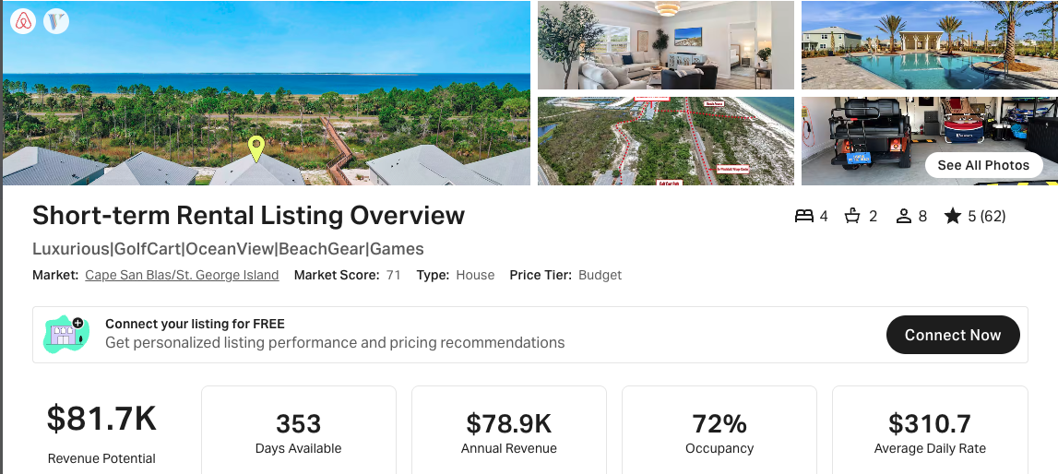
https://www.airbnb.com/rooms/1205009640930805914
https://www.vrbo.com/4255114

4 BR, 3 BA
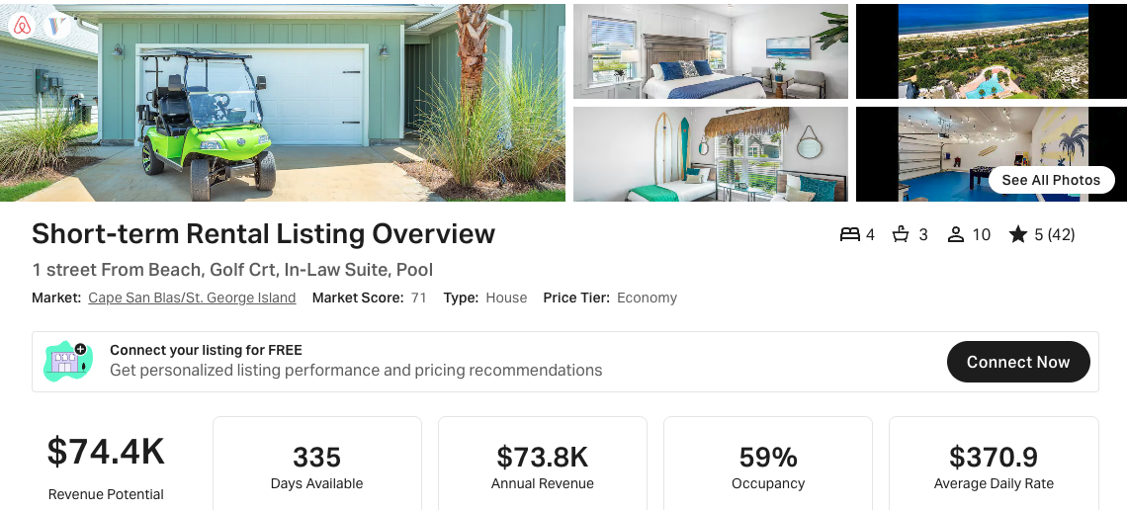
https://www.airbnb.com/rooms/1147372342868425174
https://www.vrbo.com/4025630

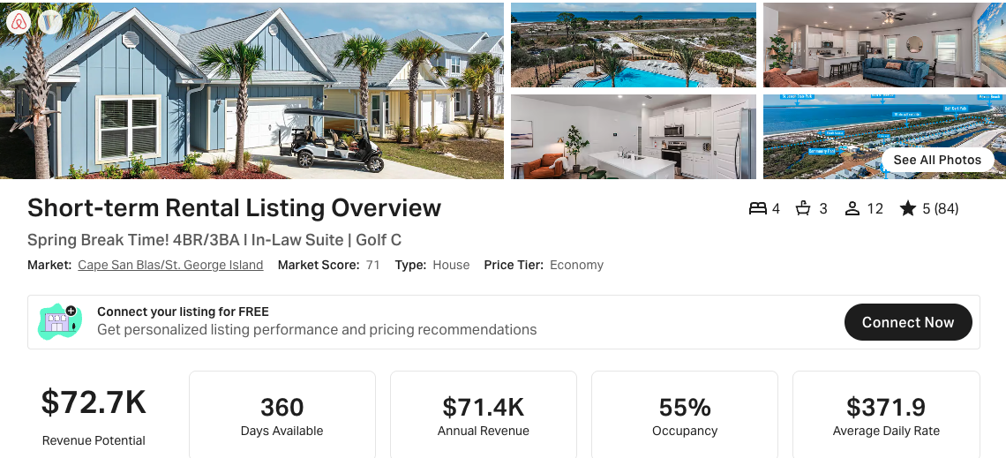
https://www.airbnb.com/rooms/842251489103080255
https://www.vrbo.com/3305453

5 BR, 3 BA:

This one has <270 days available, but it’s close to the 270 threshold:
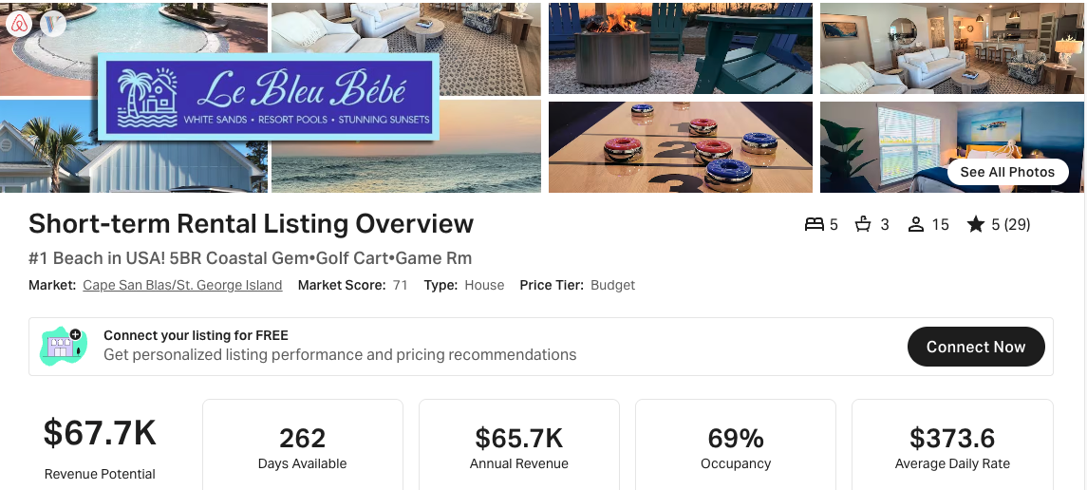
https://www.airbnb.com/rooms/1435800916643243386
https://www.vrbo.com/4579121

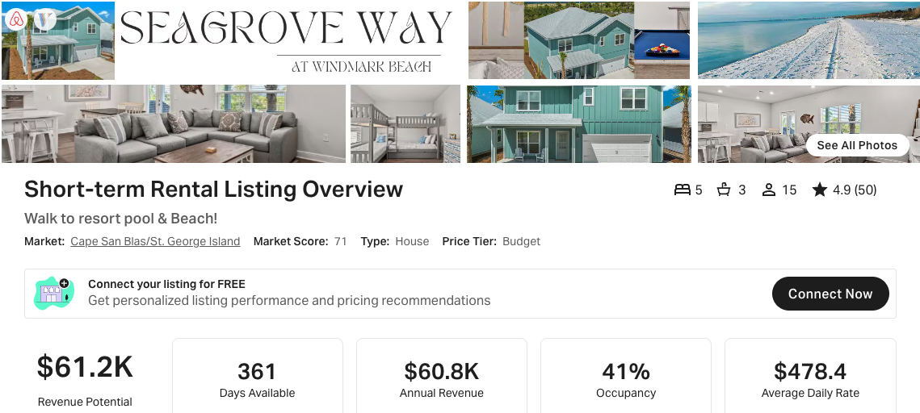
https://www.airbnb.com/rooms/686369936357020811
https://www.vrbo.com/3039514

