Tropic Winds • AirDNA High Performers
17643 Front Beach Road, PCB
Income, occupancy, and daily rate data pulled from AirDNA on 3.05.2026. Links provided.

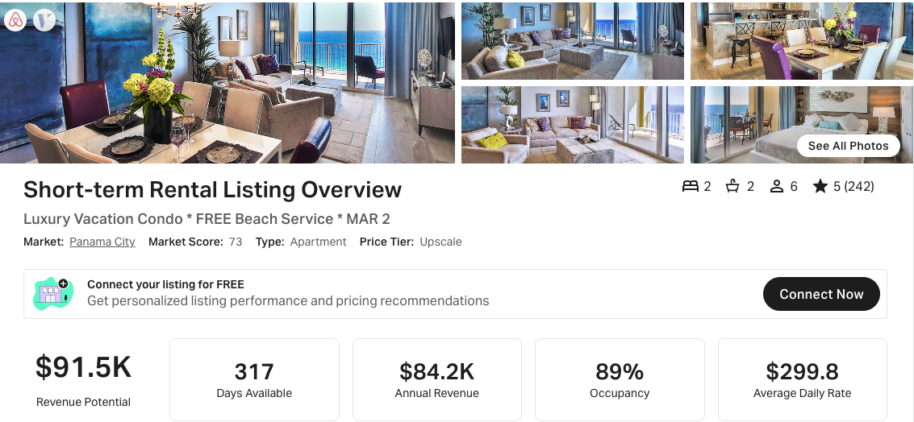
https://www.airbnb.com/rooms/44404899
https://www.vrbo.com/3899200ha

SAME FLOOR PLAN AS THIS LISTING:
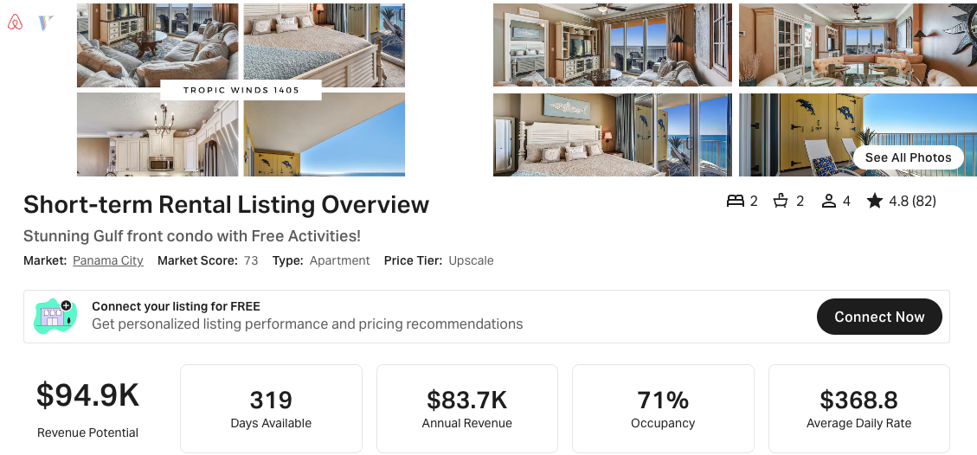
https://www.airbnb.com/rooms/53183467
https://www.vrbo.com/2535043

