Villages of Crystal Beach • AirDNA High-Performers
Data pulled on 4.17.2026 for informational purposes only.
This is not a guarantee (or a limit) of income.
CRITERIA: 270+ days on rental market and 20+ reviews unless otherwise noted.

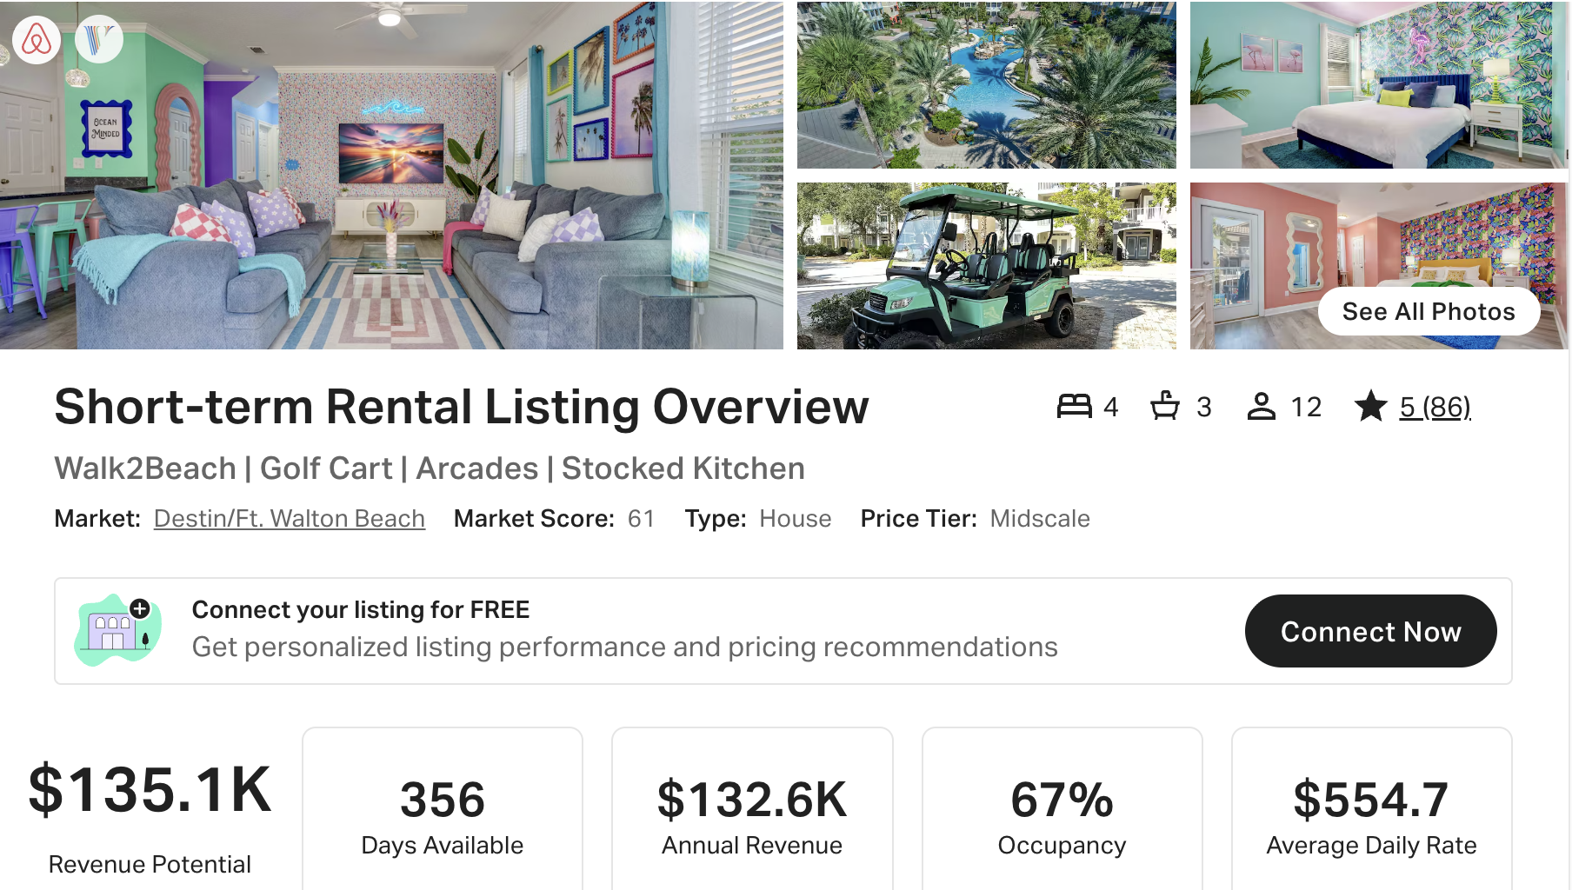
https://www.airbnb.com/rooms/53427621
https://www.vrbo.com/2670337

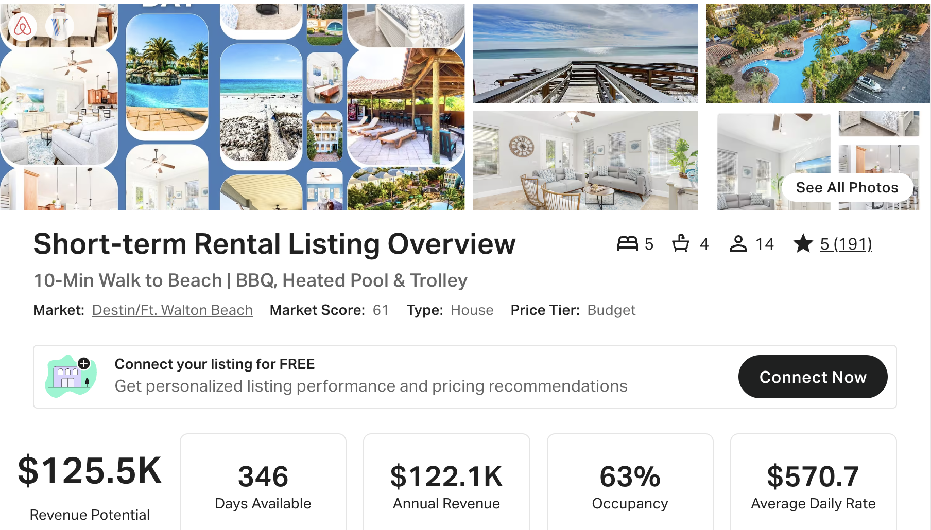
https://www.airbnb.com/rooms/53200591
https://www.vrbo.com/2542699
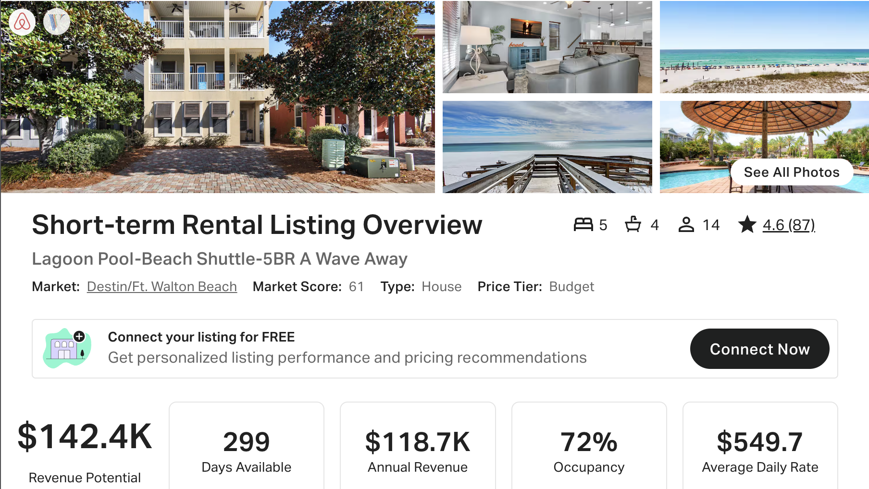
https://www.airbnb.com/rooms/25865735
https://www.vrbo.com/1362736

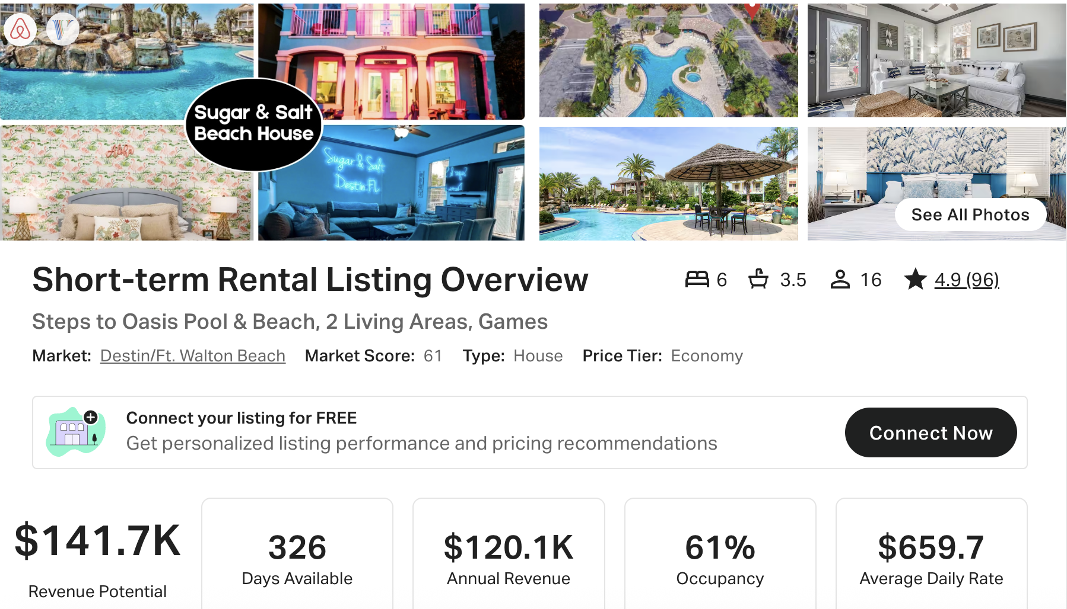
https://www.airbnb.com/rooms/42620909
https://www.vrbo.com/9456802ha

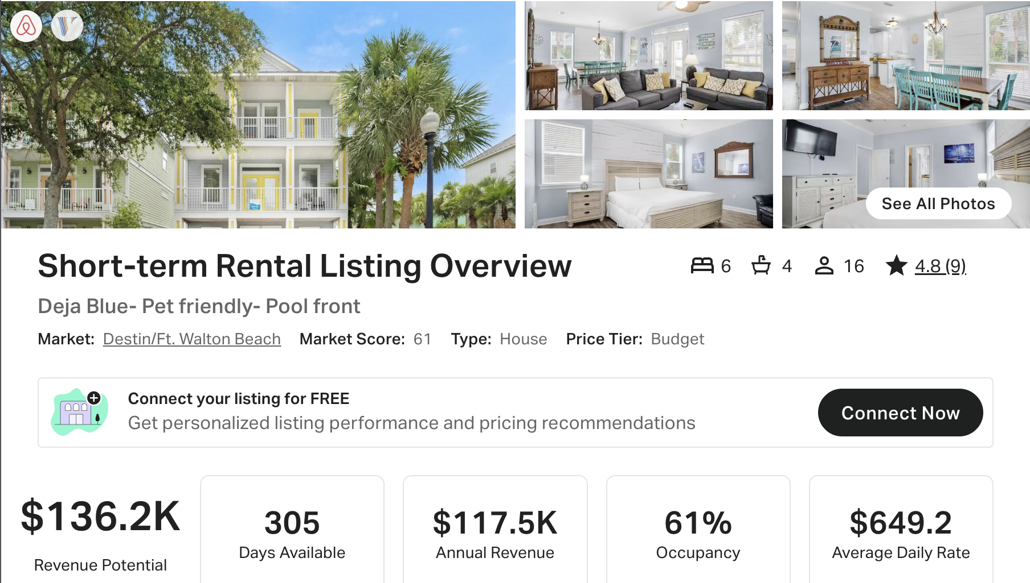
https://www.airbnb.com/rooms/1589988498609287233
https://www.vrbo.com/4108608

