Seacrest Beach, 30A • AirDNA High-Performers
Data pulled on Oct 27, 2025. This is not a guarantee (or a limit) of income.

General AirDNA Map of Seacrest – Not all listings noted here.

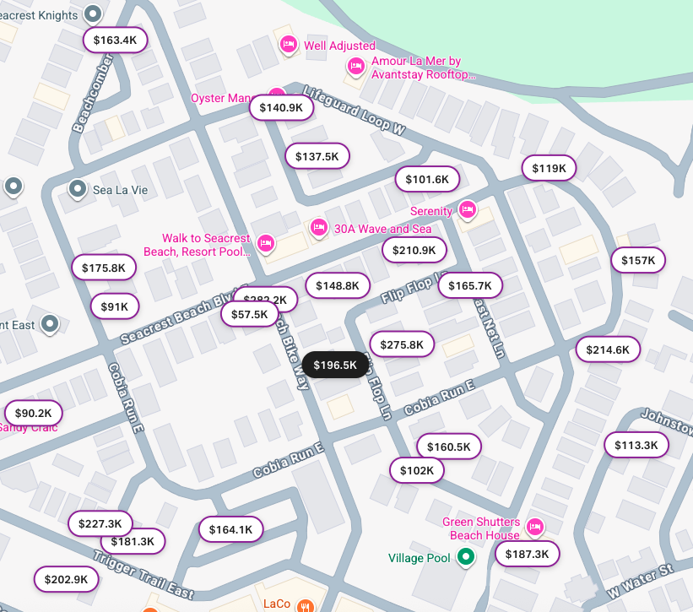

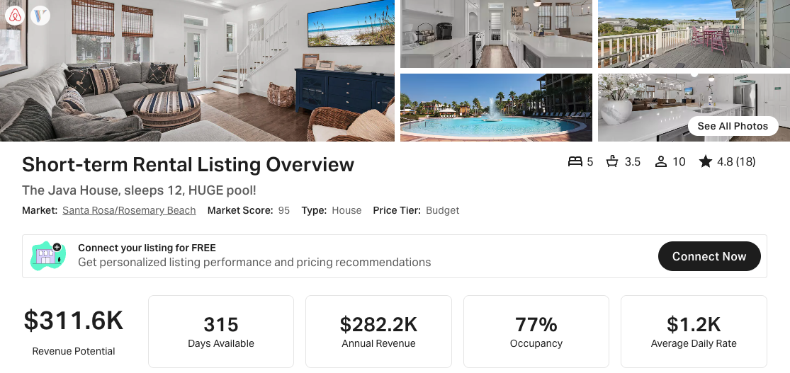
https://www.airbnb.com/rooms/1066610020386278938
https://www.vrbo.com/3798247

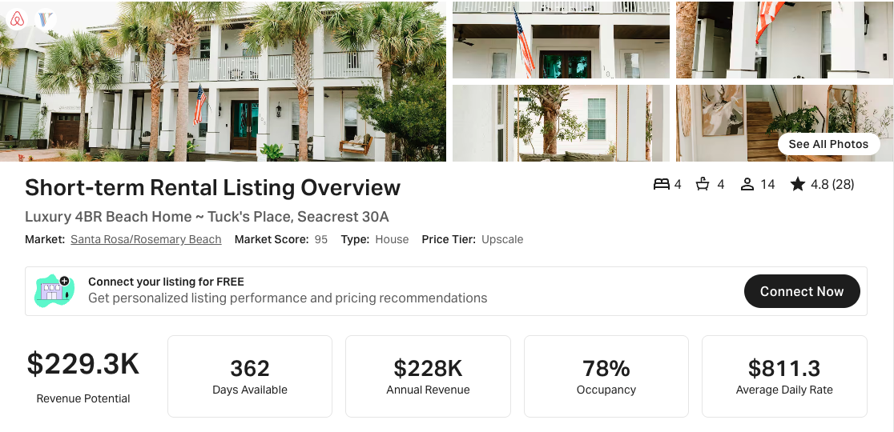
https://www.airbnb.com/rooms/774035734464480246
https://www.vrbo.com/3138435

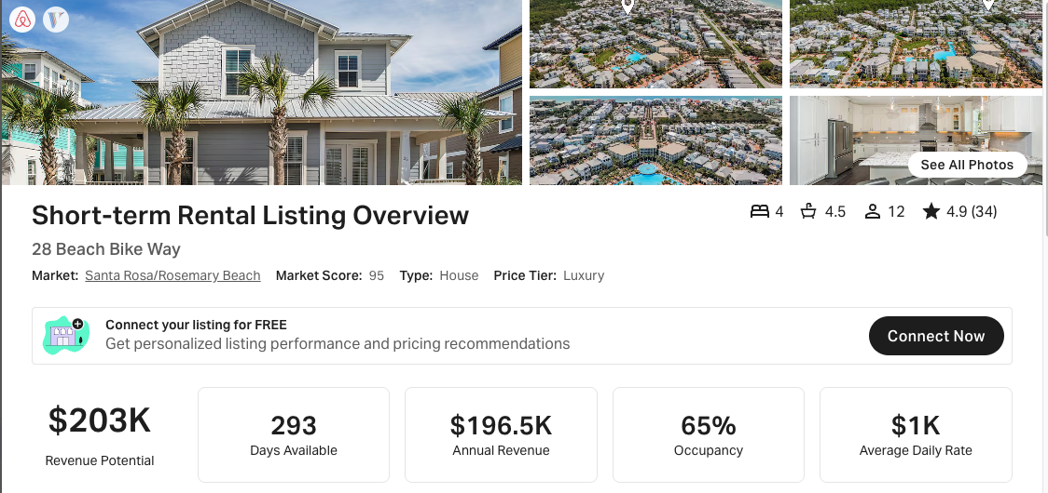
https://www.airbnb.com/rooms/49337464
https://www.vrbo.com/1558168

