Gulf Highlands, PCB • AirDNA High-Performers
Data pulled on 01.18.2026. This is not a guarantee (or a limit) of income.

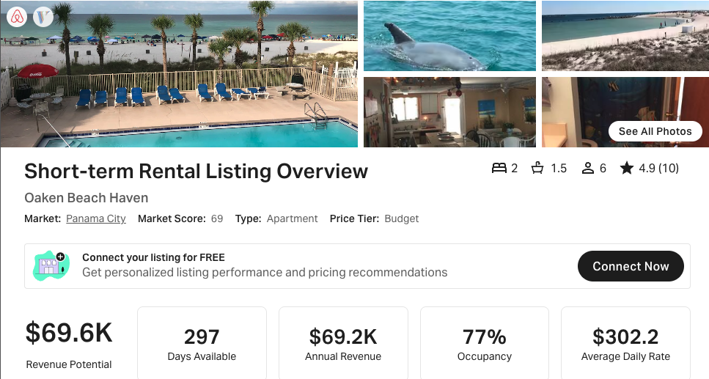
https://www.airbnb.com/rooms/28314669
https://www.vrbo.com/4458603
NOTE: 297 days available but only 10 reviews

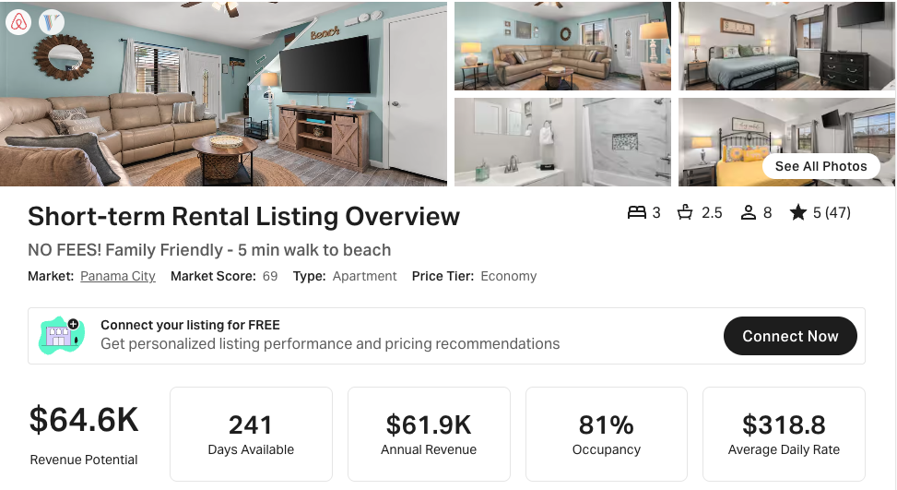
https://www.airbnb.com/rooms/792641754464507828
https://www.vrbo.com/3179666
NOTE: 241 days available (<270); also a 3 BR
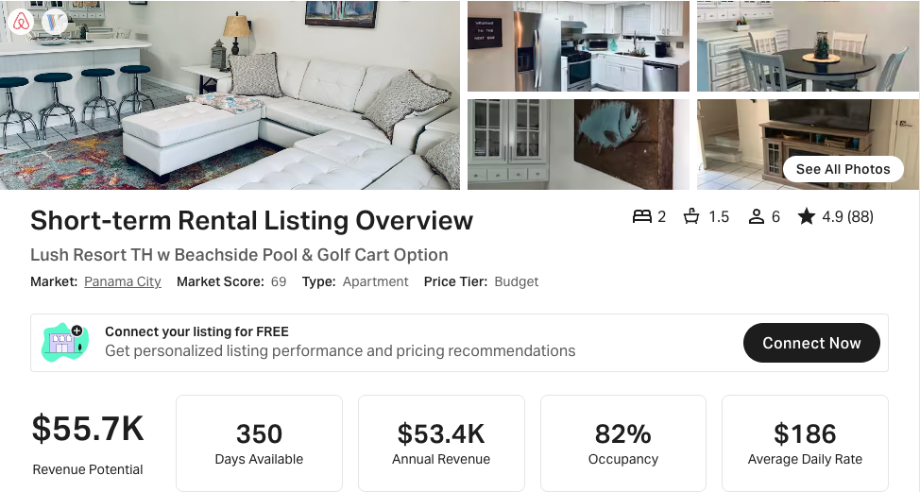
https://www.airbnb.com/rooms/53007588
https://www.vrbo.com/2517832

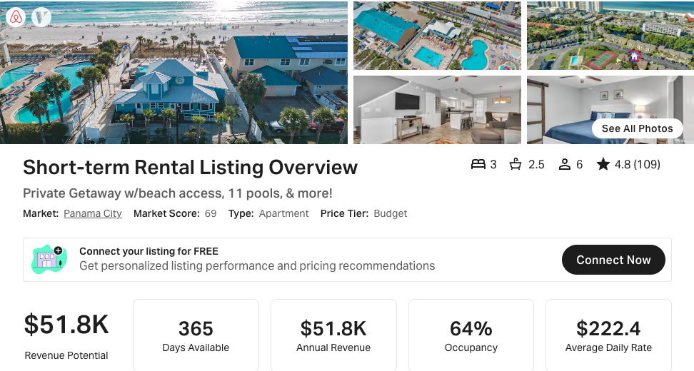
https://www.airbnb.com/rooms/701322796581489990
https://www.vrbo.com/2983394
NOTE: 3 BR
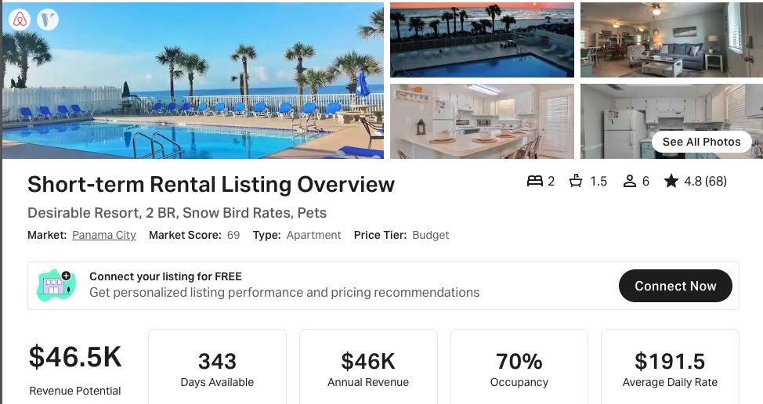
https://www.airbnb.com/rooms/591450148421253506
https://www.vrbo.com/2784992

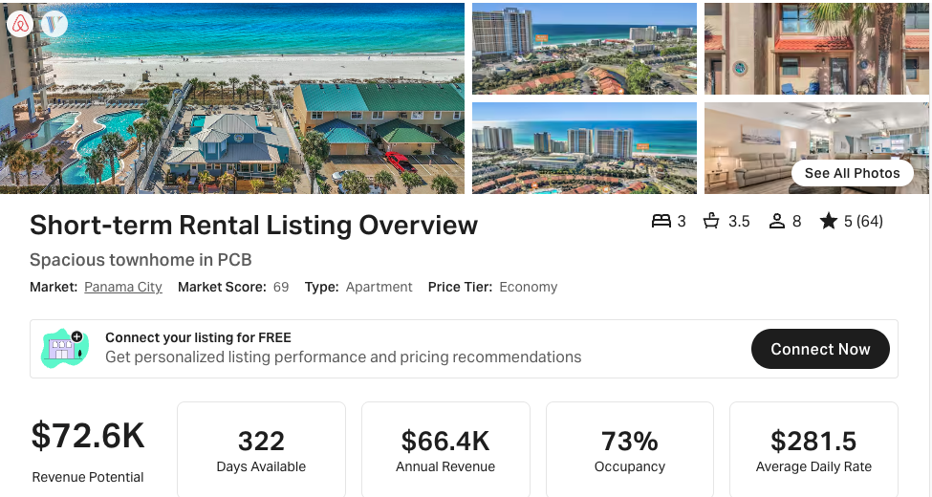
https://www.airbnb.com/rooms/784812544502051428
https://www.vrbo.com/3230838
NOTE: 3 BR

