The Summit • AirDNA High-Performers
8743 Front Beach Road, PCB • 1 BR, 1-1.5 BA • 4-5 Guests
Data pulled from AirDNA on October 2, 2025. This is not a guarantee of income.

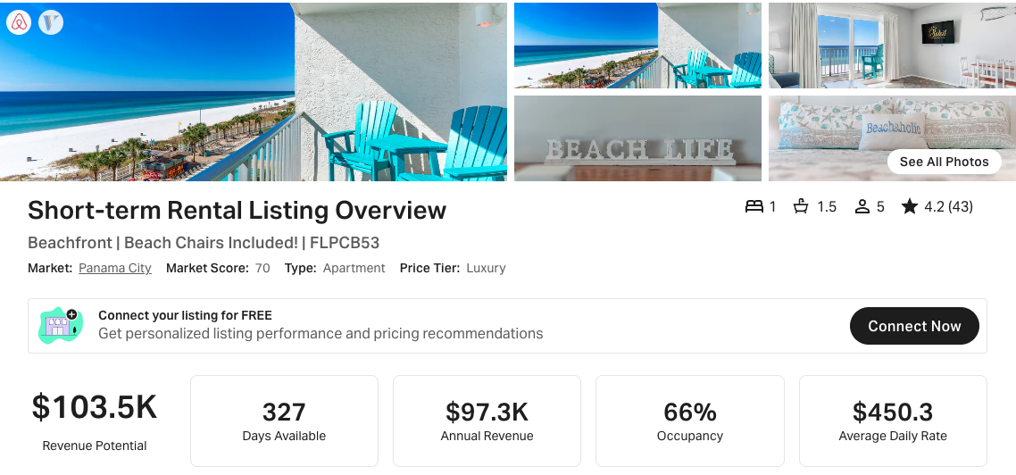
https://www.airbnb.com/rooms/633633273825319498
https://www.vrbo.com/2825414

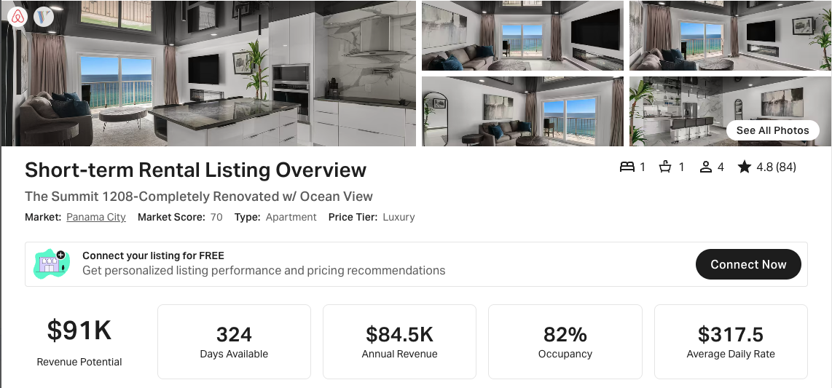
(This has been COMPLETELY redone and has a crazy mirror-like ceiling treatment, hence the strange upside-down looking view.)
https://www.airbnb.com/rooms/48562644
https://www.vrbo.com/2416234

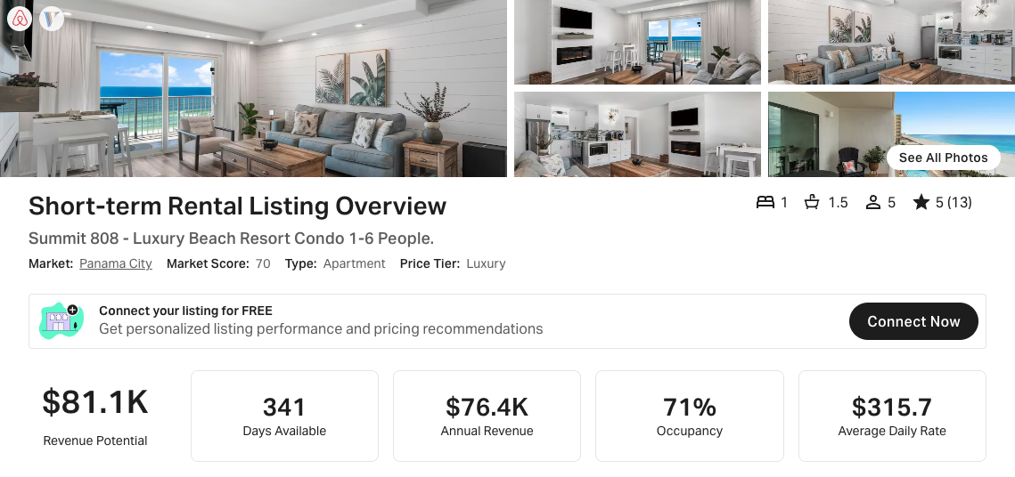
https://www.airbnb.com/rooms/806854329651031956
https://www.vrbo.com/3232967

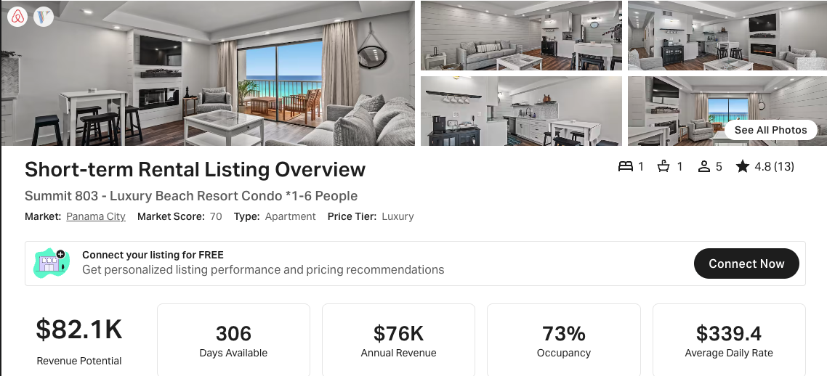
https://www.airbnb.com/rooms/806821205532742669
https://www.vrbo.com/3232966

