West End PCB SFRs NO POOL • AirDNA High-Performers
Data pulled on 2.09.2026. This is not a guarantee (or a limit) of income.

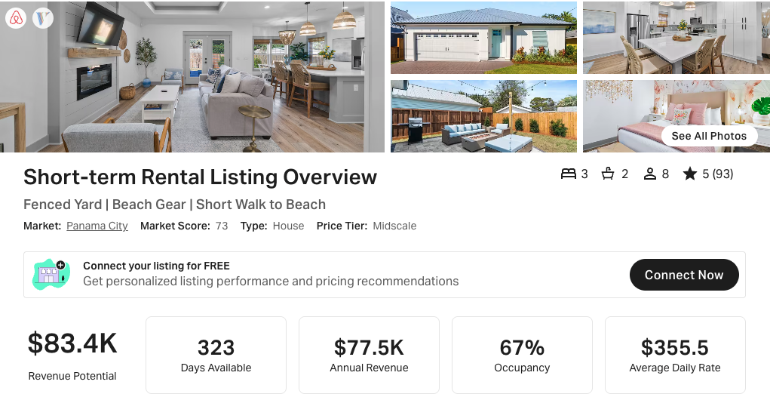
https://www.airbnb.com/rooms/1059692724579236829
https://www.vrbo.com/3791954

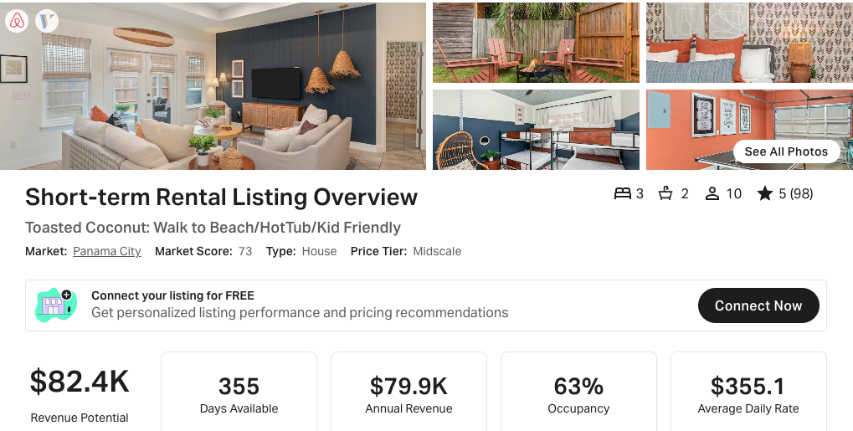
https://www.airbnb.com/rooms/995174887064944460
https://www.vrbo.com/3642976
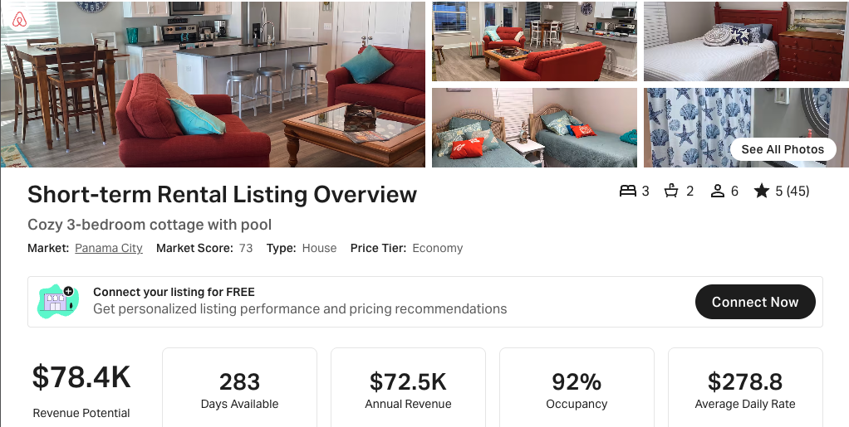
https://www.airbnb.com/rooms/53589199

Scroll to next page for data on SFRs WITH POOL

West End PCB SFRs WITH POOL • AirDNA Exemplars
Data pulled on 2.09.2026. This is not a guarantee (or a limit) of income.

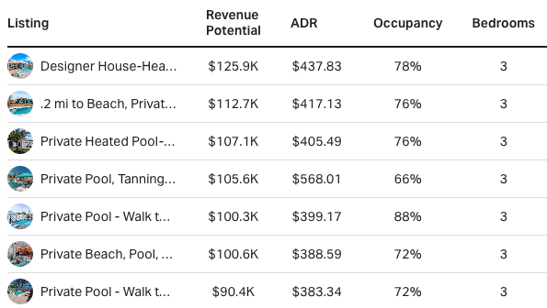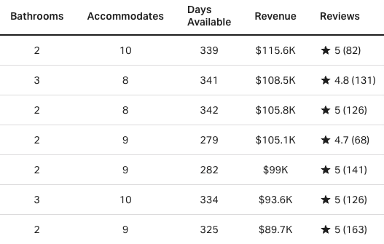

Details on top 3 properties provided below:
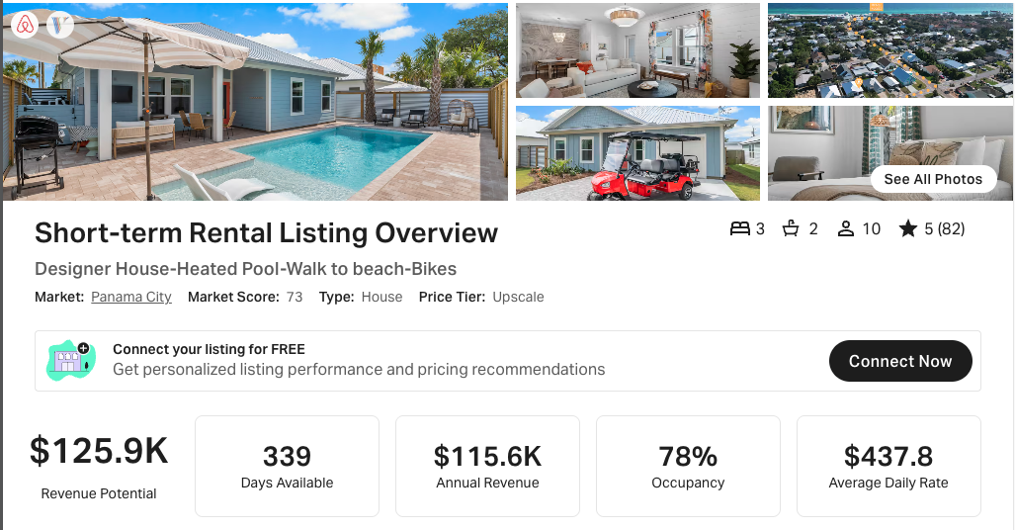
https://www.airbnb.com/rooms/1146662944644611811
https://www.vrbo.com/4005521

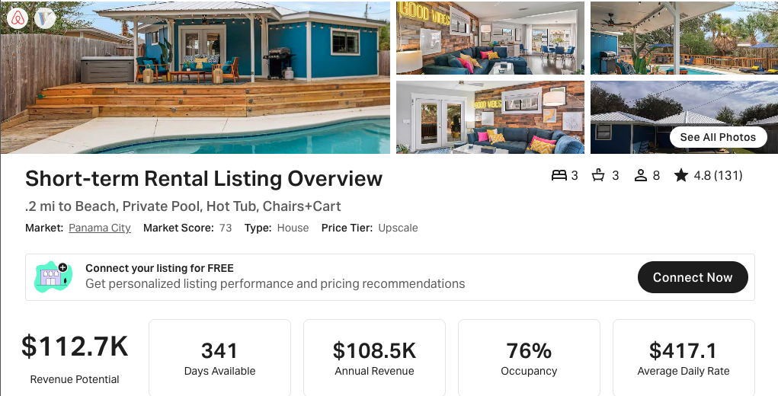
https://www.airbnb.com/rooms/32953869
https://www.vrbo.com/3935848

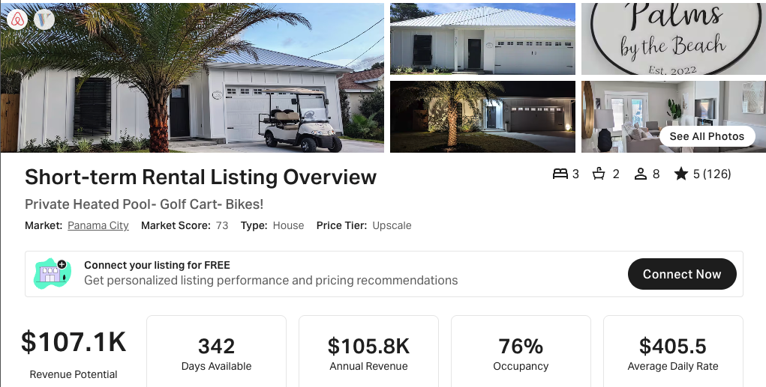
https://www.airbnb.com/rooms/579609385930956905
VRBO link not active at this time.

