Cape San Blas, 4-5 BR • AirDNA High-Performers
Info pulled from AirDNA on 9.04.2025 – For informational purposes only.

Profile:
- Sleeps 10+
- 5-6 BRs
- 4-5 BA
- No other criteria
3 exemplars provided

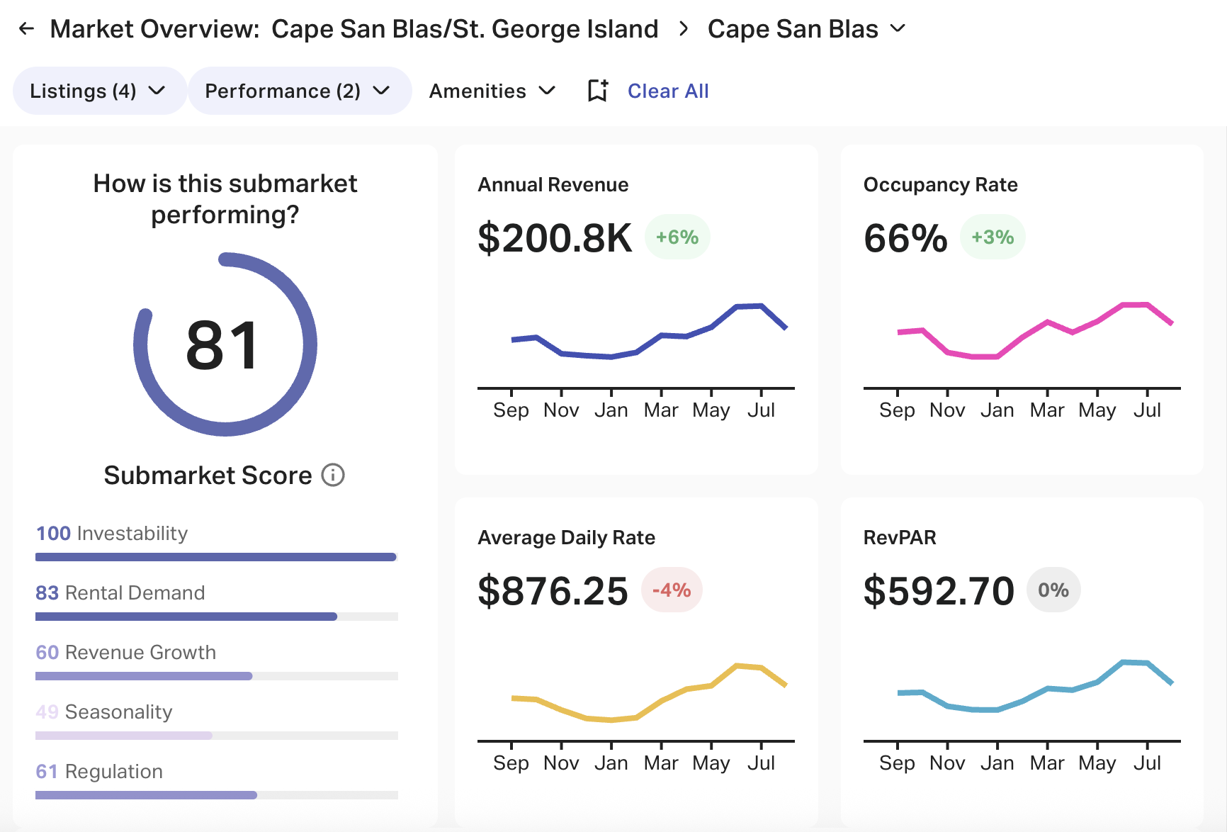

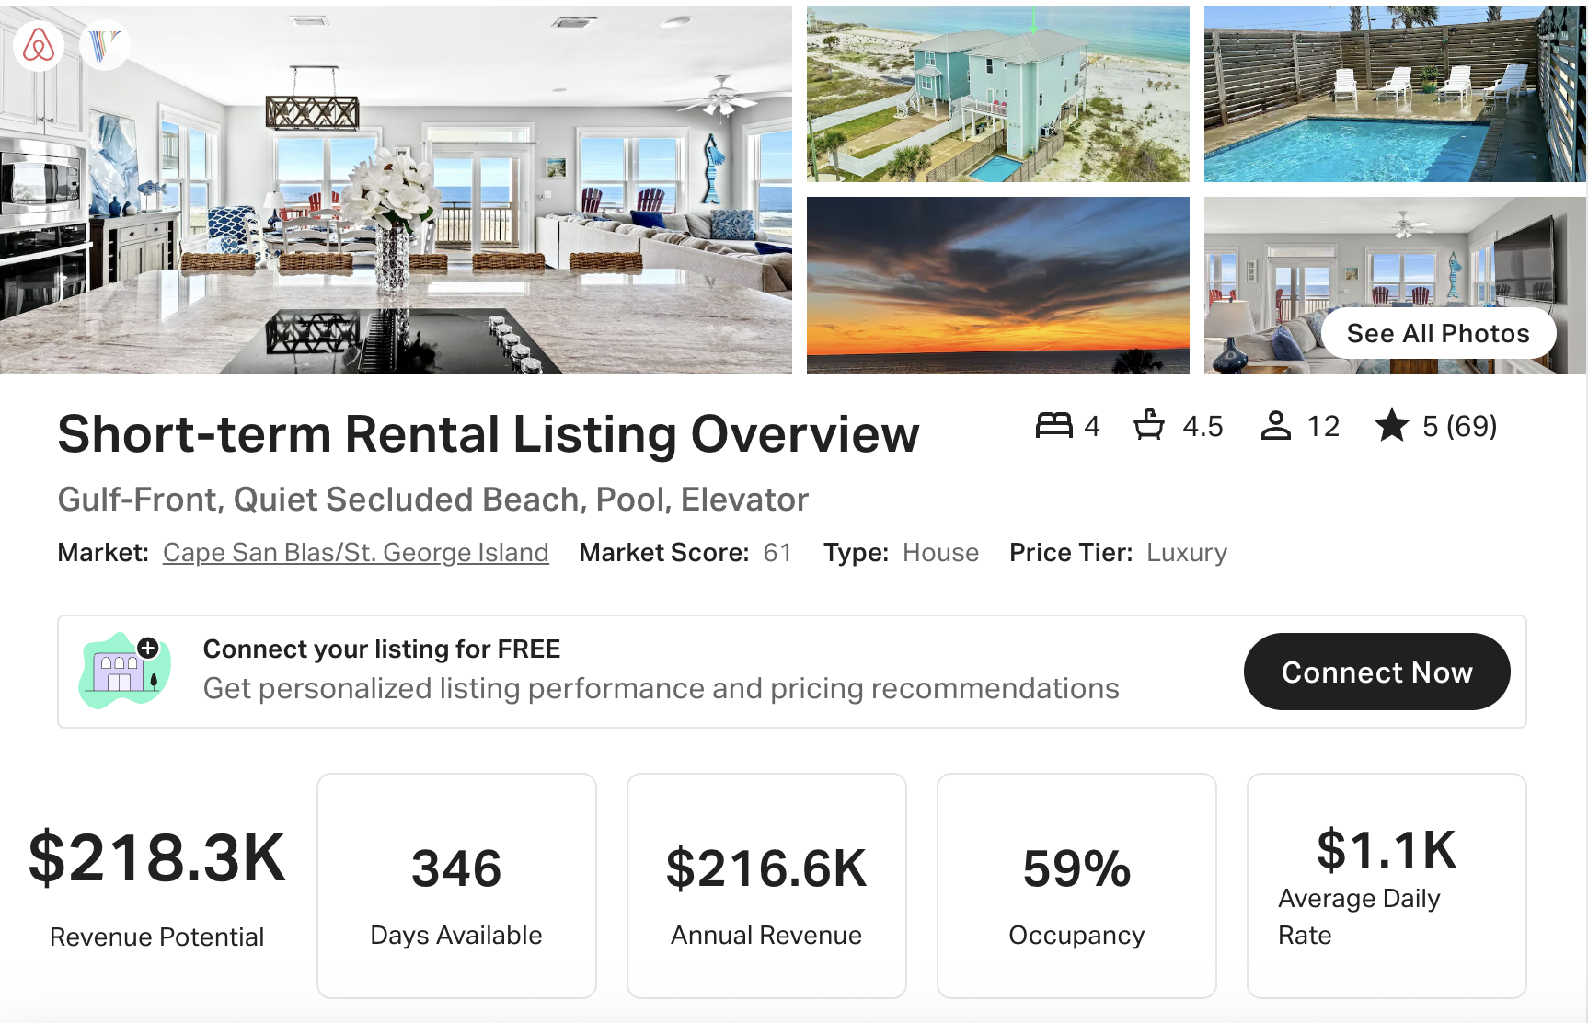
https://www.vrbo.com/3126087
https://www.airbnb.com/rooms/753124471001843773
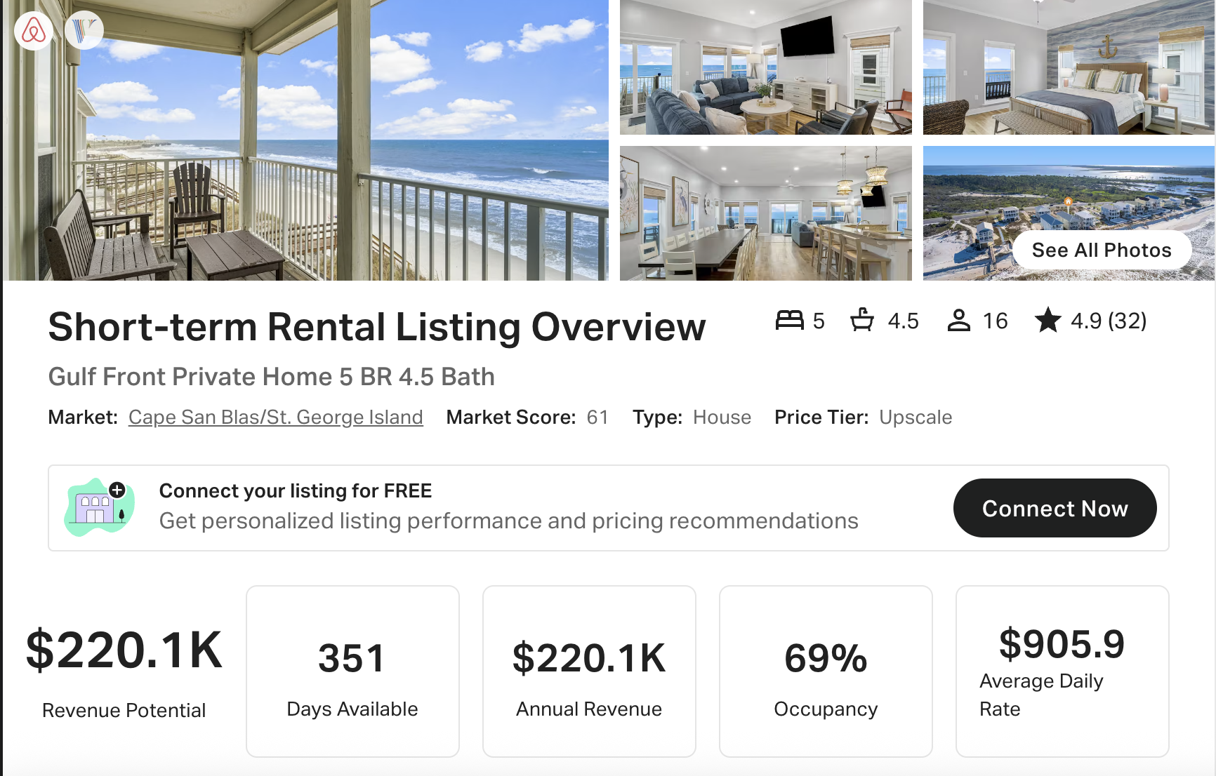
https://www.airbnb.com/rooms/1100864679730624224
https://www.vrbo.com/3895807
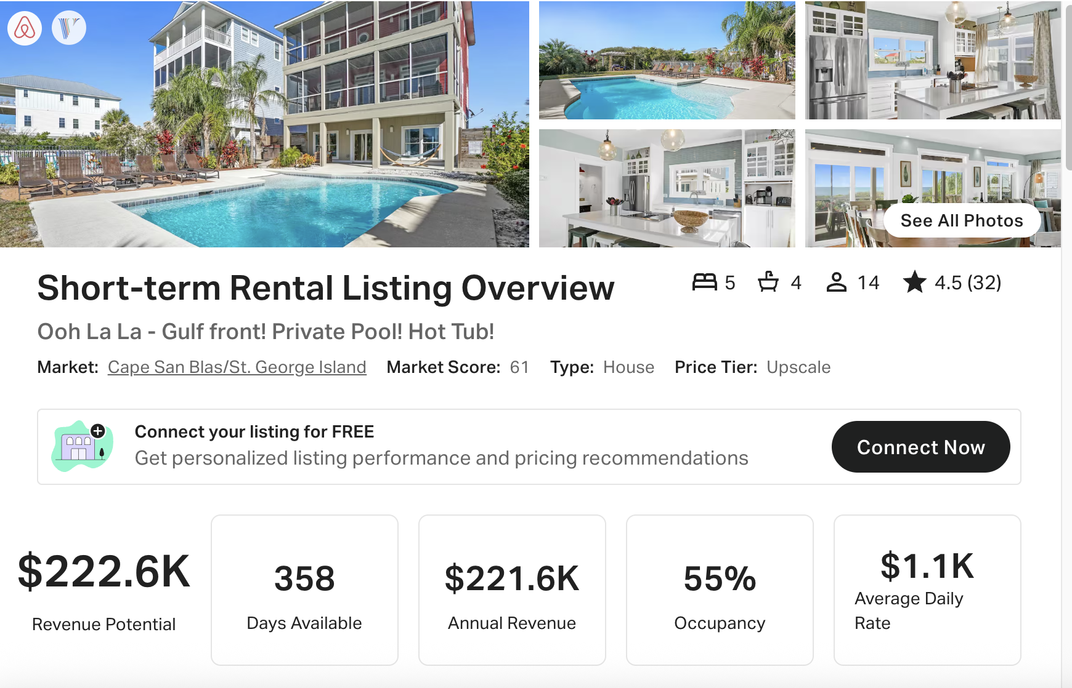
https://www.airbnb.com/rooms/19464034
https://www.vrbo.com/2826278

