Shores of Panama • AirDNA High Performers
9900 S Thomas Dr, PCB
Data pulled in 2025 and 2026. This is not a guarantee (or a limit) of income.
NOTE: There are 15 different floor plans in Shores, all with varying views.
Not all condos here have deeded/dedicated/leased parking
STUDIO:
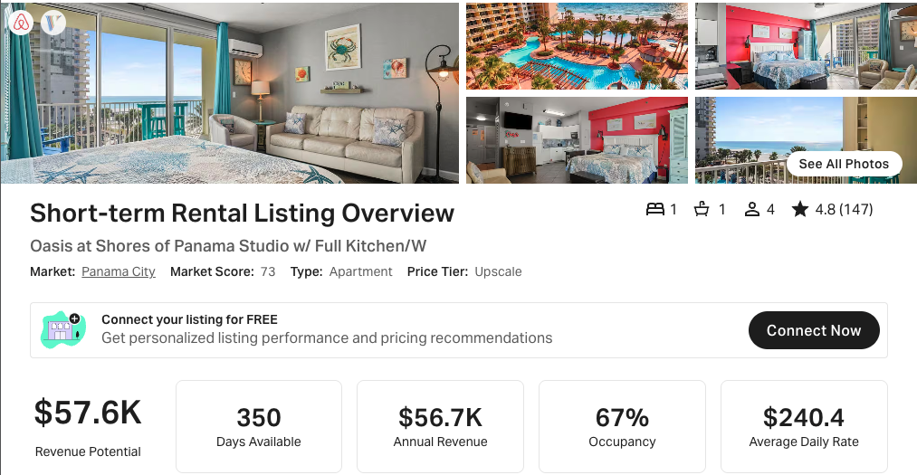
https://www.airbnb.com/rooms/599346308233232074
https://www.vrbo.com/2746291

1 BR + BUNKS, 2 BA:
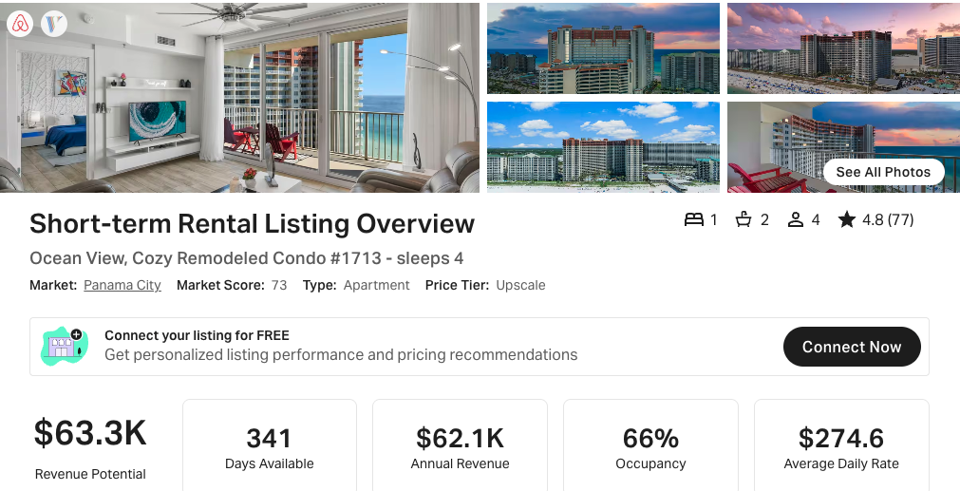
https://www.airbnb.com/rooms/978806709637331861
https://www.vrbo.com/3607390
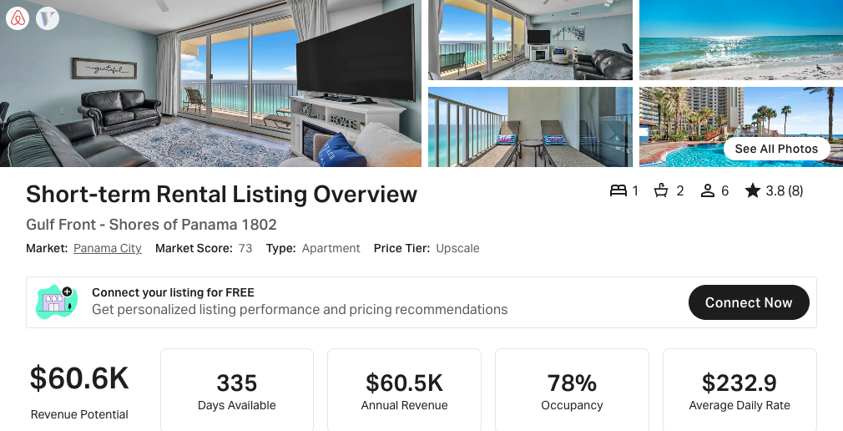
https://www.airbnb.com/rooms/883422451943399403
https://www.vrbo.com/3387911

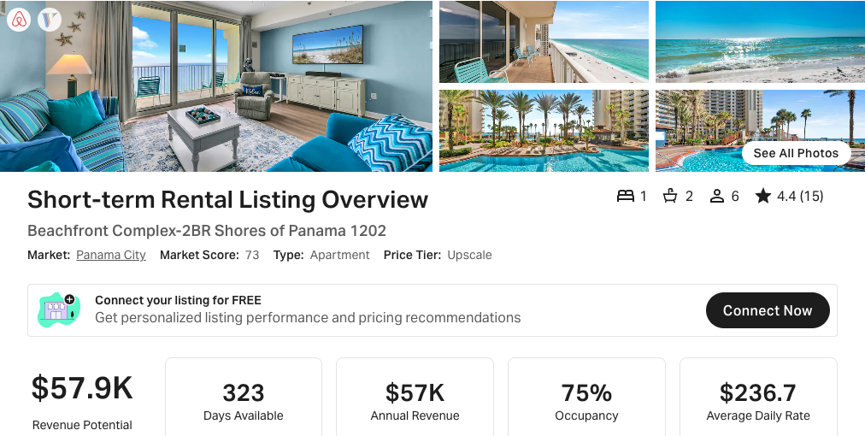
https://www.airbnb.com/rooms/1082060446264635153
https://www.vrbo.com/3835148

01 Stack:
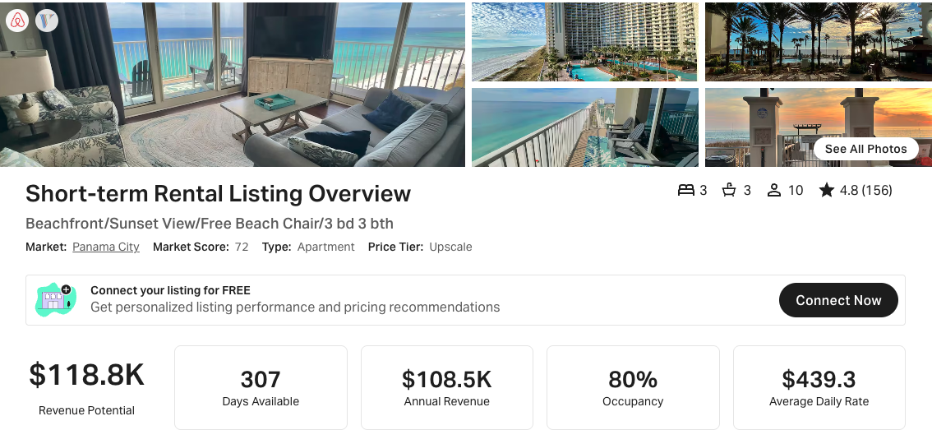
https://www.airbnb.com/rooms/11495062
https://www.vrbo.com/319896

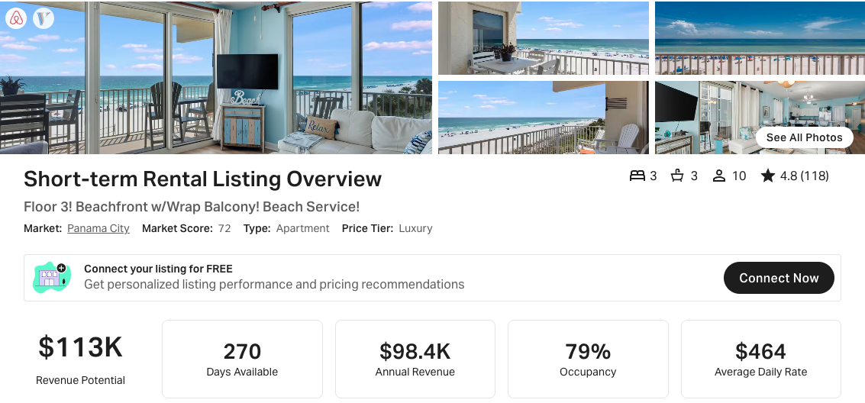
https://www.airbnb.com/rooms/48244874
https://www.vrbo.com/2211571

02 Stack:
Unit 902 –
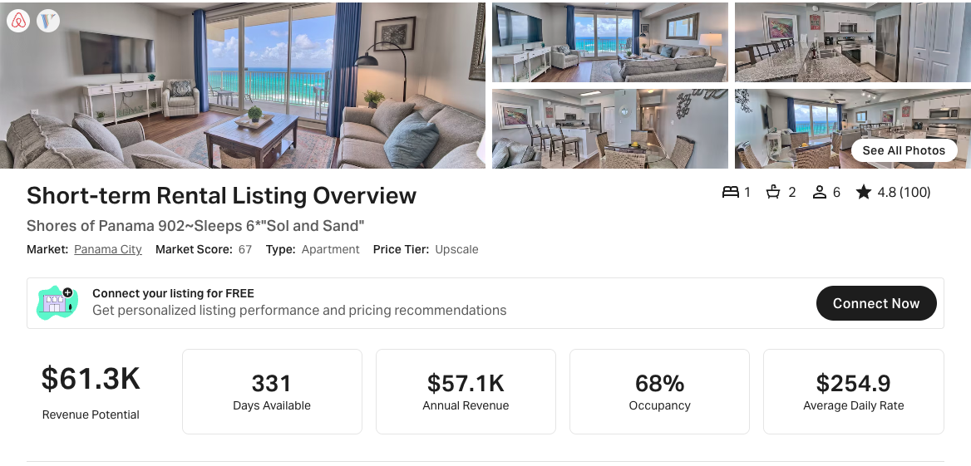
https://www.airbnb.com/rooms/53184531
https://www.vrbo.com/2535105

03 Stack:
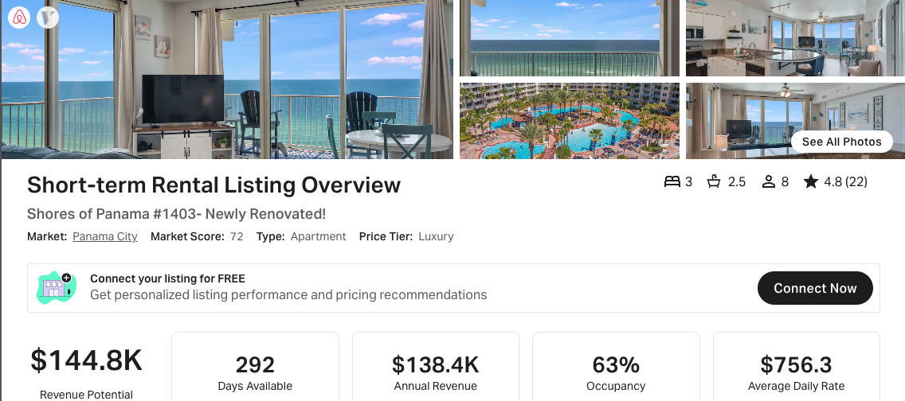
https://www.airbnb.com/rooms/1239260584526482209
https://www.vrbo.com/4181713

07 Stack:
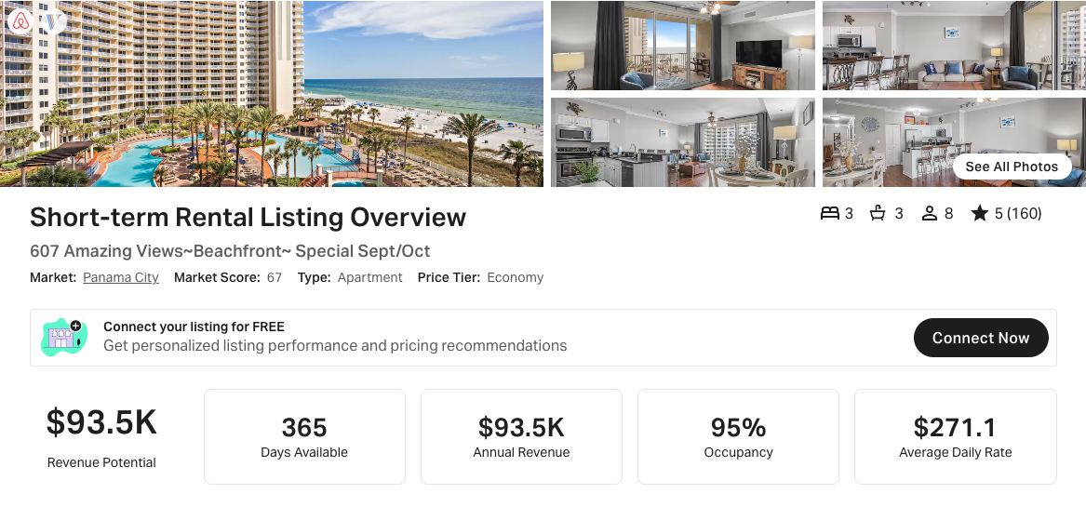
https://www.airbnb.com/rooms/897157643541251419
https://www.vrbo.com/394670

18 Stack:
Unit 118, ground floor
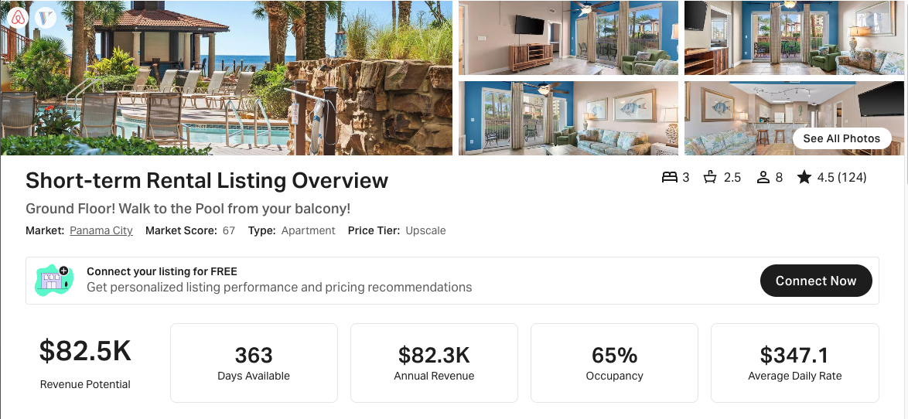
https://www.airbnb.com/rooms/46729467 - VRBO link not working at time of data pull

19 Stack:
Unit 419 –
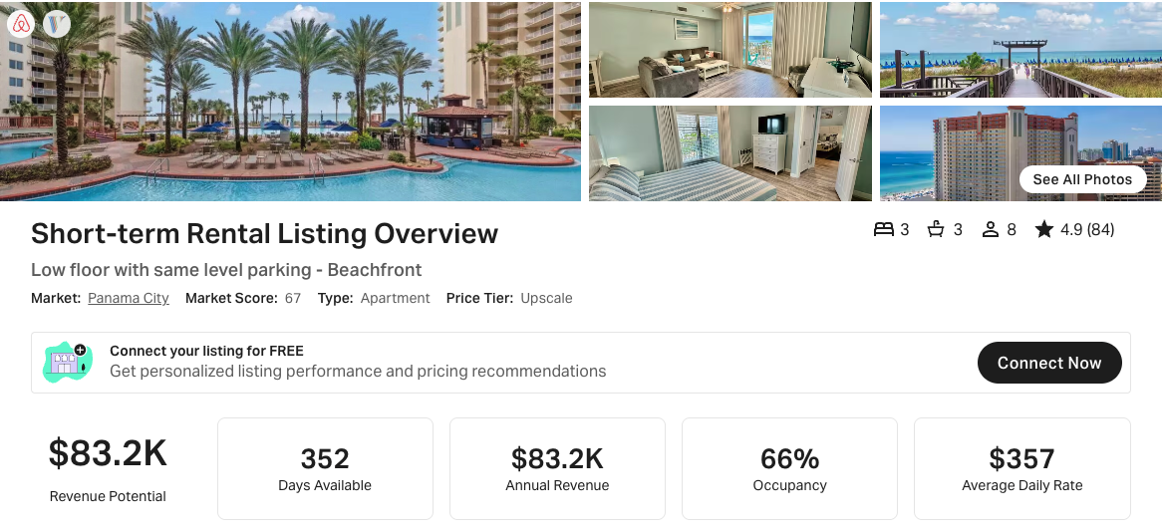
https://www.airbnb.com/rooms/609462463073897069
https://www.vrbo.com/2763998

20 Stack:
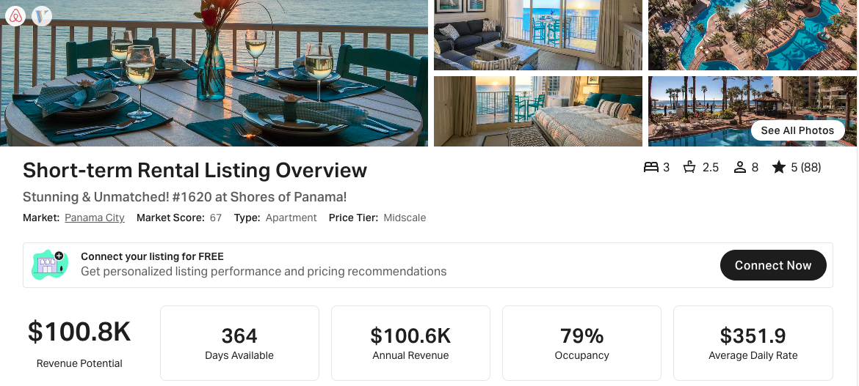
https://www.airbnb.com/rooms/53723561
https://www.vrbo.com/2606059

23 Stack:
Unit 2023 -
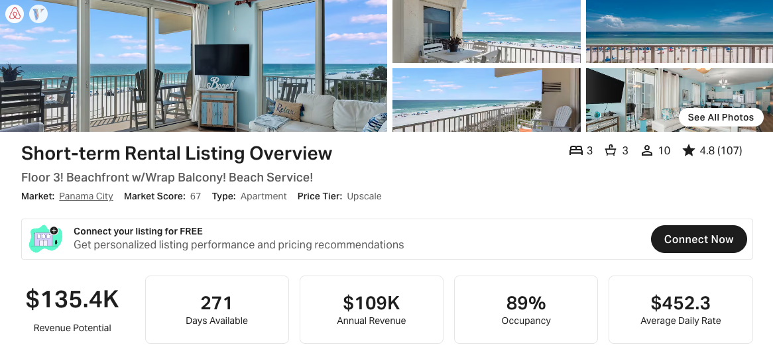
https://www.airbnb.com/rooms/48244874 - VRBO link not working at time of data pull

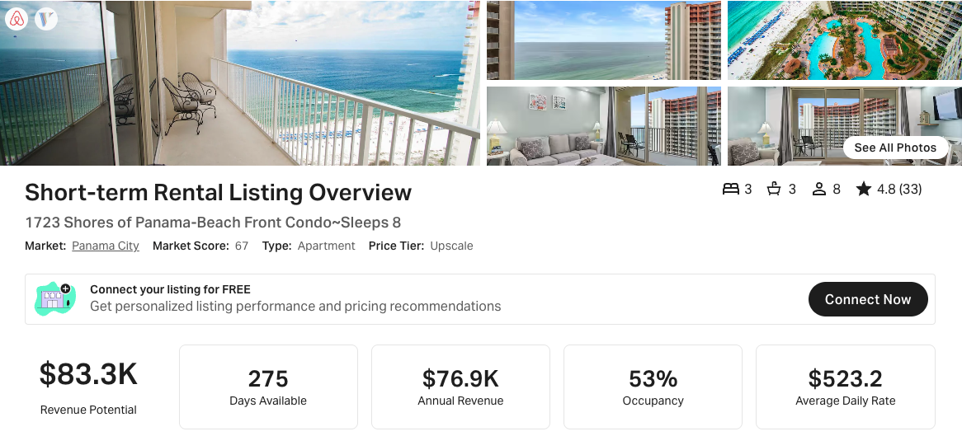
https://www.airbnb.com/rooms/43375836
https://www.vrbo.com/9415780ha

25 Stack:
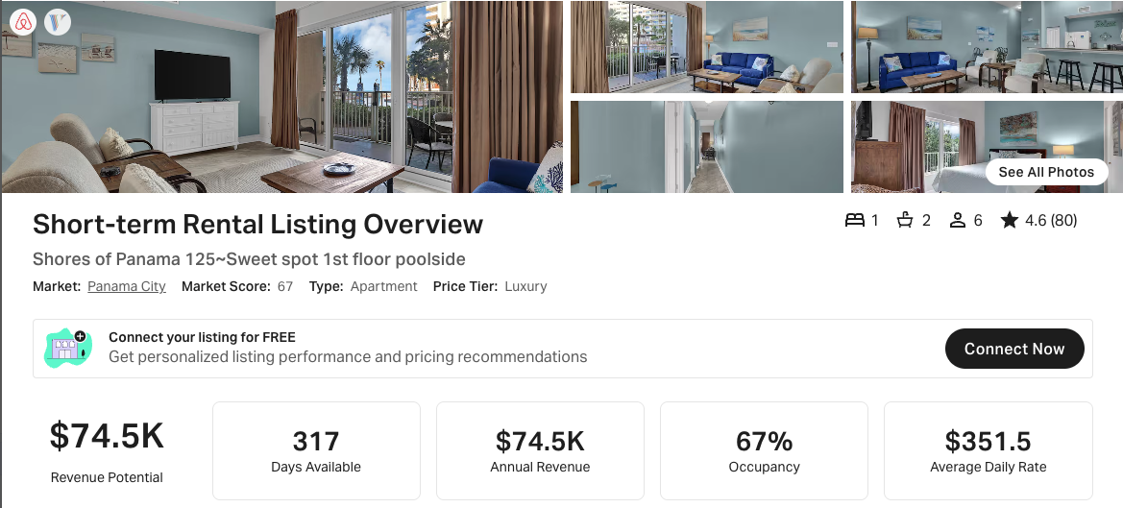
https://www.airbnb.com/rooms/1011671408840614115
https://www.vrbo.com/3681560

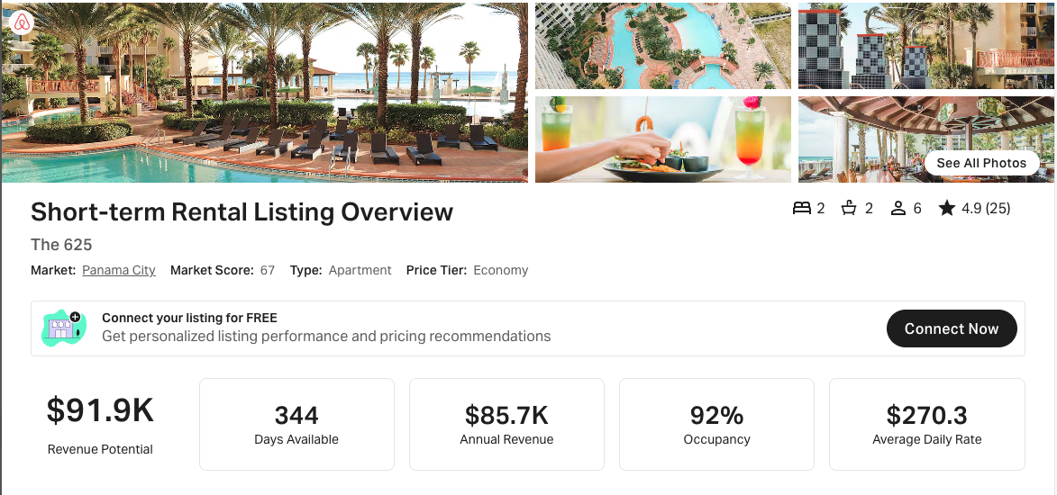
https://www.airbnb.com/rooms/851450914888833823 - No VRBO link

27 Stack:
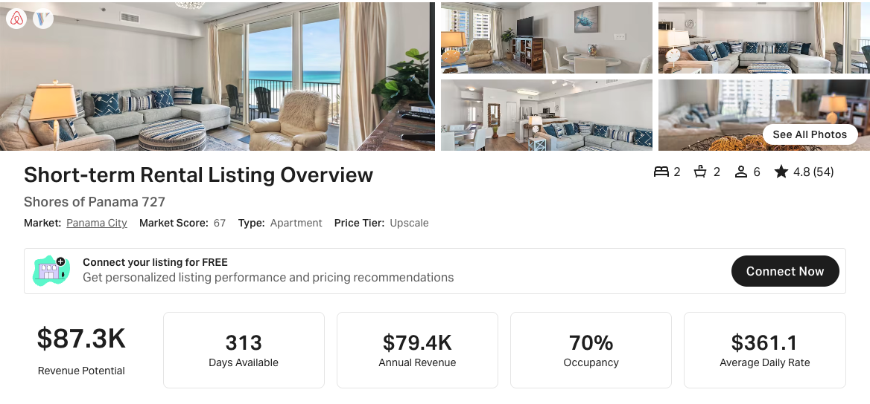
https://www.airbnb.com/rooms/730362420473856936
https://www.vrbo.com/3042082

29 Stack:
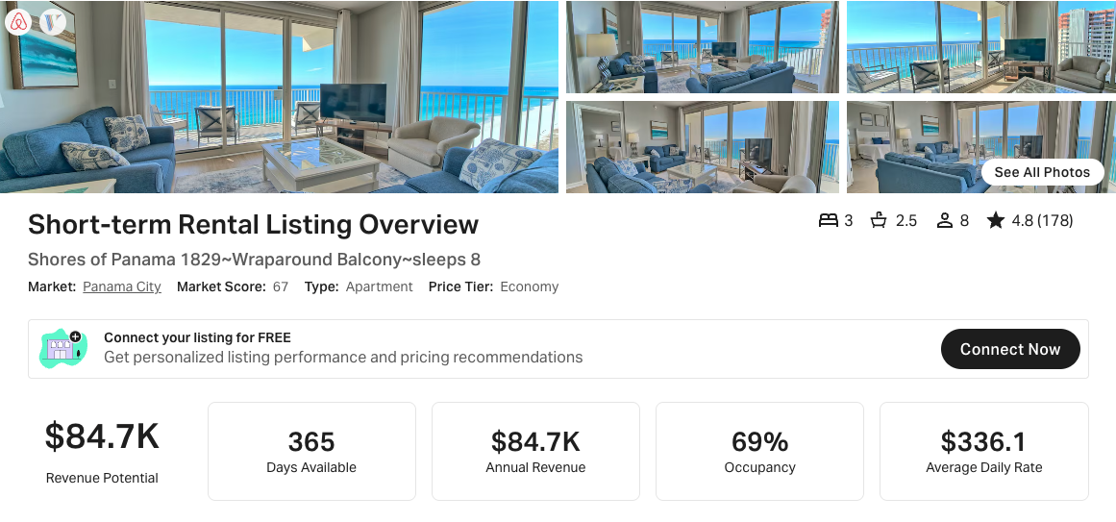
https://www.airbnb.com/rooms/43467998
https://www.vrbo.com/1989767

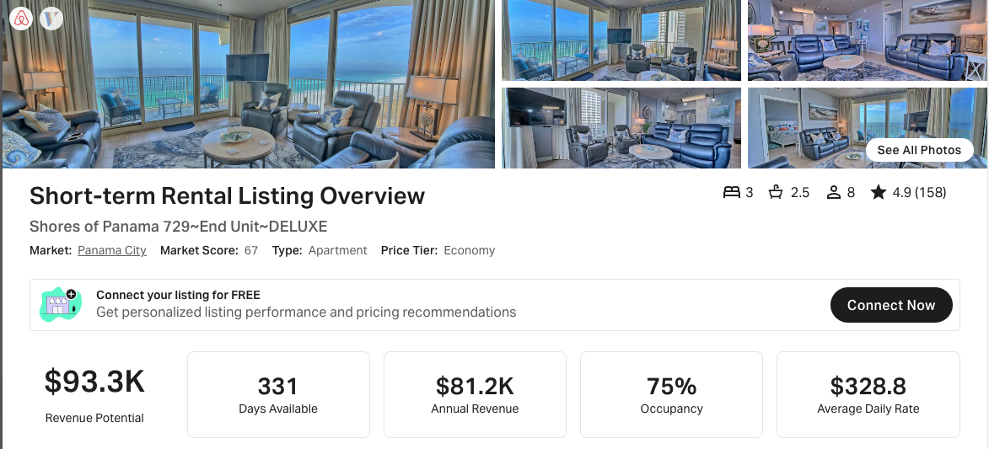
https://www.airbnb.com/rooms/47867592
https://www.vrbo.com/2185193

30 Stack:
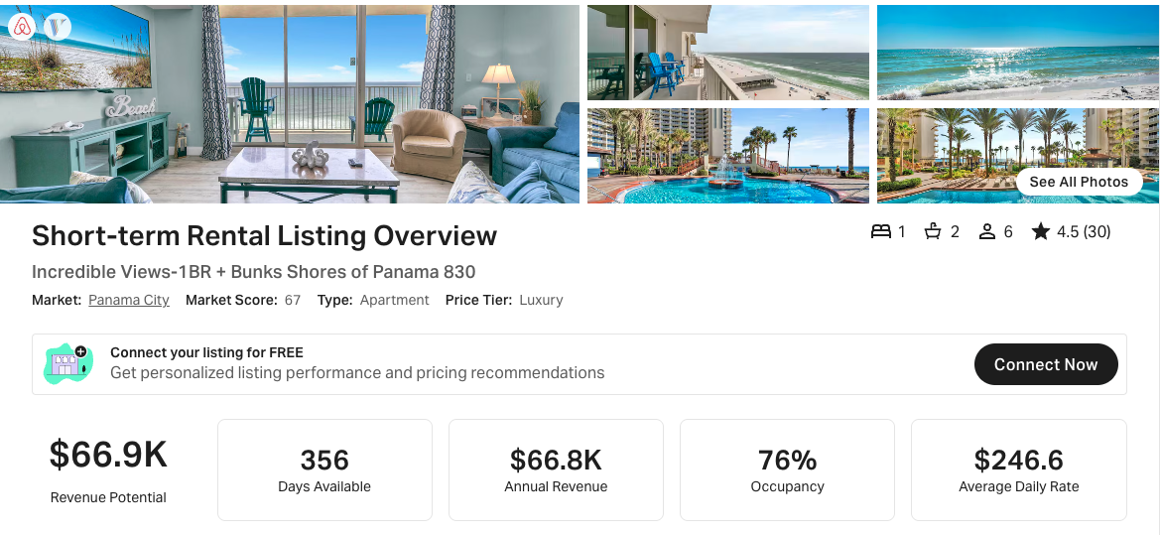
https://www.airbnb.com/rooms/603559774765640006
https://www.vrbo.com/2764534
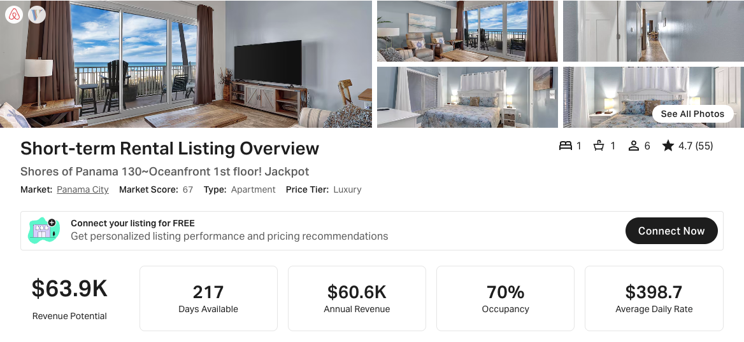
https://www.airbnb.com/rooms/1015214485607042377
https://www.vrbo.com/3684607

31 Stack:
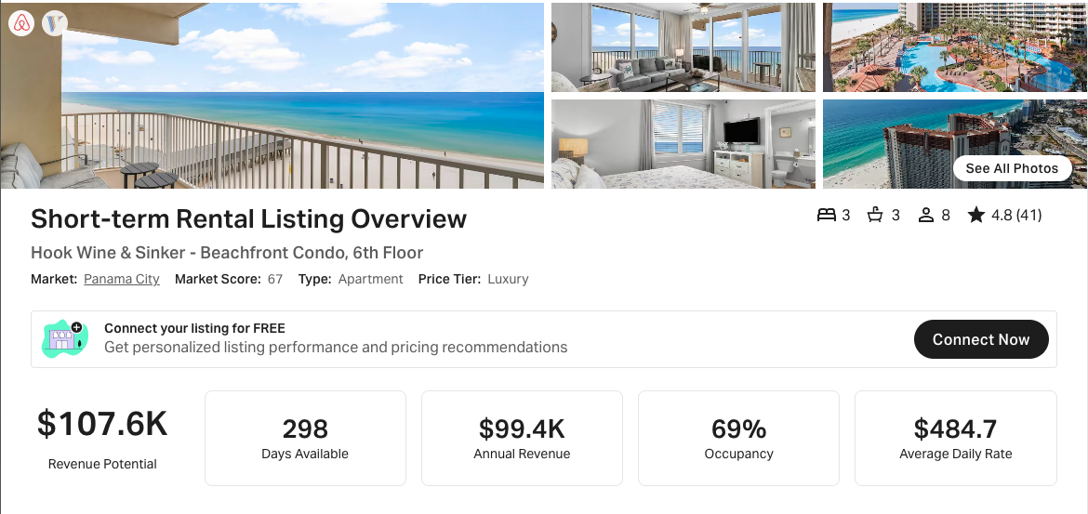
https://www.airbnb.com/rooms/800836819900024711
https://www.vrbo.com/3192541

