Prominence C Unit • AirDNA High-Performers
Data pulled from AirDNA Sept 24, 2025.
This is for informational purposes only and is not a guarantee (or a limit) of income.
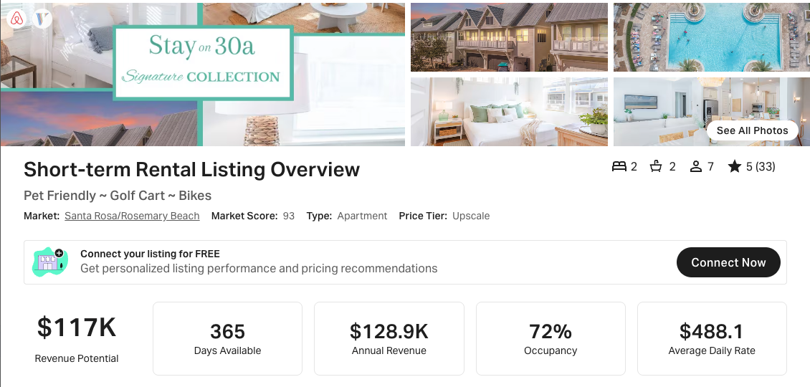
https://www.airbnb.com/rooms/1105408678538264080
https://www.vrbo.com/3888725
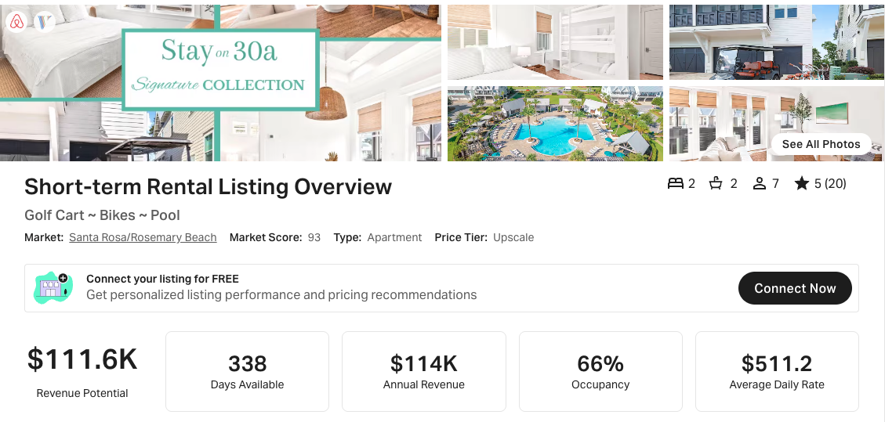
https://www.airbnb.com/rooms/1073330993309194178
https://www.vrbo.com/3818549
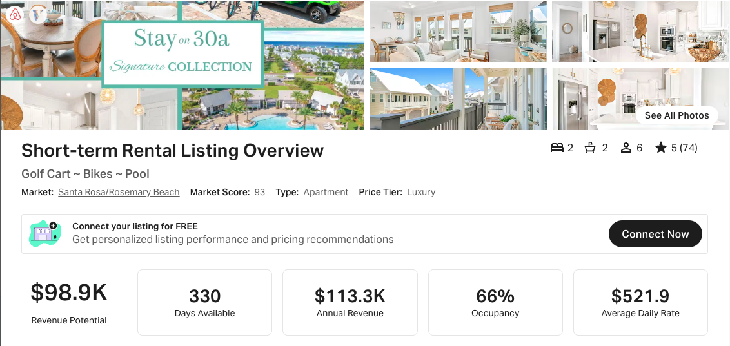
https://www.airbnb.com/rooms/871264101722338341
https://www.vrbo.com/3389408
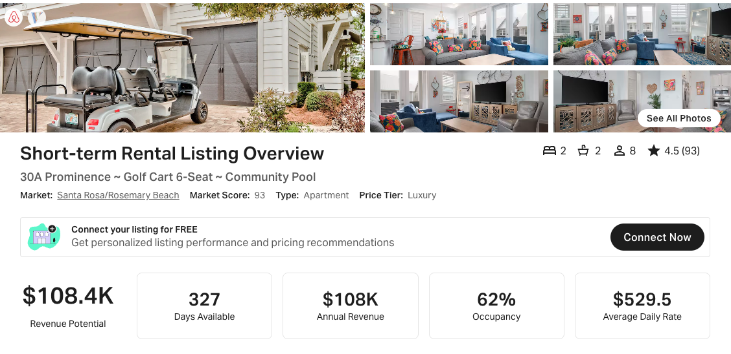
https://www.airbnb.com/rooms/23265235
https://www.vrbo.com/995529

