Splash Condo • AirDNA High Performers
This is not a guarantee (or a limit) of income.

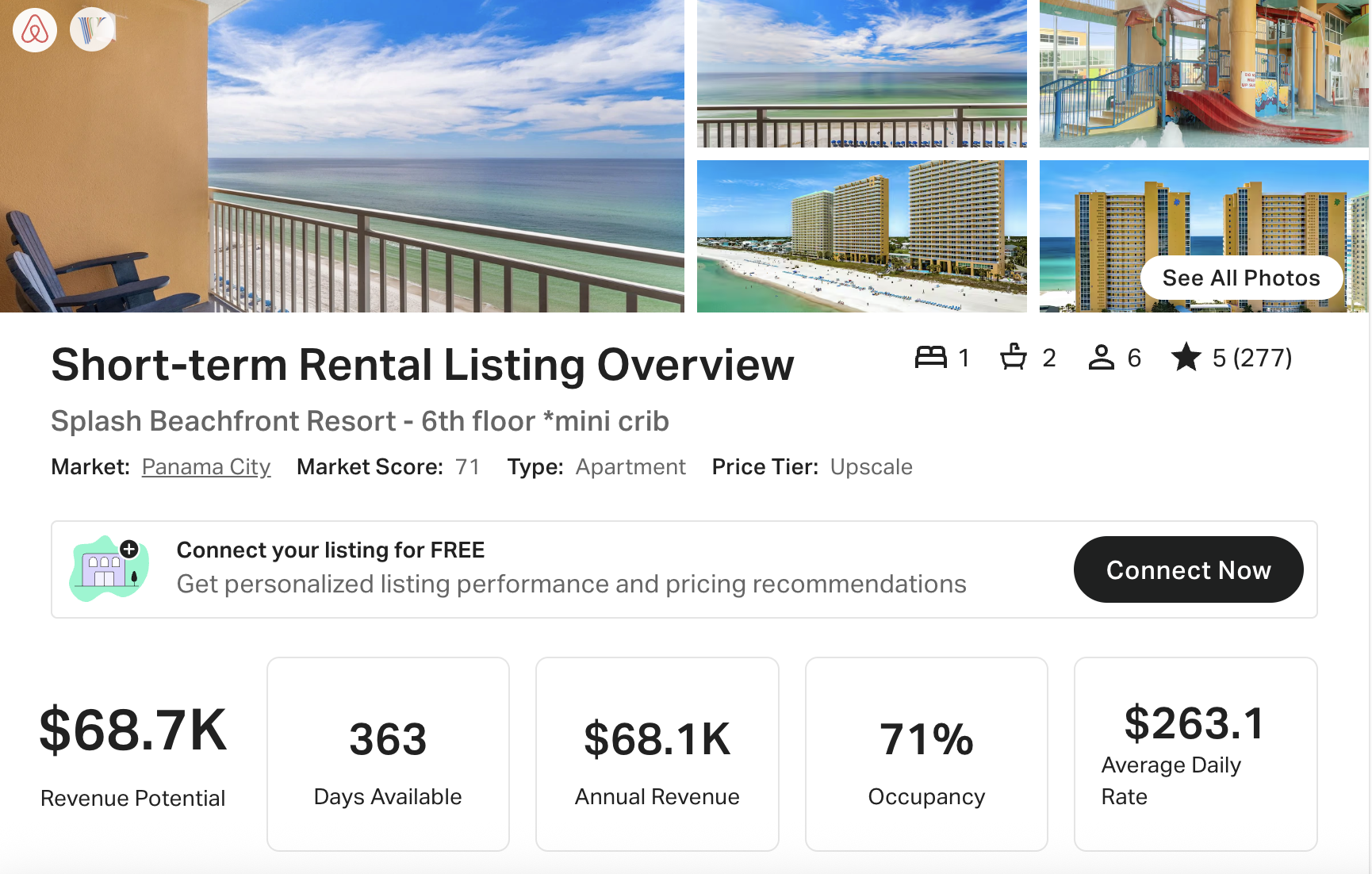
https://www.airbnb.com/rooms/569832220134799247

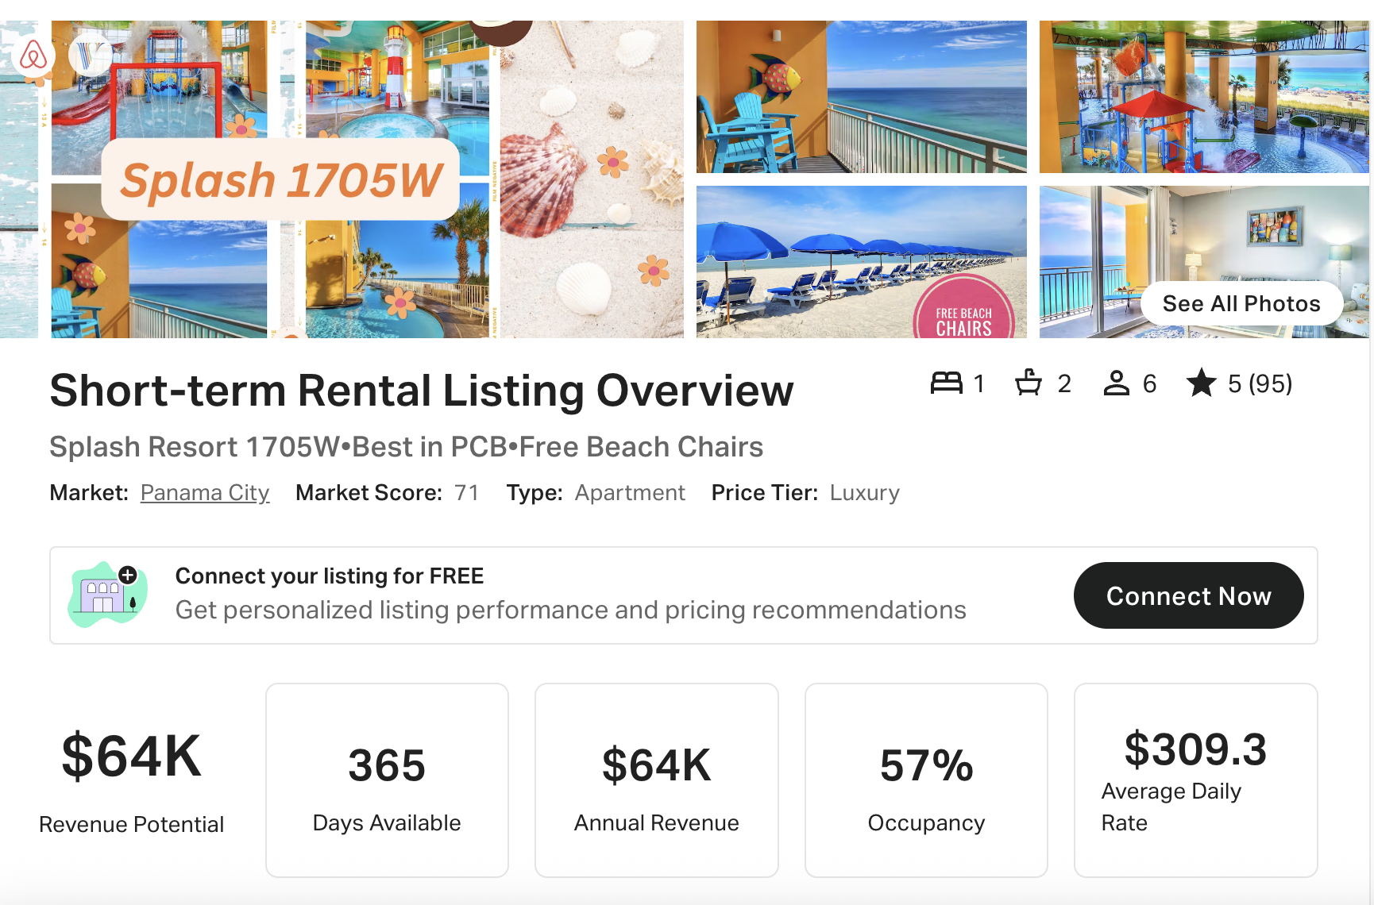
https://www.airbnb.com/rooms/894167244618165517

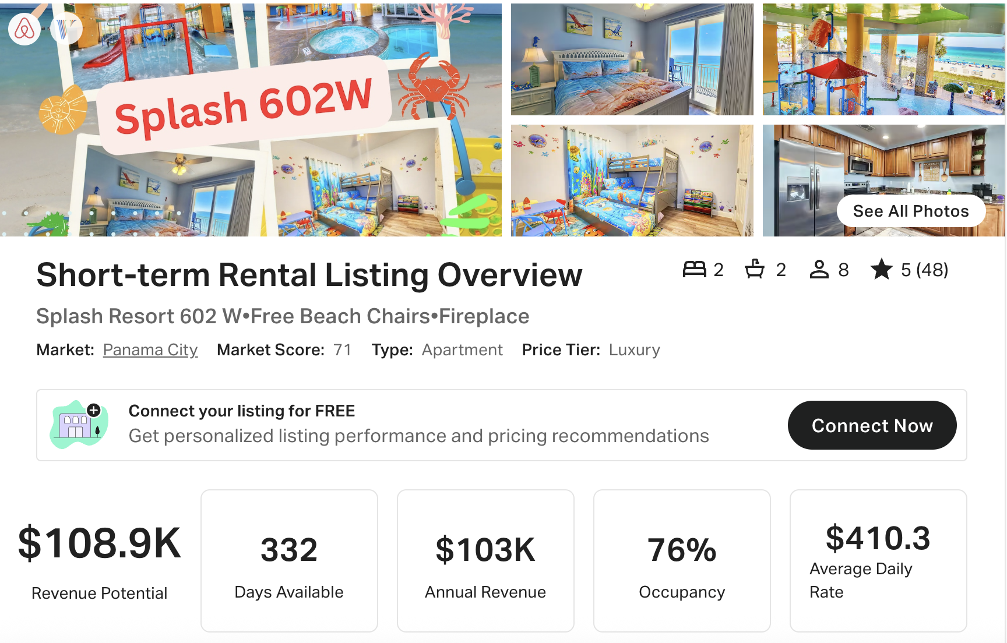
https://www.airbnb.com/rooms/1054975635374313450
https://www.vrbo.com/3797876

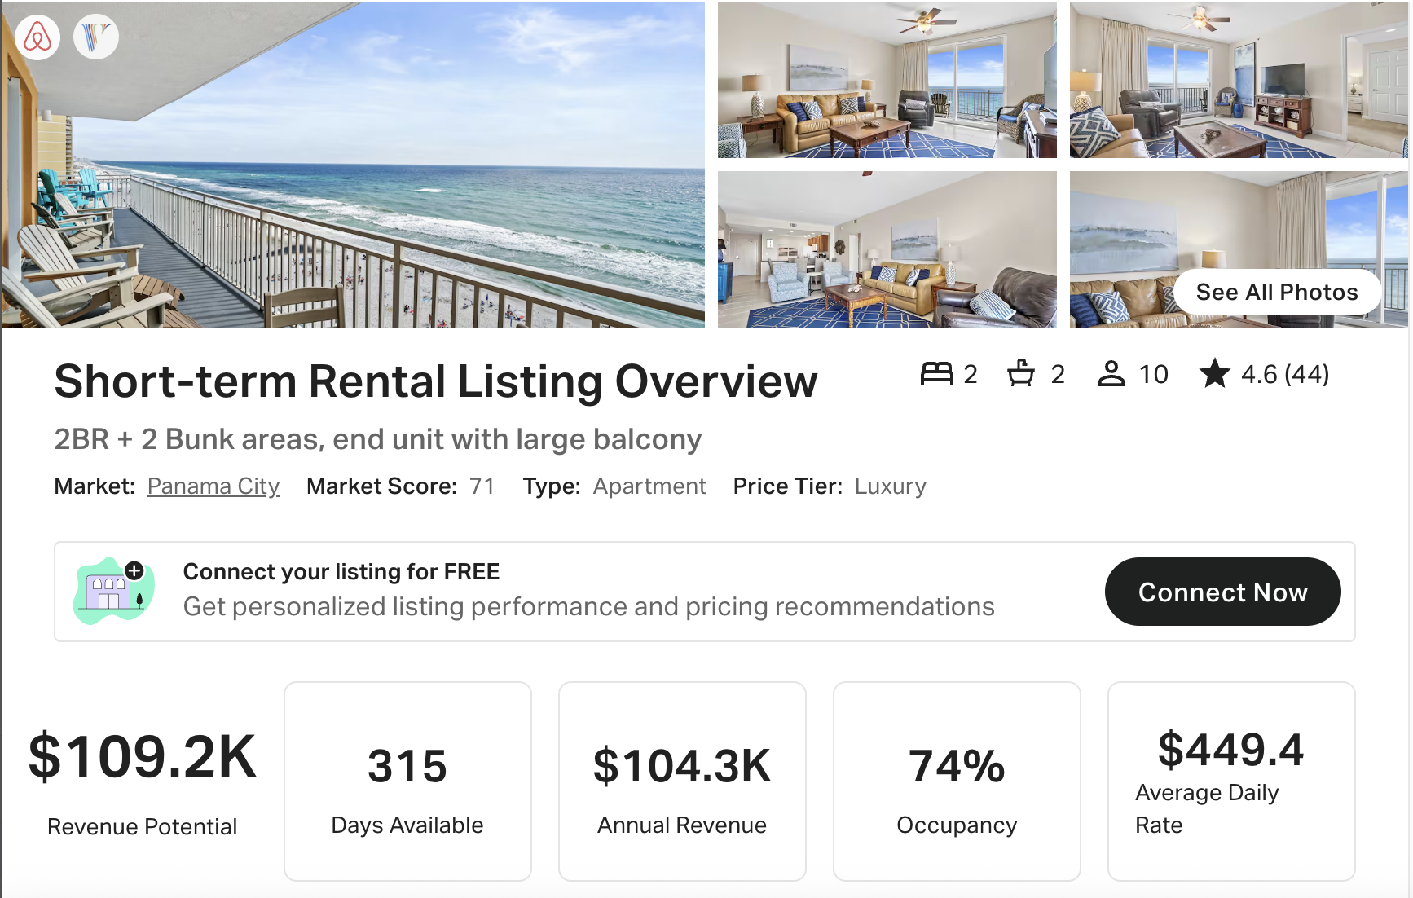
https://www.airbnb.com/rooms/17921867
https://www.vrbo.com/620582

