Edgewater, PCB • AirDNA High-Performers
Data Pulled September 2025. This is not a guarantee (or a limit) of income
Tower I: 11483 Front Beach Road
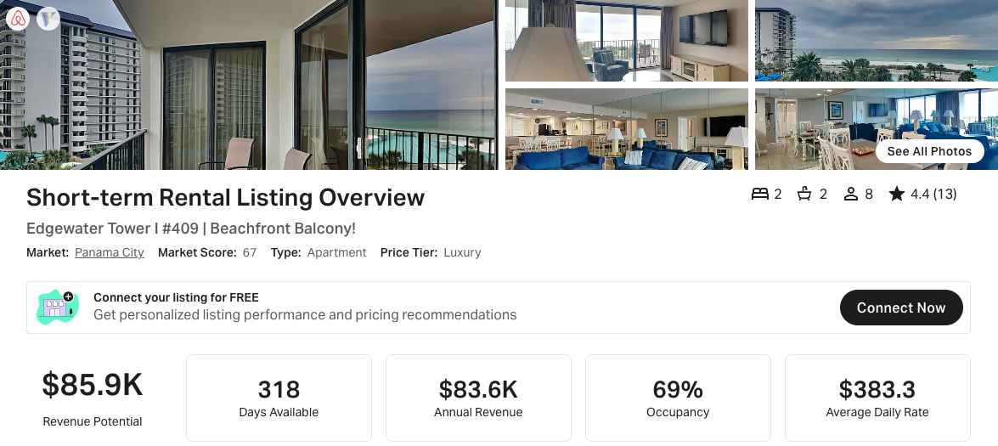
https://www.airbnb.com/rooms/802199454008477496
https://www.vrbo.com/3197370
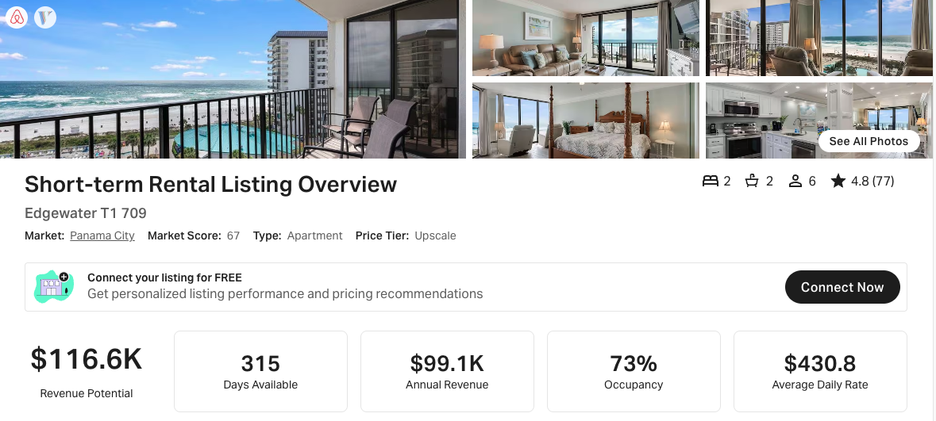
https://www.airbnb.com/rooms/562857386401688082
https://www.vrbo.com/2667586
Tower 2: 11619 Front Beach Road
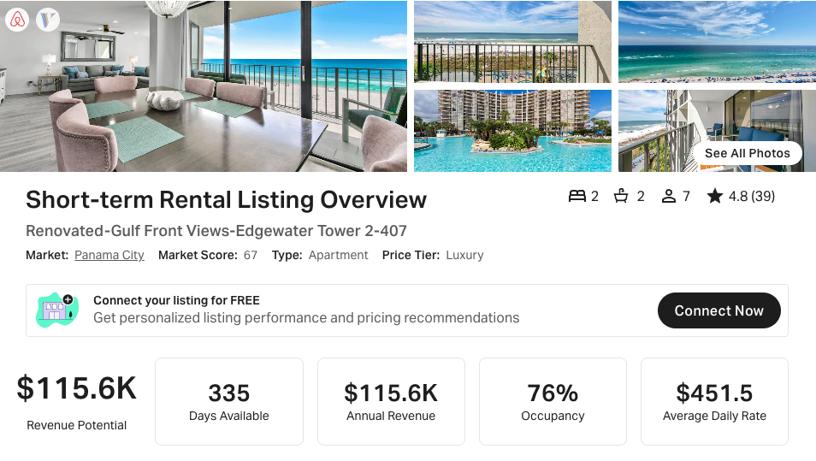
https://www.airbnb.com/rooms/54341399
https://www.vrbo.com/2417999
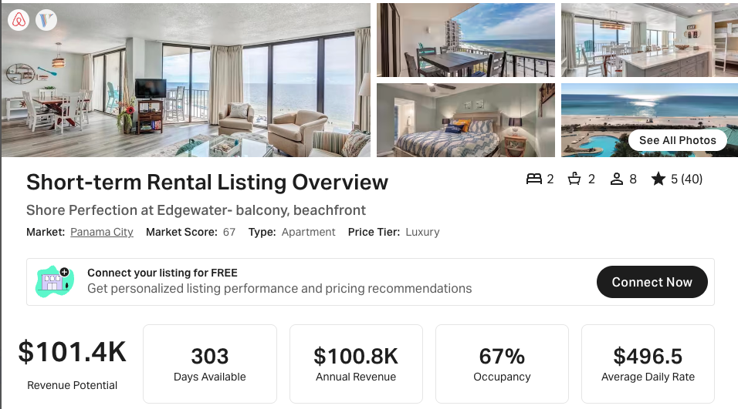
https://www.airbnb.com/rooms/831824070257098952
https://www.vrbo.com/3264564
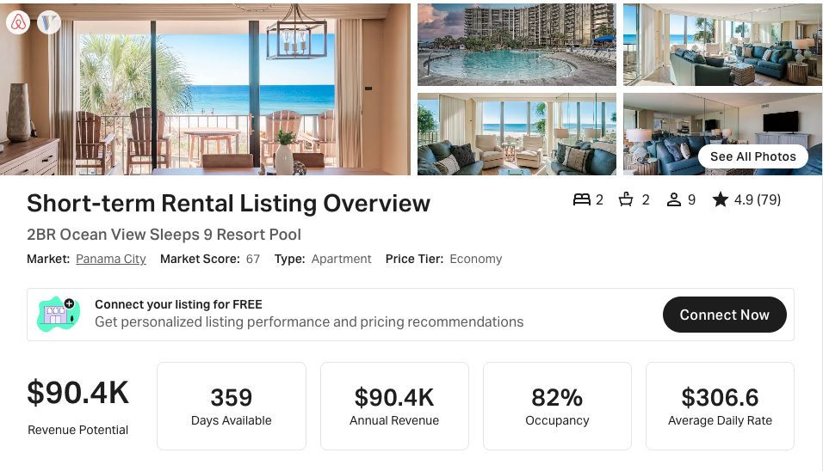
https://www.airbnb.com/rooms/1198618947622844899
https://www.vrbo.com/4286277
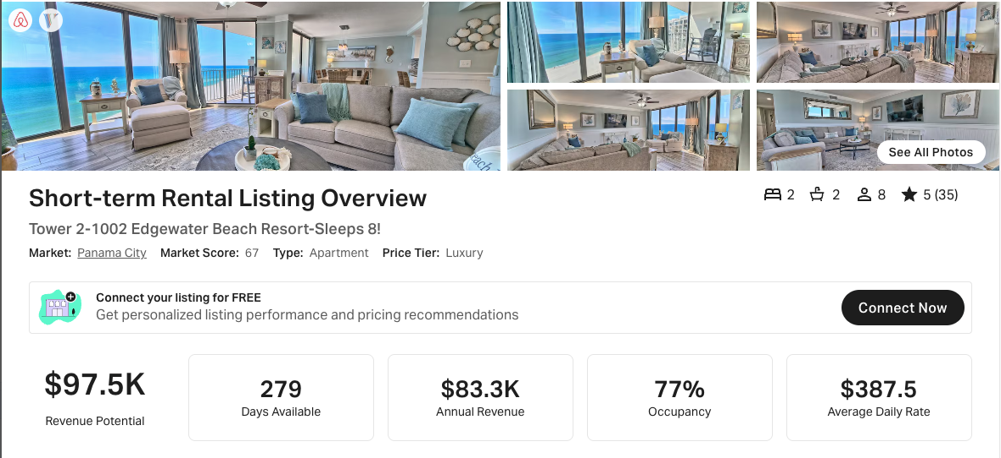
https://www.airbnb.com/rooms/1076221030426647568
https://www.vrbo.com/3825682

Tower III: 11347 Front Beach Road
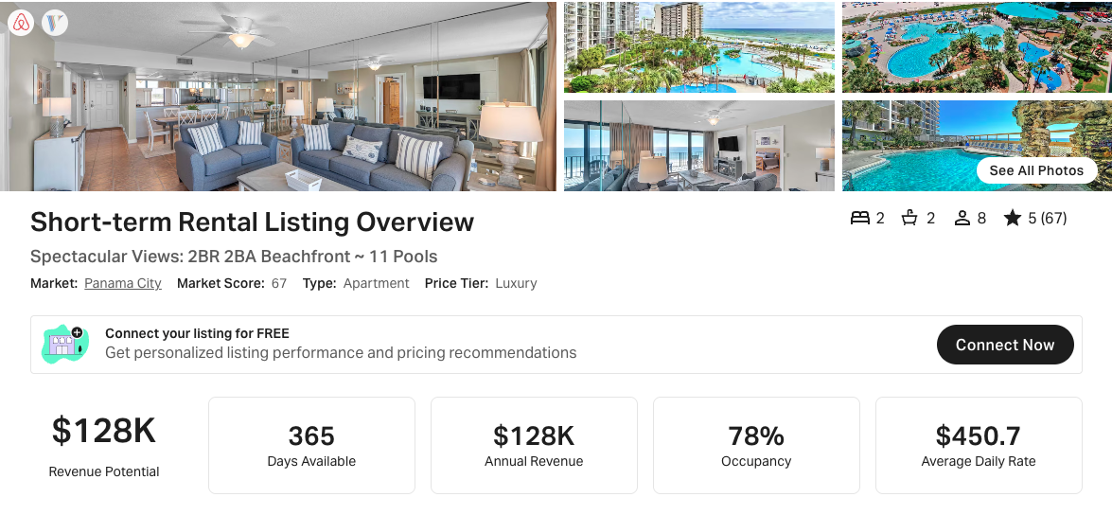
https://www.airbnb.com/rooms/51451404
https://www.vrbo.com/2640905
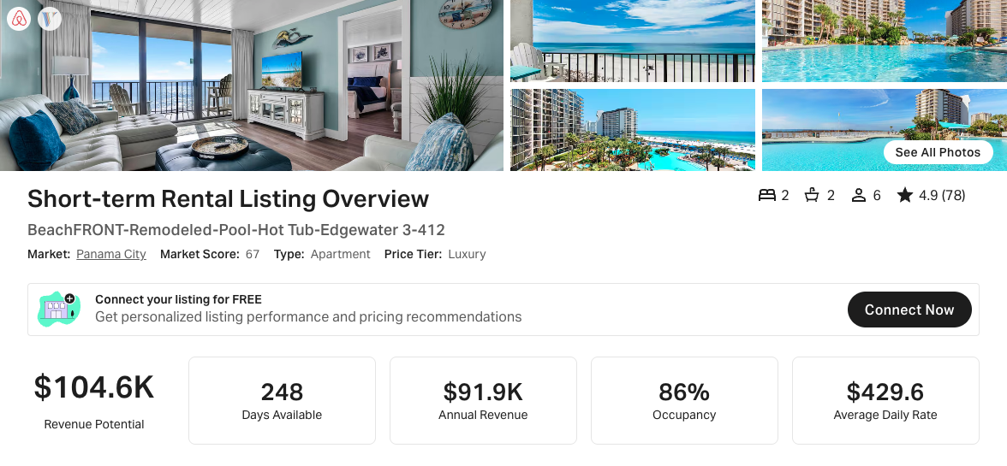
https://www.airbnb.com/rooms/32989183
https://www.vrbo.com/1583776

Leeward/Windward Buildings
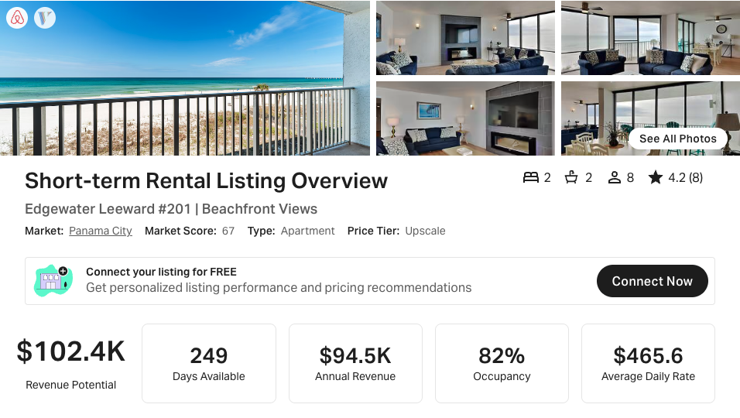
Airbnb and VRBO links not available

