Tidewater Condo, PCB • AirDNA High-Performers
Data pulled on 5.01.2026 for informational purposes only.
This is not a guarantee (or a limit) of income.
CRITERIA: 270+ days on rental market and 20+ reviews unless otherwise noted.

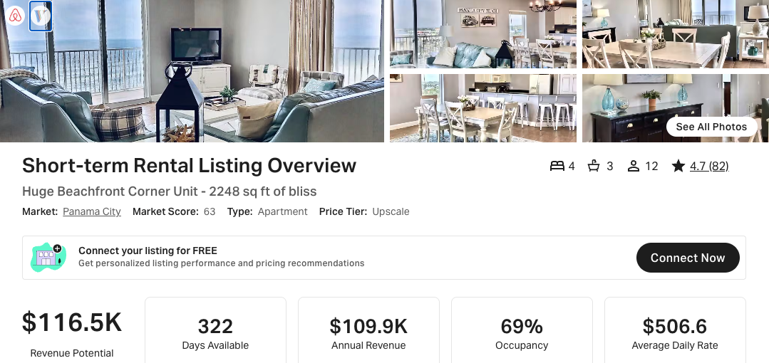
https://www.airbnb.com/rooms/42971618
https://www.vrbo.com/1938506

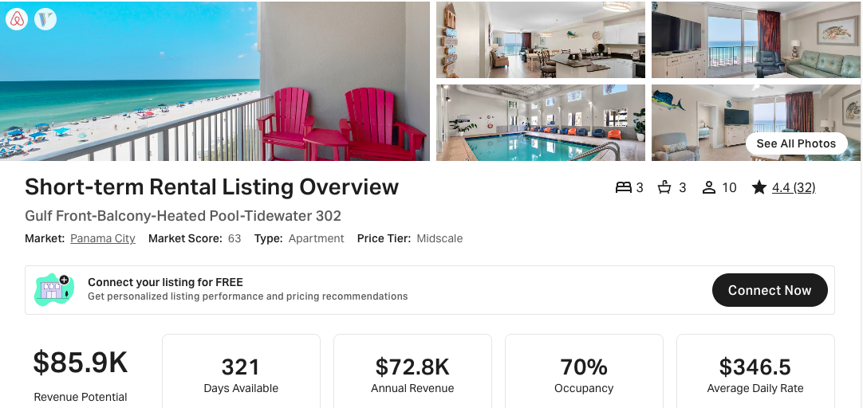
https://www.airbnb.com/rooms/613644998340059988
https://www.vrbo.com/2777783

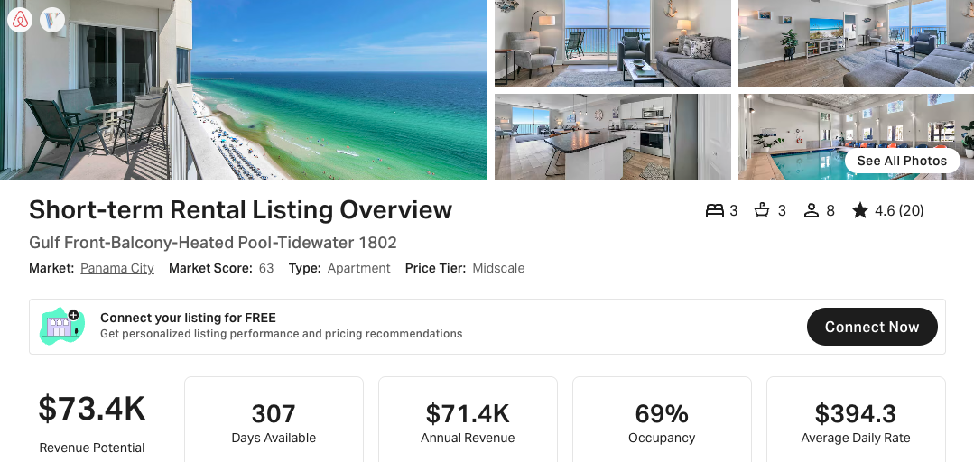
https://www.airbnb.com/rooms/1161592466869165006
https://www.vrbo.com/4014324

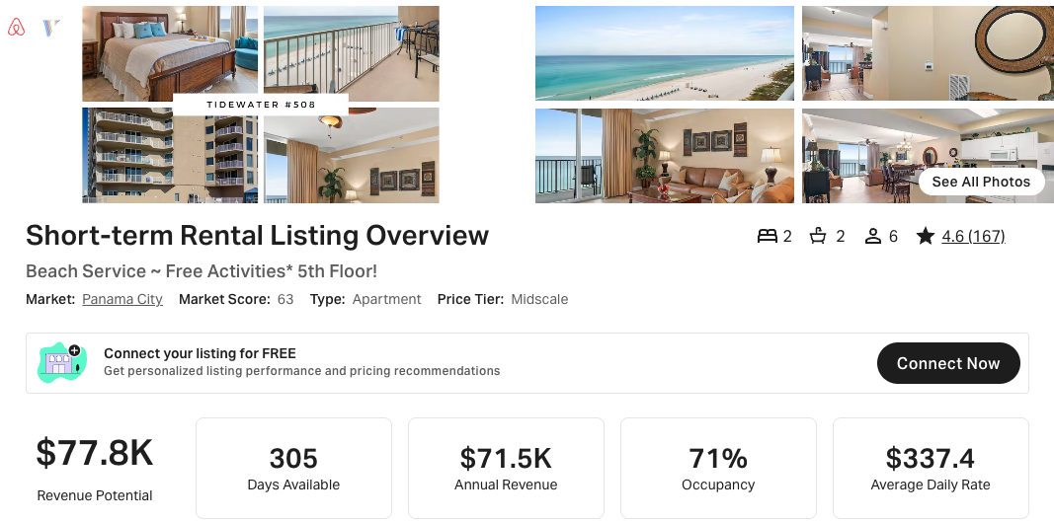
https://www.airbnb.com/rooms/37045032
https://www.vrbo.com/1681044

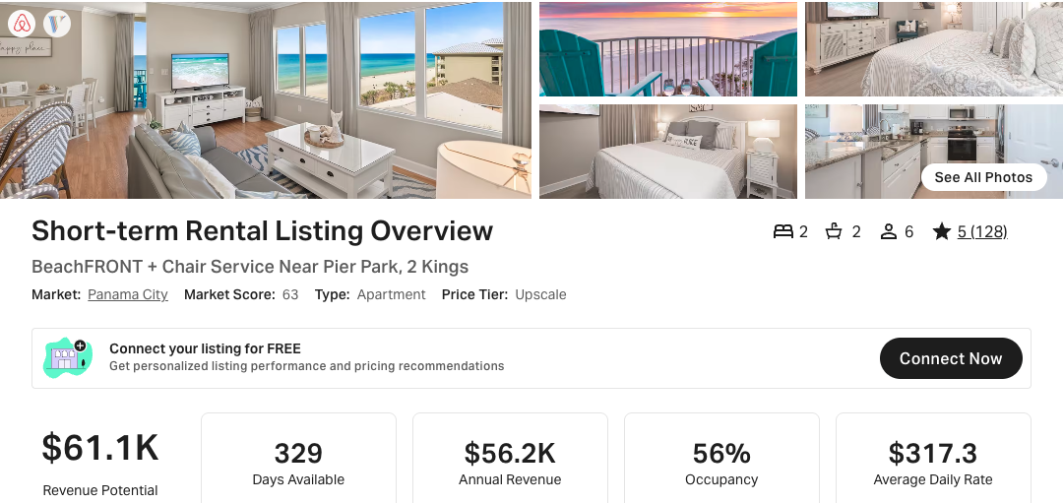
https://www.airbnb.com/rooms/50598435
https://www.vrbo.com/2329123

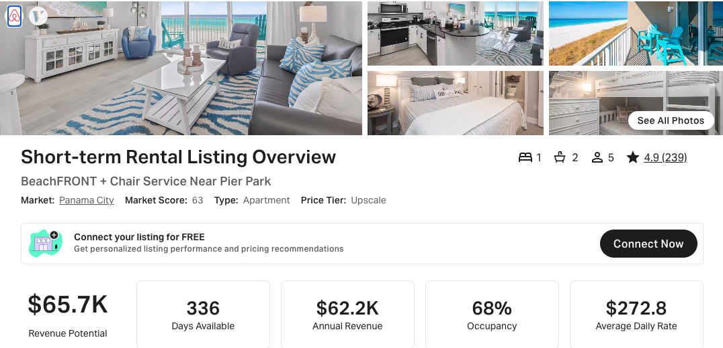
https://www.airbnb.com/rooms/45384797
https://www.vrbo.com/2063978
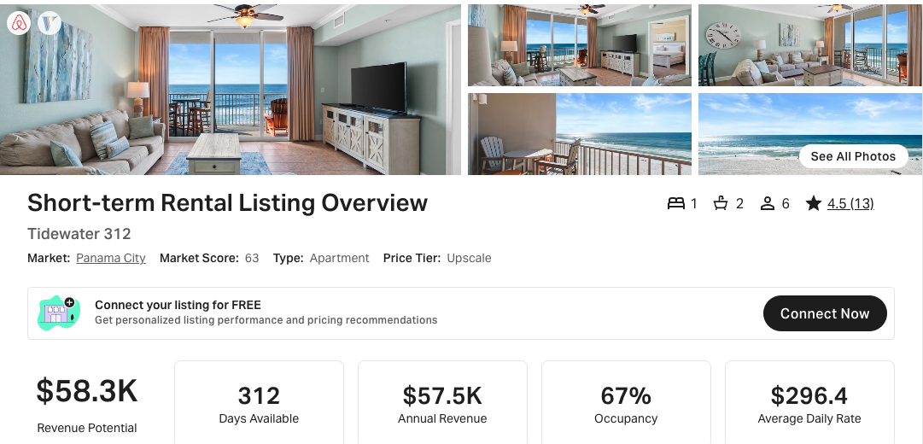
https://www.airbnb.com/rooms/1287709370689593451
https://www.vrbo.com/4222333

