East End PCB SFRs NO POOL • AirDNA High-Performers
Data pulled on 2.10.2026. This is not a guarantee (or a limit) of income.

Table data shows summary info only. Some have pools, some do not.
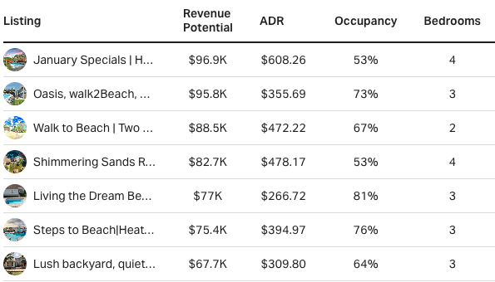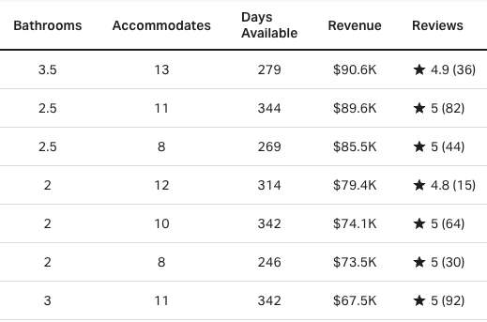

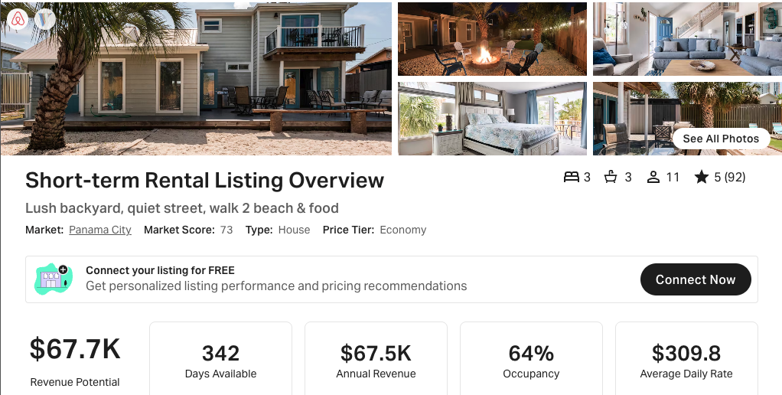
https://www.airbnb.com/rooms/683367686485555875
https://www.vrbo.com/2747261

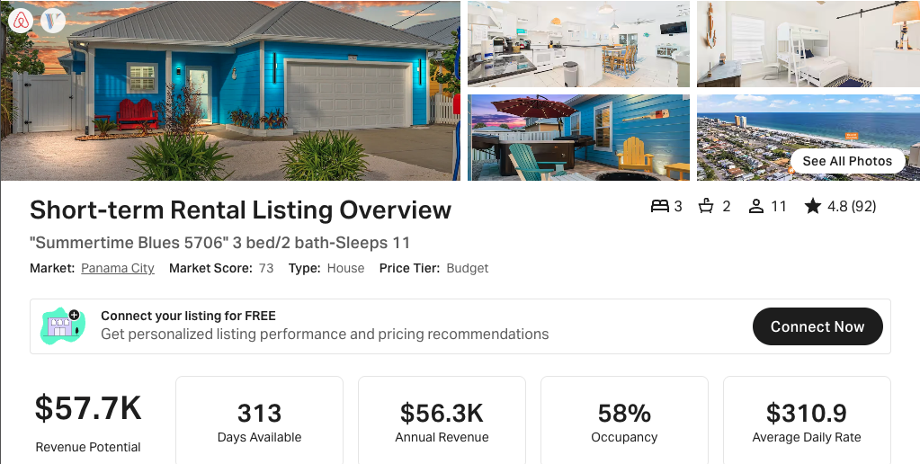
https://www.airbnb.com/rooms/960628196387739561
https://www.vrbo.com/3564698

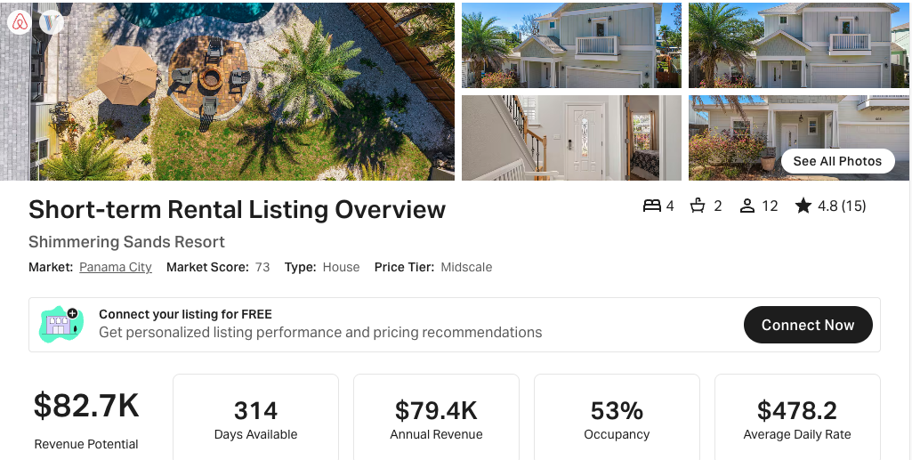
https://www.airbnb.com/rooms/1143437199520283529
https://www.vrbo.com/3867651

Scroll to next page for data on SFRs WITH POOL

West End PCB SFRs WITH POOL • AirDNA High-Performers
Data pulled on 2.09.2026. This is not a guarantee (or a limit) of income.

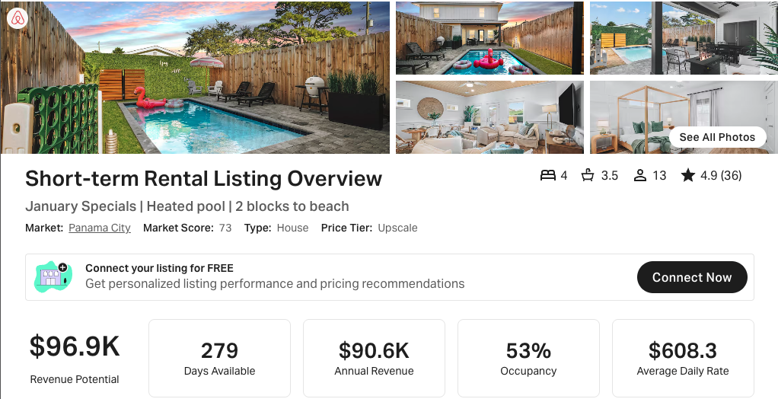
https://www.airbnb.com/rooms/1308237470090493298

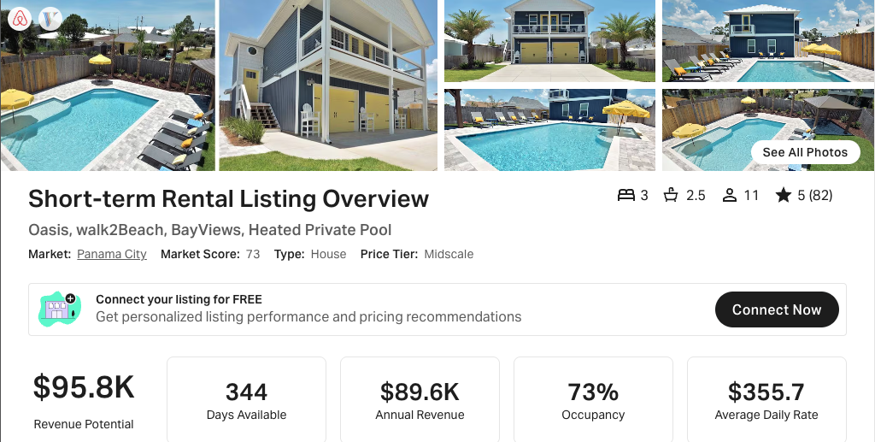
https://www.airbnb.com/rooms/679909429740106108
https://www.vrbo.com/2892245

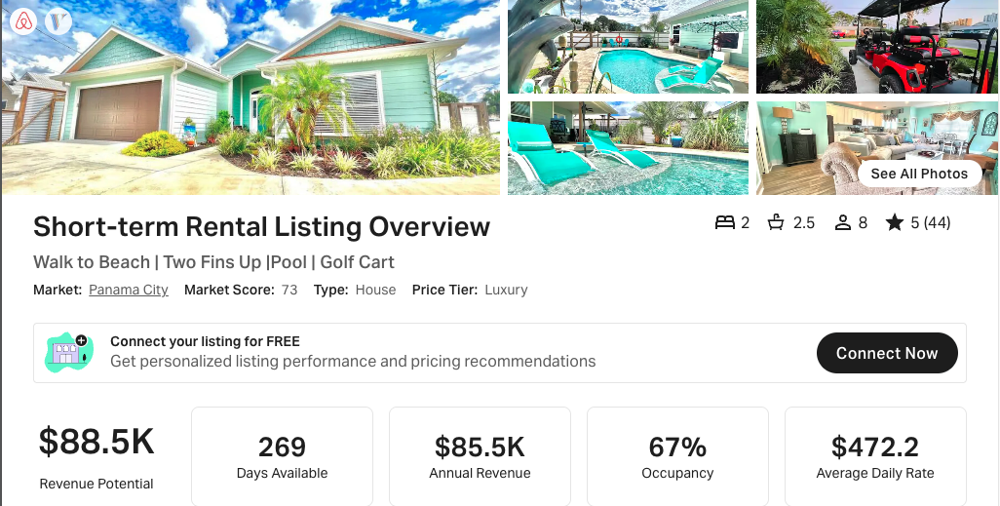
https://www.airbnb.com/rooms/791246301789469970
https://www.vrbo.com/2993507

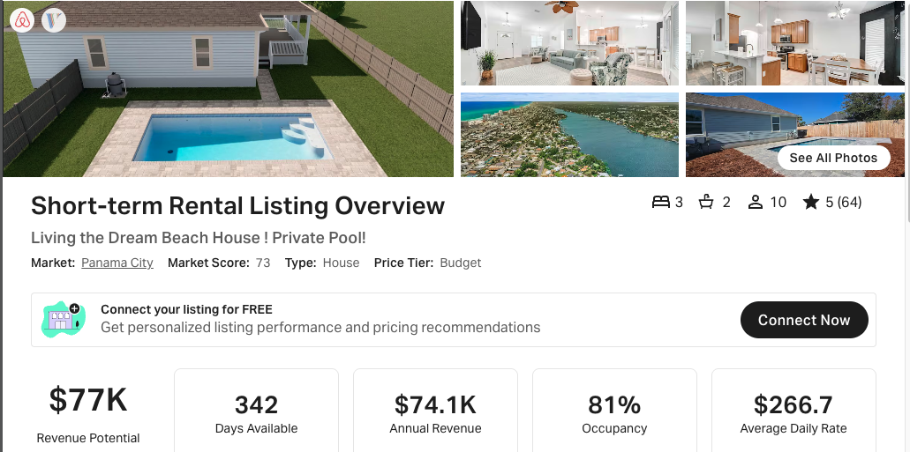
https://www.airbnb.com/rooms/1249664653308164130
https://www.vrbo.com/4305485

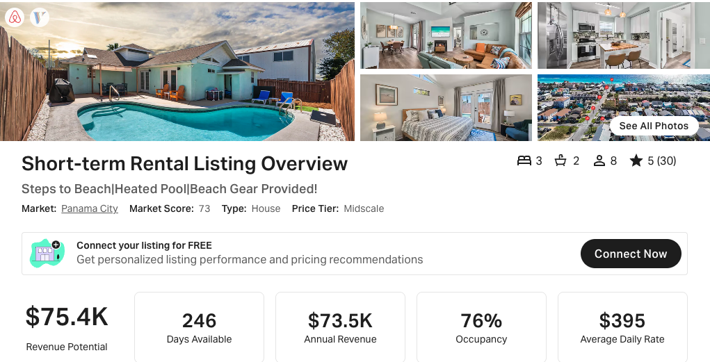
https://www.airbnb.com/rooms/1383413344367144149
https://www.vrbo.com/4505251

