Calypso Tower III • AirDNA High-Performers
1598 Front Beach Road, PCB. Data pulled on December 12, 2025. For informational purposes only.
This is not a guarantee (or a limit) of income.

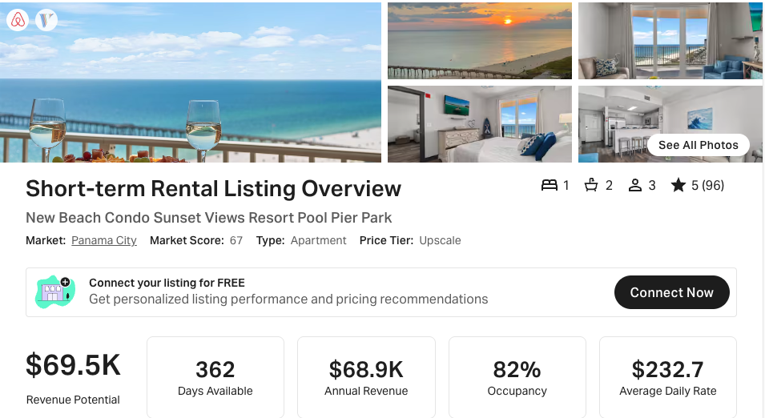
https://www.airbnb.com/rooms/708796630082338945
https://www.vrbo.com/2998823

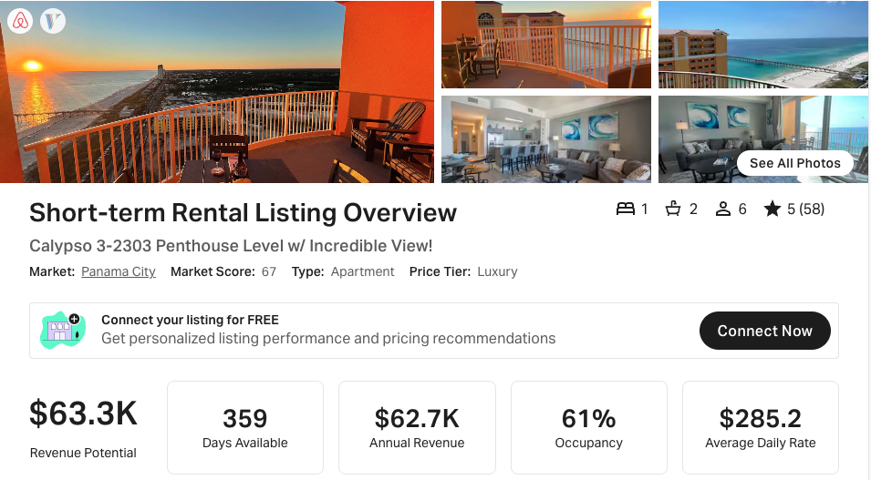
https://www.airbnb.com/rooms/51977573
https://www.vrbo.com/2515780
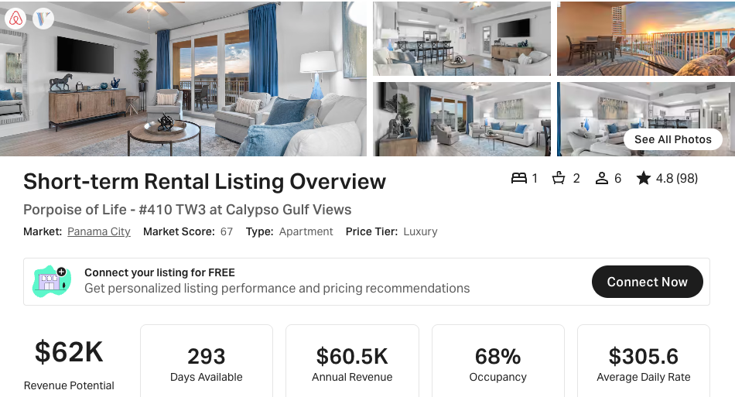
https://www.airbnb.com/rooms/732780703449851469
https://www.vrbo.com/3056416

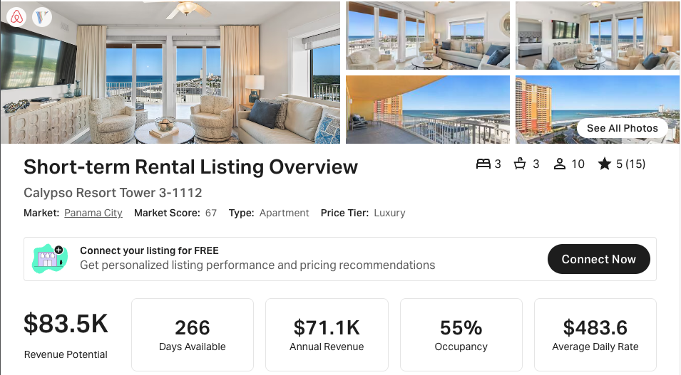
NOTE: This has <20 reviews and was not available 270 days (but close!)
https://www.airbnb.com/rooms/50413573
https://www.vrbo.com/2322057

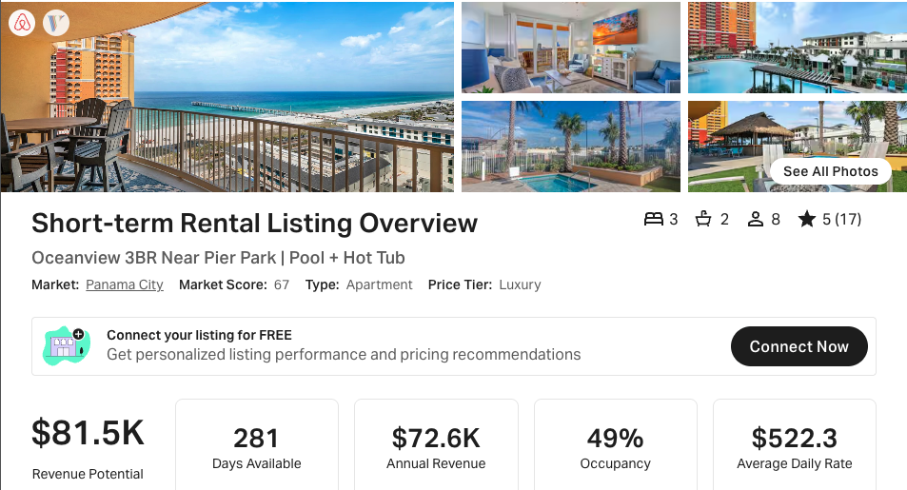
NOTE: This has <20 reviews. No VRBO link available
https://www.airbnb.com/rooms/752410706909787951

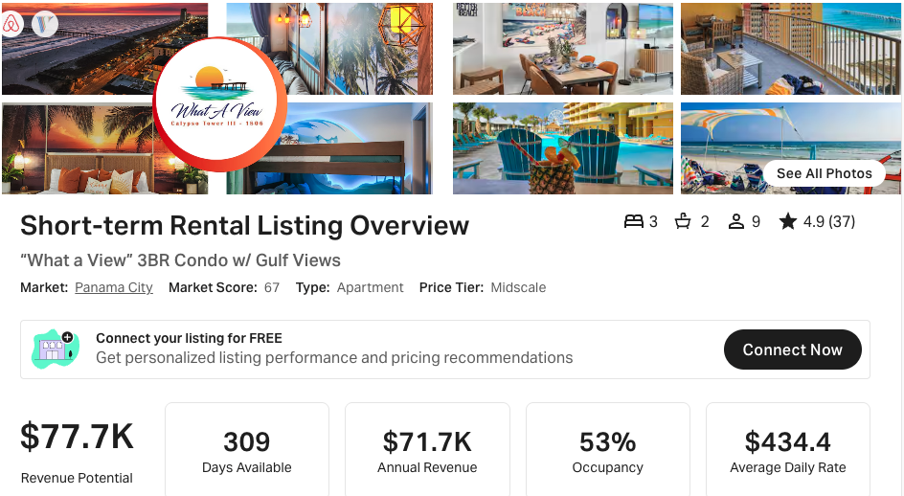
https://www.airbnb.com/rooms/51391775
https://www.vrbo.com/2412699

