Majestic Condo • AirDNA High-Performers
Two towers: 10811 Front Beach Road and 10901 Front Beach Road, PCB
Data pulled on December 29, 2025. For informational purposes only.
This is not a guarantee (or a limit) of income.

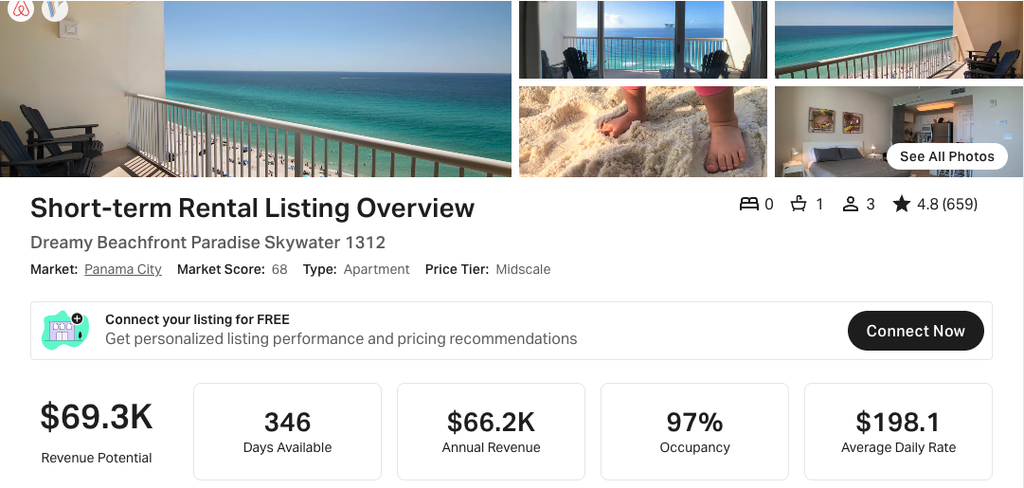
https://www.airbnb.com/rooms/17872951
NOTE: The VRBO link to this property did not appear to show THIS property, so I excluded it.

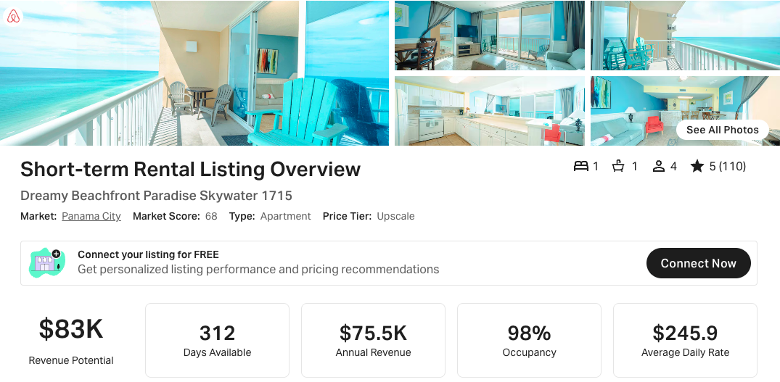
https://www.airbnb.com/rooms/1147854157004027650

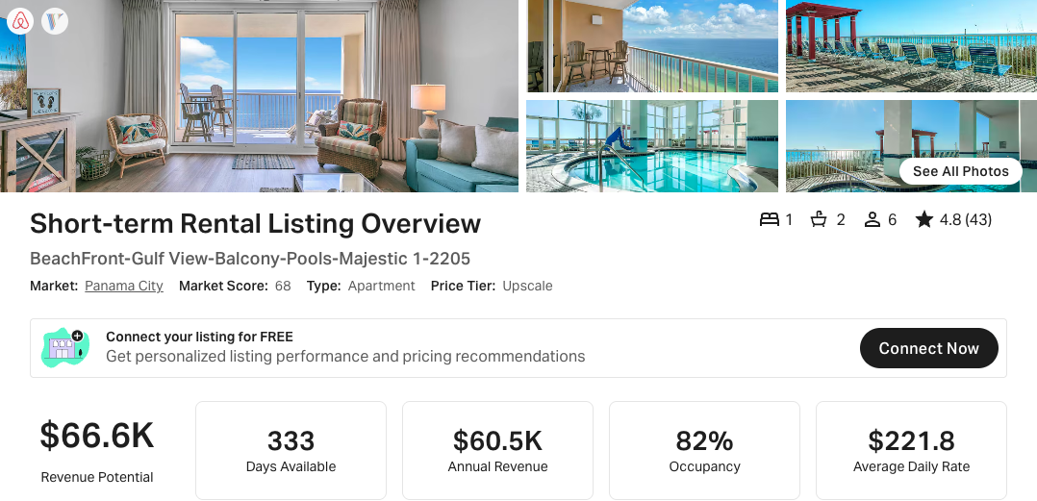
https://www.airbnb.com/rooms/739893353766751525
https://www.vrbo.com/3064764

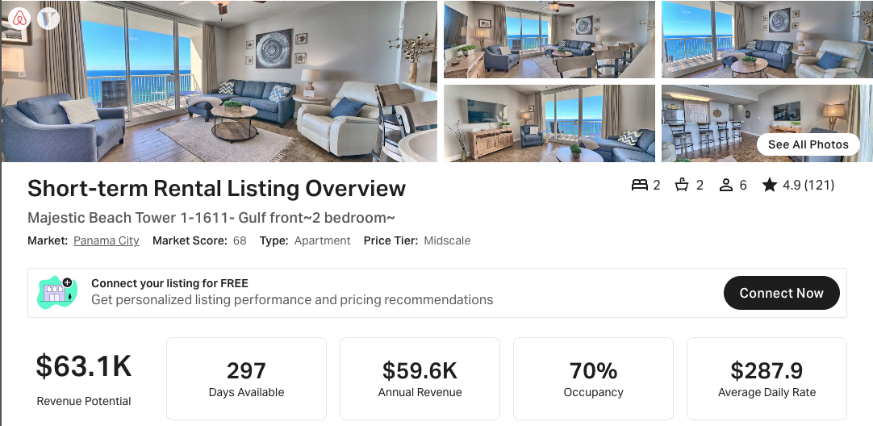

NOTE: I did not see any AirDNA 2 BR comps doing better than the high performing 1 BR 2 Bunk comps, which was unexpected but interesting. This is the highest one I saw in AirDNA for 2 BR that meet my selection criteria (270+ days on market and 20+ reviews).

https://www.airbnb.com/rooms/51707678
https://www.vrbo.com/2462101

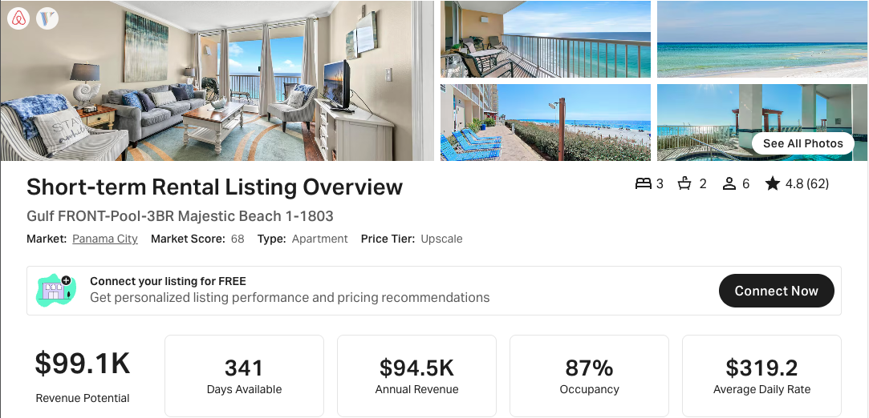
https://www.airbnb.com/rooms/43205880
https://www.vrbo.com/1960499

