Panama Dunes, PCB • AirDNA High-Performers
Data pulled on 5.01.2026 for informational purposes only.
This is not a guarantee (or a limit) of income.
CRITERIA: 270+ days on rental market and 20+ reviews unless otherwise noted.

NOTE: There are only 14 units in this single-family complex (with community pool). This example is the highest performing unit I was able to find.

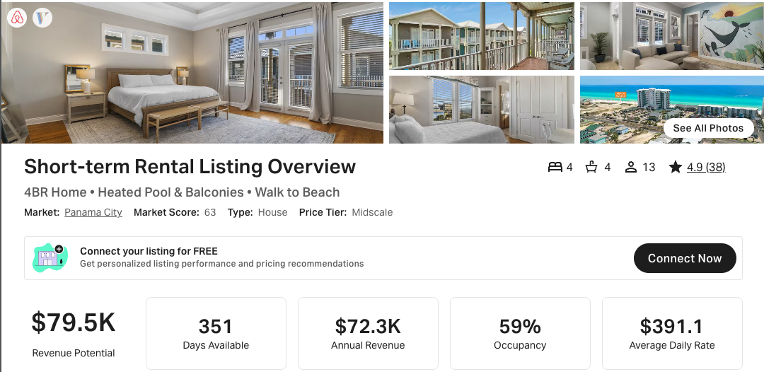

https://www.airbnb.com/rooms/891989828946725704
https://www.vrbo.com/3407478

