Sandpiper Cove • AirDNA High-Performers
Data pulled on 4.01.2026 for informational purposes only.
This is not a guarantee (or a limit) of income.
CRITERIA: 270+ days on rental market and 20+ reviews unless otherwise noted.

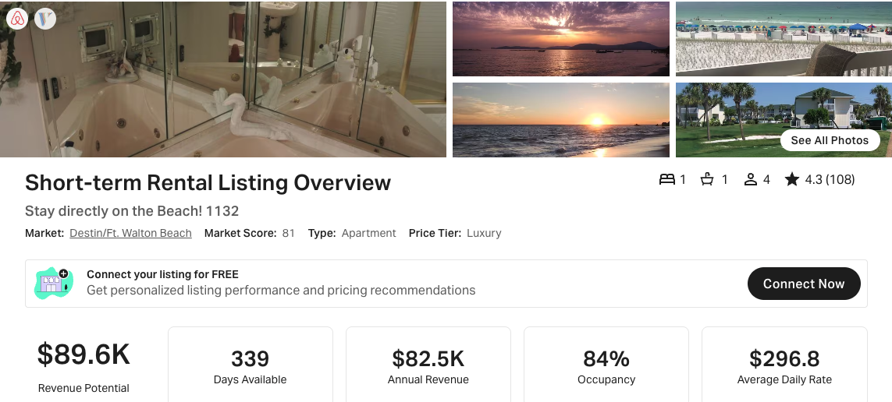
https://www.airbnb.com/rooms/43246778
https://www.vrbo.com/87799

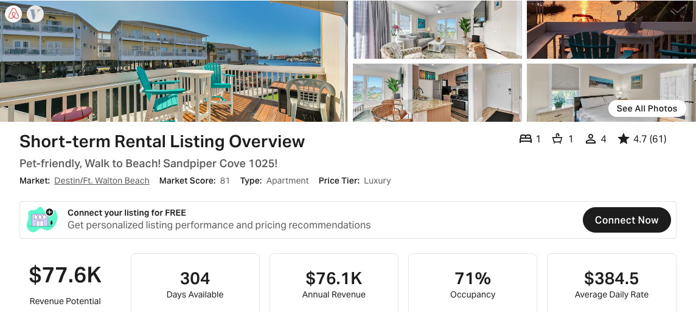
https://www.airbnb.com/rooms/36601880
https://www.vrbo.com/1708160

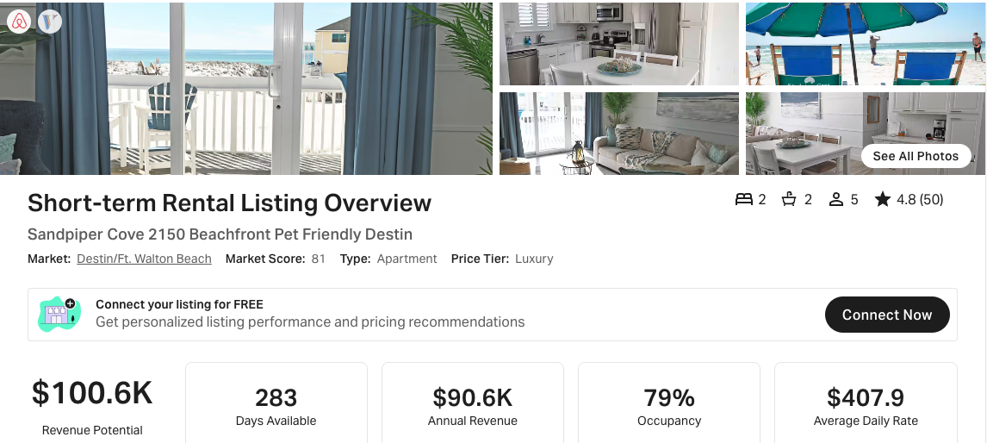
https://www.airbnb.com/rooms/1080498200029267519
https://www.vrbo.com/3835771

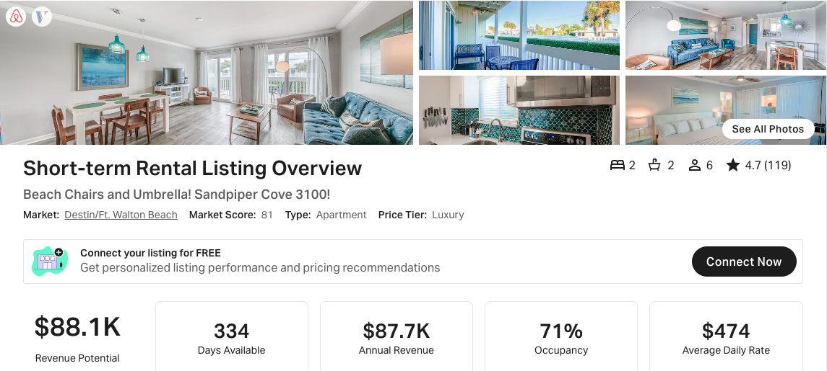https://www.airbnb.com/rooms/17305416
https://www.vrbo.com/1005609

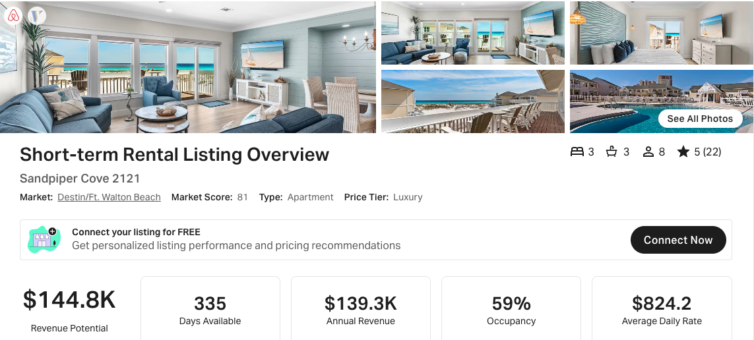
https://www.airbnb.com/rooms/51286773
https://www.vrbo.com/9595664ha

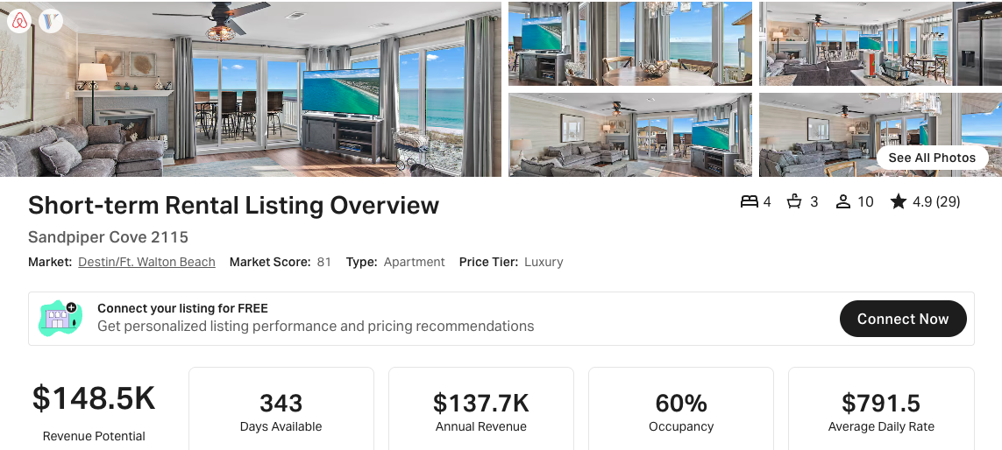
https://www.airbnb.com/rooms/836362070028171002
https://www.vrbo.com/3264599

