Sugar Beach Condos • AirDNA High-Performers
8727 Thomas Dr, PCB
Data pulled on 01.252026. This is not a guarantee (or a ceiling) of income.

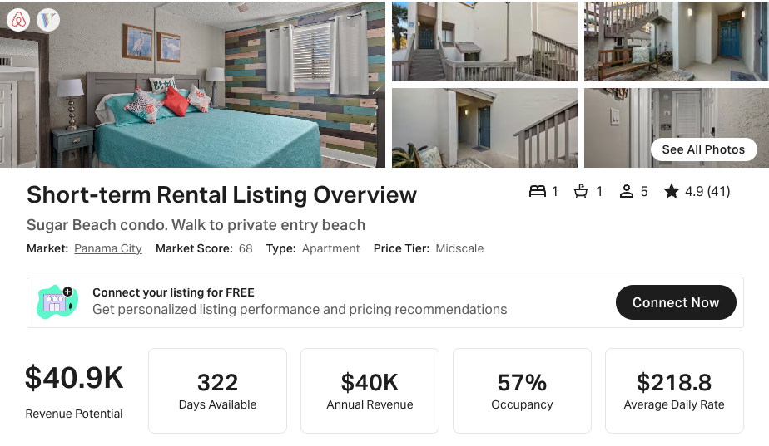
https://www.airbnb.com/rooms/699157046144967730
https://www.vrbo.com/2971007

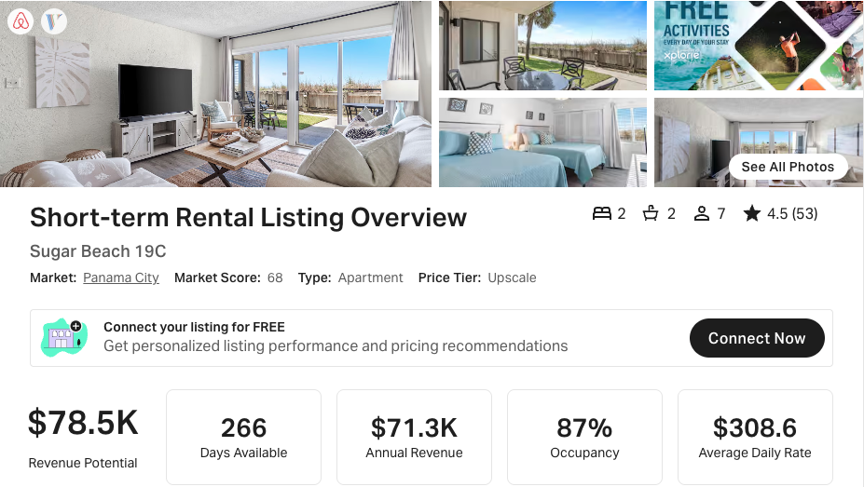
https://www.airbnb.com/rooms/604404931116222601
https://www.vrbo.com/2697751

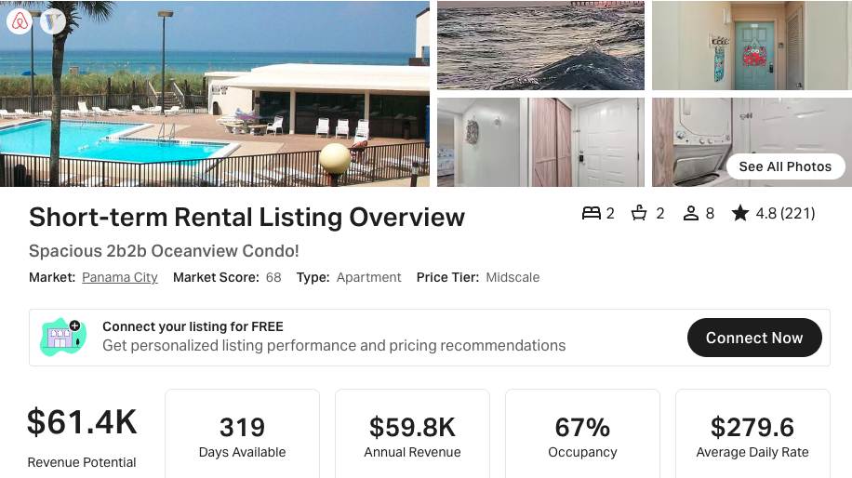
https://www.airbnb.com/rooms/11662867
https://www.vrbo.com/759241

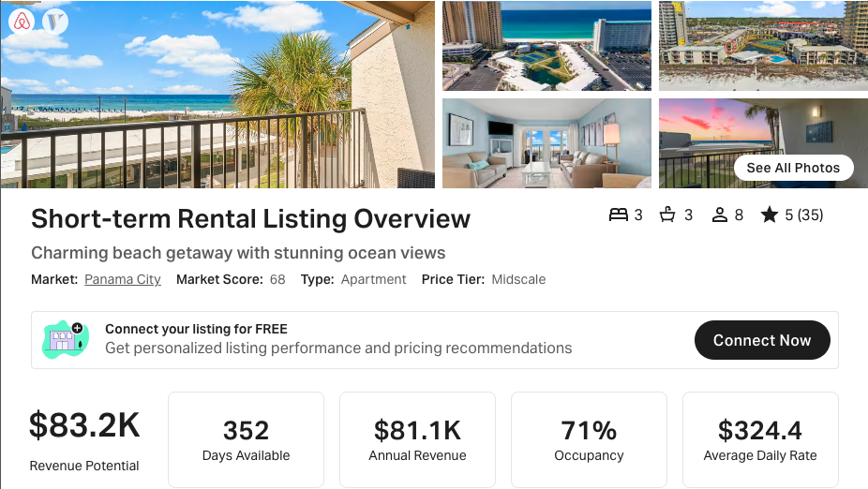
https://www.airbnb.com/rooms/1162569461219285624
https://www.vrbo.com/4019743

