Beachwalk Drive, Sandestin • AirDNA Exemplars
2/2 Comps. Data pulled on Oct 27, 2025. This is not a guarantee of income.

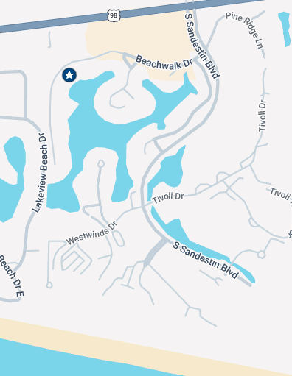

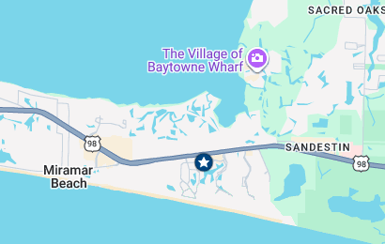
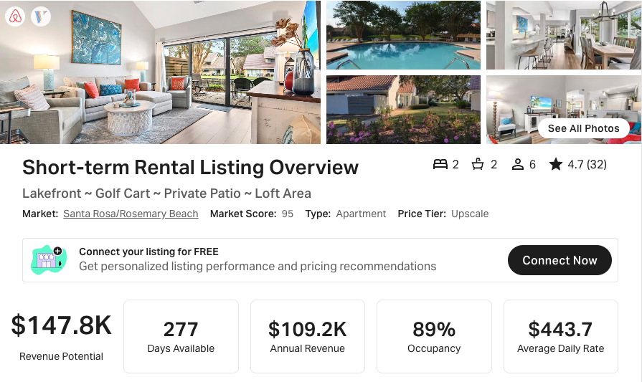
https://www.airbnb.com/rooms/45272103
https://www.vrbo.com/2033659

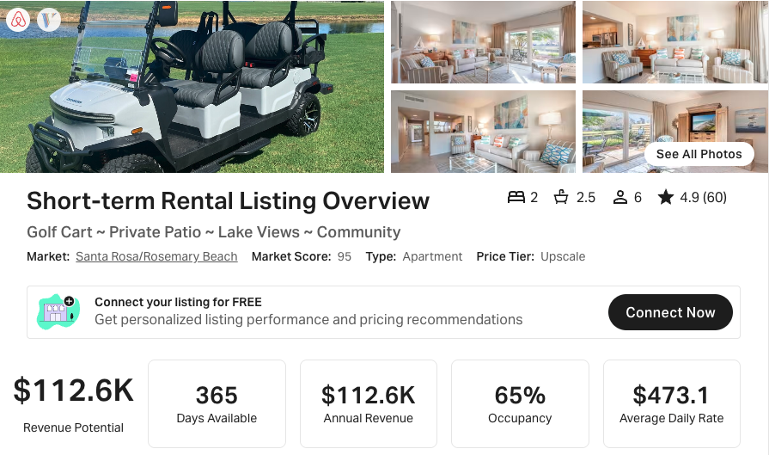
https://www.airbnb.com/rooms/32746127
https://www.vrbo.com/988040

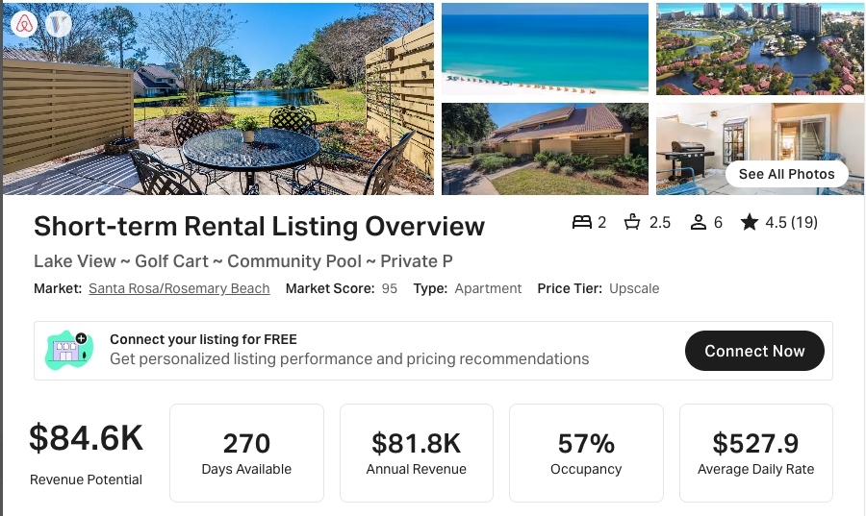

https://www.airbnb.com/rooms/54301168
https://www.vrbo.com/2618131

