Horizon South • AirDNA High Performers
Data pulled on 3.19.2026. This is not a guarantee (or a limit) of income.

2 BR, 2BA UNITS:

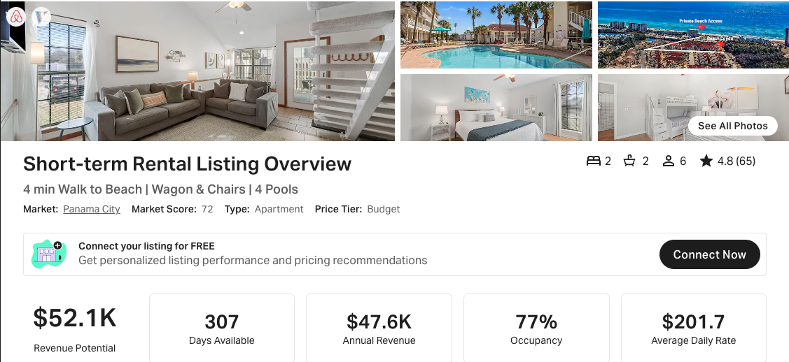
https://www.airbnb.com/rooms/1049273615200924315
https://www.vrbo.com/3778525

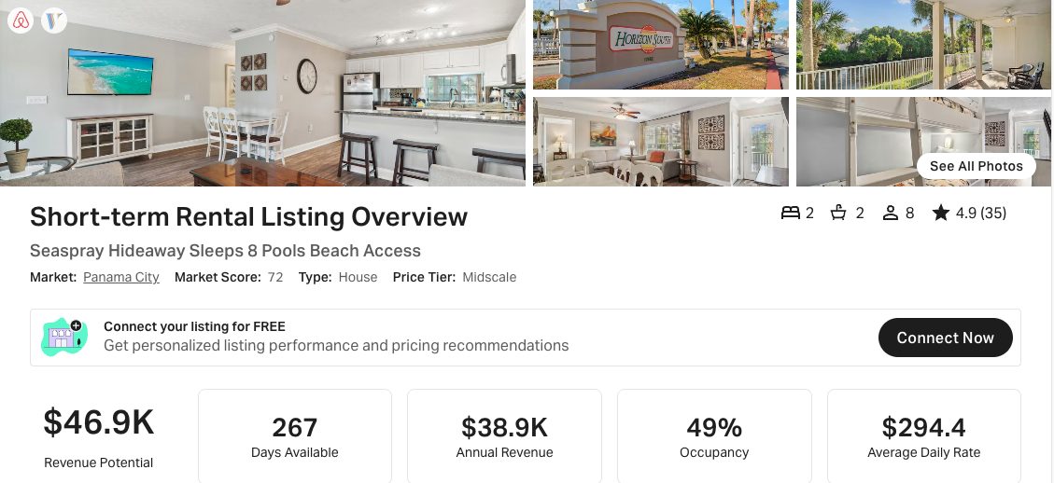
https://www.airbnb.com/rooms/892791009699317057
VRBO link not active at time of data pull.
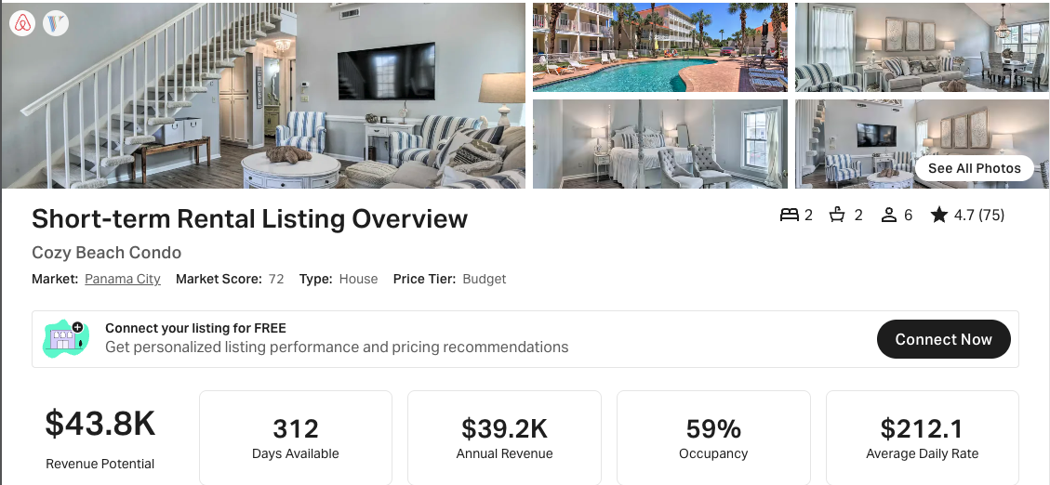
https://www.airbnb.com/rooms/822443142201098350
VRBO link not active at time of data pull.

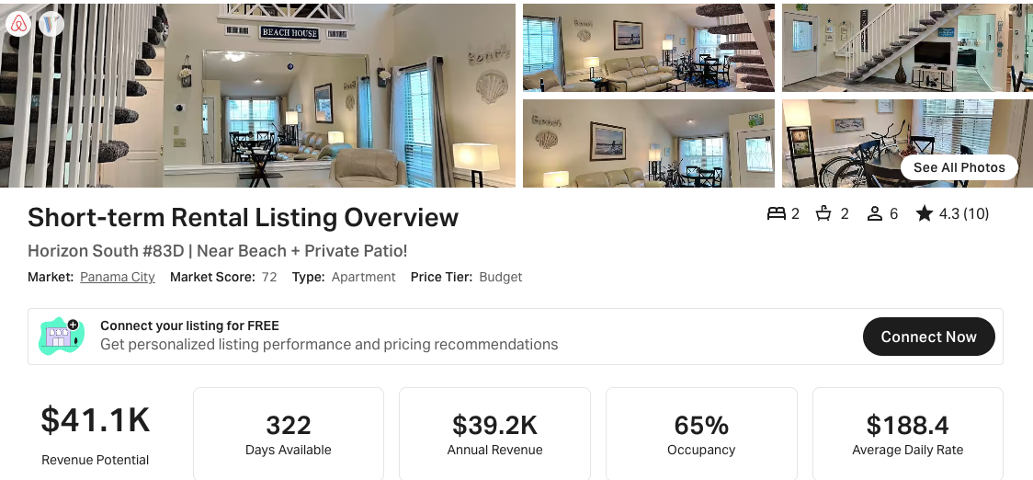
https://www.airbnb.com/rooms/1115871941918388989
https://www.vrbo.com/3913816

1 BR, 1.5 BA UNITS:

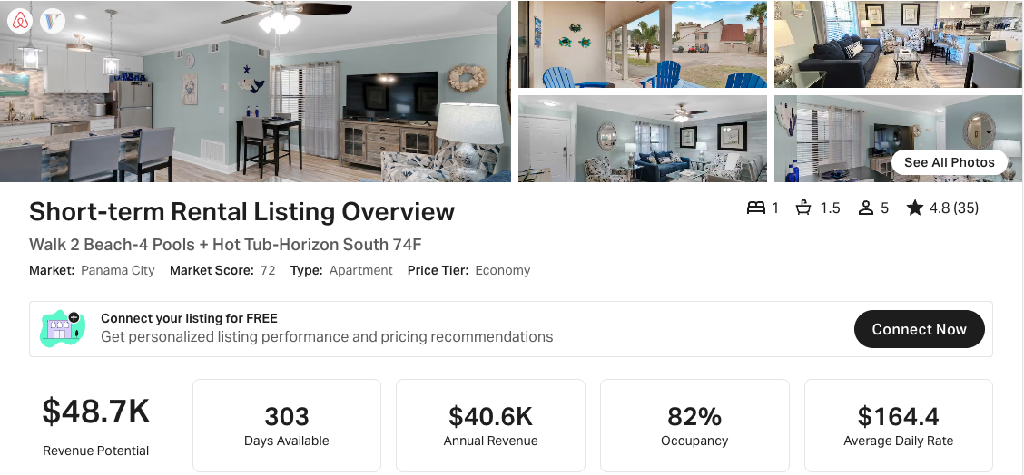
https://www.airbnb.com/rooms/52653189
https://www.vrbo.com/2495083

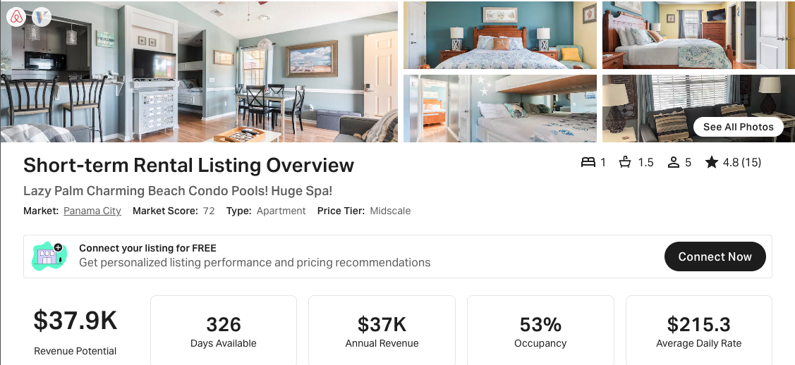
https://www.airbnb.com/rooms/817981525981080946
https://www.vrbo.com/3233503
NOTE: Has <20 reviews

