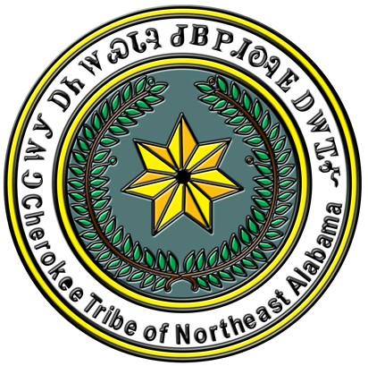
CHEROKEE TRIBE OF NORTHEAST ALABAMA

Criteria for all CTNEAL Scholarships

- Must be enrolled in the Cherokee Tribe of Northeast Alabama for a minimum of three (3) years AND
  - Must be current in all applicable taxes and fees.
  - Must produce documentation of active participation in tribal/American Indian projects for the past year. Tribal projects could include presence at quarterly Council meetings, participation in youth retreat, participation in Cherokee or American Indian presentations within a school or community setting, etc. Documentation may include, but not be limited to, name/date/location of the event or project, photos of applicant participating in the event or project, letter of verification from a project supervisor or event coordinator, and/or paperwork reflecting participation in the development of, or preparation for, the project.
- Must have a minimum GPA of 3.0.
- Must be an Alabama resident or an out of state citizen¹ in good standing of the Cherokee Tribe of Northeast Alabama.
- Must attach proof of acceptance or current enrollment from the school you plan to attend (school must be located in the State of Alabama unless the courses needed are not offered in Alabama).
- Must attach an essay (at least 250 words but not to exceed 500 words). The subject of the 2021 essay must be “What three changes would you make in the Cherokee Tribe of Northeast Alabama if you were Chief?” This essay will be used only in case of a tie.
¹Out-of-state qualification applies to CTNEAL scholarships only; AIAC scholarships cannot be awarded to non-residents.
------------------------------------------------------------------------------------------------------------------------------------
2021 APPLICATION FOR THE FOLLOWING:
REBECCA BRANNAN SCHOLARSHIP
CHIEF JIM PELL APPLICATION

Incomplete scholarship applications will not be considered.

NAME:
(Last) (First) (Middle)

ADDRESS:
(Street/PO Box) (City) (State) (Zip)

EMAIL: SEX: M F
(circle one)

CONTACT: ( ) ALTERNATE PHONE: ( )

SCHOOL TO WHICH YOU HAVE BEEN ACCEPTED:
Incoming college freshman must provide a letter of acceptance from the college you plan to attend and have your high school counselor send a letter of recommendation, along with an official copy of your high school transcripts, to the tribal office. Students already enrolled in college must have the college mail your official transcripts to the tribal office.

NAME: Your GPA:

ADDRESS:
(Street/PO Box) (City) (State) (Zip)

List specific CTNEAL sanctioned events that you attended and/or in which you participated. Provide verifiable dates and times (i.e. council meetings, youth retreat, community meetings, etc.) and level of your participation (i.e., speaker, demonstrator, volunteer, spectator, etc.)
_______________________________________________________________________________________
_______________________________________________________________________________________
_______________________________________________________________________________________
_______________________________________________________________________________________

(over)
OPTIONAL: List other verifiable American Indian Activities in which you participated: (Specify date, event title/description, location and level of your activity (i.e., speaker, demonstrator, volunteer, spectator, etc.)
_______________________________________________________________________________________
_______________________________________________________________________________________
_______________________________________________________________________________________
_______________________________________________________________________________________
_______________________________________________________________________________________

I certify that I am a citizen of the Cherokee Tribe of Northeast Alabama (Roll # ) and that all information on this application is true and correct.

SIGNATURE:

SOCIAL SECURITY NUMBER: DATE:

The completed application must be postmarked NO LATER THAN April 30, 2021 and mailed to:

CTNEAL Scholarship Committee
PO Box 1997
Oneonta AL 35121

Award notices will be sent to recipients by June 1. Scholarships will be awarded at the CTNEAL Annual Meeting on June 26, 2021; recipients must be present to accept awards.

