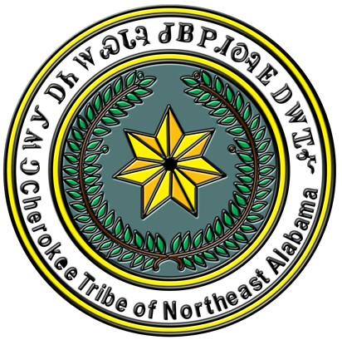
CHEROKEE TRIBE OF NORTHEAST ALABAMA

Criteria for all CTNEAL Scholarships

- Must be enrolled in the Cherokee Tribe of Northeast Alabama for a minimum of three (3) years AND
  - Must be current in all applicable taxes and fees.
  - Must produce documentation of active participation in tribal/American Indian projects for the past year. Tribal projects could include presence at quarterly Council meetings, participation in youth retreat, participation in Cherokee or American Indian presentations within a school or community setting, etc. Documentation may include, but not be limited to, name/date/location of the event or project, photos of applicant participating in the event or project, letter of verification from a project supervisor or event coordinator, and/or paperwork reflecting participation in the development of, or preparation for, the project.
- Must have a minimum GPA of 3.0. The official transcript must be forwarded in a sealed envelope.
- Must be an Alabama resident or an out of state citizen¹ in good standing of the Cherokee Tribe of Northeast Alabama.
- Must attach proof of acceptance or current enrollment from the school you plan to attend (school must be located in the State of Alabama unless the courses needed are not offered in Alabama).
- Must attach an essay (at least 250 words but not to exceed 500 words). The subject of the 2021 essay must be “Why is it important for you to identify yourself as Native American in today’s society and how can you do this in a meaningful way?” This essay will be used only in case of a tie.
¹Out-of-state qualification applies to CTNEAL scholarships only; AIAC scholarships cannot be awarded to non-residents.
------------------------------------------------------------------------------------------------------------------------------------
2022 PAPA GENE STORY SCHOLARSHIP APPLICATION
(Awarded for postgraduate studies only)

Incomplete scholarship applications will not be considered.

This scholarship is designated for postgraduate studies. To be eligible for this scholarship, you must already have a bachelor’s degree and working on a secondary degree.

NAME:
(Last) (First) (Middle)

ADDRESS:
(Street/PO Box) (City) (State) (Zip)

EMAIL: SEX: M F
(circle one)

CONTACT: ( ) ALTERNATE PHONE: ( )

CURRENT DEGREE:_______ EDUCATIONAL INSTITUTIION:
(attach a cop of your diploma)

SCHOOL TO WHICH YOU HAVE BEEN ACCEPTED:
Incoming students working on a secondary degree must provide a letter of acceptance from the college you plan to attend and a copy of your undergraduate diploma, along with an official copy of your transcripts. Students already enrolled in college must have the college mail your official transcripts.

NAME: Your GPA:

ADDRESS:
(Street/PO Box) (City) (State) (Zip)

List specific CTNEAL sanctioned events that you attended and/or in which you participated. Provide verifiable dates and times (i.e. council meetings, youth retreat, community meetings, etc.) and level of your participation (i.e., speaker, demonstrator, volunteer, spectator, etc.).
_______________________________________________________________________________________
_______________________________________________________________________________________

(over)
_______________________________________________________________________________________
_______________________________________________________________________________________

OPTIONAL: List other verifiable American Indian Activities in which you participated: (Specify date, event title/description, location and level of your activity (i.e., speaker, demonstrator, volunteer, spectator, etc.).
_______________________________________________________________________________________
_______________________________________________________________________________________
_______________________________________________________________________________________
_______________________________________________________________________________________
_______________________________________________________________________________________

I certify that I am a citizen of the Cherokee Tribe of Northeast Alabama (Roll # ) and that all information on this application is true and correct.

SIGNATURE:

SOCIAL SECURITY NUMBER: DATE:

The completed application must be postmarked NO LATER THAN April 30, 2022 and mailed to:

CTNEAL Scholarship Committee
PO Box 1997
Oneonta AL 35121

Award notices will be sent to recipients by June 1. Scholarships will be awarded at the CTNEAL Annual Meeting on June 25, 2022; recipients must be present to accept awards.

