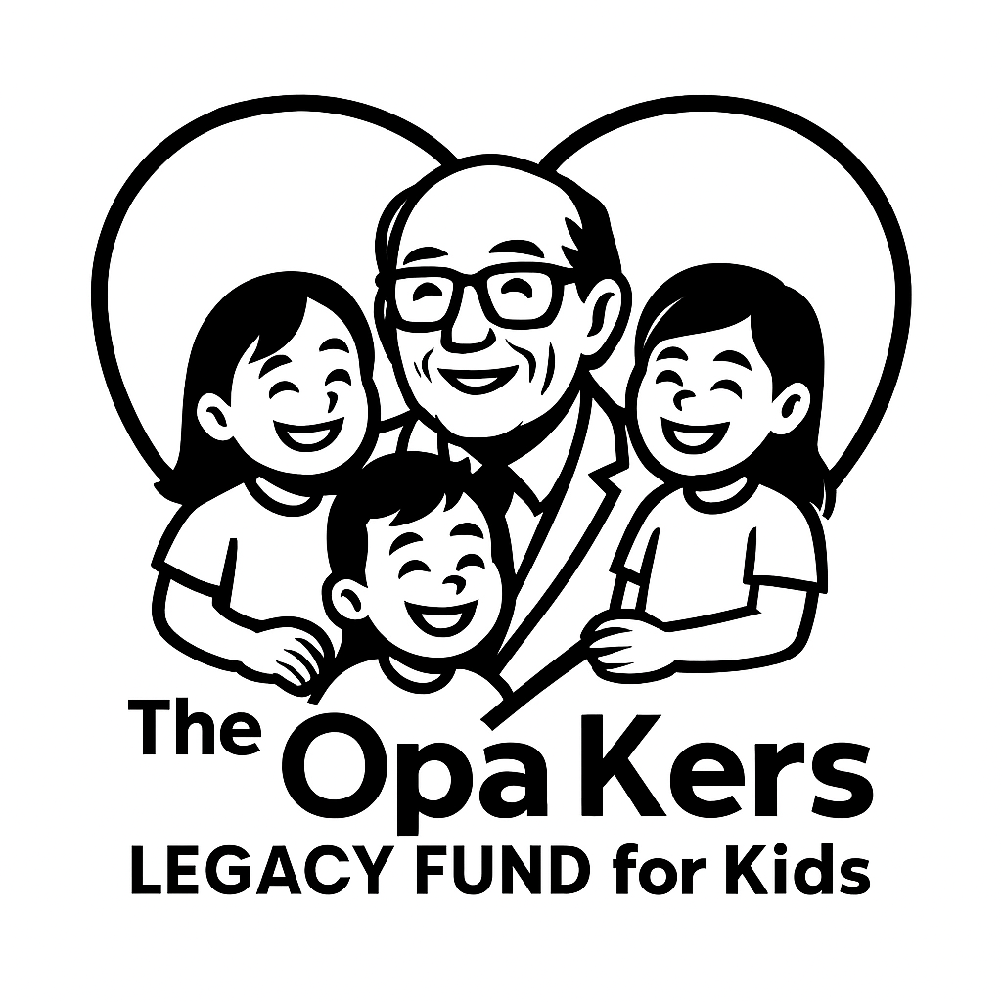Sponsorship & Funding Application
  - Inspired by Opa. Rooted in Love. Powered by Community.

  - Supporting Kids in the Town of Claresholm
Thank you for your interest in applying for sponsorship or funding from The Opa Kers Legacy Fund for Kids. Our mission is to help children and youth in the Town of Claresholm thrive by supporting programs, projects, and events that make a positive impact. Please complete all sections of the application form below. If you have any questions, contact us at info@opakersfund.ca.

Applicant Information
Name of Organization / Individual:
Contact Person:
Mailing Address:
Phone Number:
Email Address:
Website (if applicable):

Project / Initiative Details
Question | Response
Project/Initiative Name:
Brief Description:
Target Age Group(s):
Estimated Number of Kids Impacted:
Location (must be within Town of Claresholm):
Timeline / Dates:

Funding / Sponsorship Request
Question | Response
Total Amount Requested (CAD):
How will these funds be used?
Have you received funding from The Opa Kers Legacy Fund for Kids before?
Have you received funding from other sources for this project?

Impact Statement
Question | Response
Explain how sponsorship or funding from The Opa Kers Legacy Fund for Kids will help kids in the Town of Claresholm thrive.
Describe the anticipated outcomes and long-term benefits for youth and the community.
Include any relevant stories, testimonials, or evidence supporting your application.

Additional Information
Question | Response
Are there opportunities for The Opa Kers Legacy Fund for Kids to assist with promotional activities such as event signage, social media, newsletters? Please describe.
Is there anything else you would like us to know about your organization or project?

Declaration & Signature
I certify that the above information is true and accurate to the best of my knowledge. I understand that incomplete applications may delay processing.
Name:
Signature:
Date (YYYY-MM-DD):
Please email your completed application to apply@opakersfund.ca or mail to The Opa Kers Legacy Fund for Kids, c/o Town of Claresholm, PO Box 1000, Claresholm, AB T0L 0T0.

