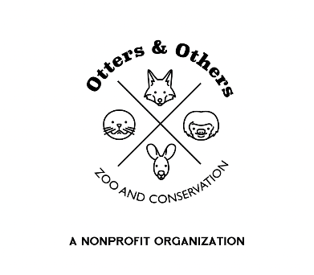

Public Statement 5/10/2025

As part of our ongoing commitment to responsible animal stewardship and sustainability, we have recently redefined our Animal Master Plan to better align with our long-term goals for care, conservation, and education.

In keeping with this updated plan, we have made the thoughtful decision to rehome one of our Highland cattle. This choice reflects our belief that breeding should never be done simply because it is possible, but rather with clear intent, purpose, and intelligent reasoning.

Every animal in our care deserves a life shaped by thoughtful decisions that prioritize their well-being and the health of our greater ecosystem. We are confident that this rehoming provides the best outcome for the animal and supports our evolving vision for ethical animal management.

Thank you for your continued support and understanding as we work to ensure a mindful and meaningful future for all the animals in our care.

We will miss Fergus and know that he is in good hands at his new pasture.