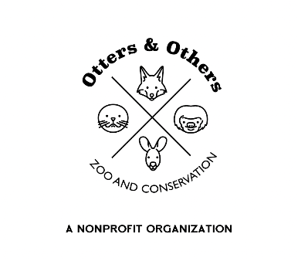

Public Statement 3/22/2025

We are thrilled to announce that earlier this week, our beloved goat June welcomed a healthy baby boy! Both mom and baby are doing great, and we can’t wait for you to meet him.

Baby goats are full of personality, and this little one is already showing off his playful side! Be sure to book your visit and watch him bounce, leap, and explore his new world.

Once he’s old enough, he will be available for adoption—so if you’ve been thinking about adding a goat to your family, let us know! In the meantime, come say hello and enjoy all the fun this little guy brings.

We can’t wait to introduce him to you! 🐐💕