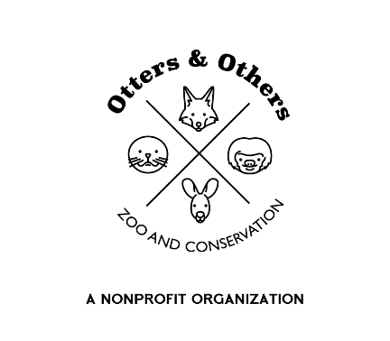

Public Statement 7/14/2025

We are thrilled to introduce the newest member of our Raccoon family at Otters and Others Zoo and Conservation — Meeko!

We weren’t actively seeking to add another raccoon to our care, but when we heard Meeko’s story and met him in person, we knew we had to step in. Orphaned as a young kit, Meeko likely suffered a spinal cord injury that left his hind legs paralyzed. Despite this, thanks to the compassion of some incredible people — and Meeko’s unshakable will — he has continued to grow, adapt, and thrive.

Life with Meeko’s condition will come with its challenges, but we are fully committed to providing him with the care, enrichment, and companionship he deserves. He will now have the opportunity to socialize with fellow raccoons in a safe, accessible environment and experience a life filled with love and support.

Unfortunately, our state’s laws are not always favorable when it comes to raccoons, and it breaks our hearts to see how many of these intelligent and sensitive animals face uncertain and often tragic outcomes. It’s our hope that Meeko’s story can help change that.

We would love to include Meeko in our Animal Ambassador Program to help us continue our mission of educating the public about wildlife, cohabitation, and conservation. Through animals like Meeko, we hope to inspire a deeper respect for our natural world and the incredible animals we share it with.

Welcome to the family, Meeko — your journey is just beginning, and we’re honored to be part of it.