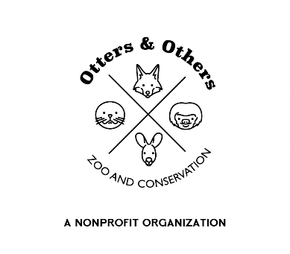
Public Statement 11/18/2025
Our fox skulk has grown!
We are excited to announce that we have welcomed 7 Red Foxes to our zoo, and we can’t wait to share more about this beautiful and fascinating species. Red foxes are commonly found throughout Utah and are widespread across North America. Here in Utah, they thrive in open and semi-open habitats, forests, farmlands, and even in our cities and suburban neighborhoods. Their adaptability is part of their magic—but also part of why humans must take responsibility for living alongside them respectfully.
Sadly, despite their beauty and ecological value, foxes are still bred on fur farms in the United States. The USDA does not monitor these facilities, but estimates suggest that over 50 fox fur farms across roughly 10 states produce about 10,000 fox pelts each year.
Within our skulk at Otters and Others Zoo & Conservation, our 7 foxes represent both natural wild coat colors and coat colors that were selectively bred for the fur trade. Knowing that their fate could have been drastically different is heartbreaking—and it fuels our mission to educate our community about compassion and conservation.

