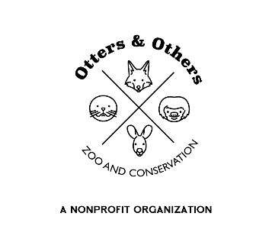

Public Statement 3/3/2025

We are thrilled to announce a truly extraordinary new addition to Otters and Others Zoo and Conservation, a rare white-water buffalo! White water buffaloes are incredibly rare, with estimates suggesting that only one in every 10 million is born. This makes the arrival of our newest family member a remarkable and special occasion.

We are especially grateful for our dedicated volunteers, whose passion and commitment help make moments like this possible. One of our wonderful volunteers, Myka, had the honor of naming her, and we are delighted to introduce **Lilly** to the world!

Lilly’s presence is a symbol of resilience, purity, and the deep connection we share with nature. We invite the community to join us in celebrating this once-in-a-lifetime event and to visit Lilly as she settles into her new home.