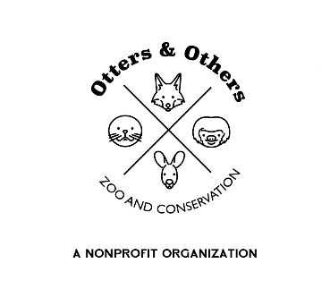

New Look, Same Trashy Charm: Meet Our Blonde Raccoon!

At Otters and Others Zoo and Conservation, our raccoons have become something of a local legend. Whether it’s their clever antics, sneaky snack stealing, or the famous high-five photo op—meeting our mischievous bandits is a must for any raccoon lover.

But did you know raccoons can come in blonde?

Blonde raccoons are incredibly rare. Their unique coloration is caused by a genetic condition called leucism, which results in a partial loss of pigmentation—unlike albino animals, leucistic animals still have dark eyes and some color variation. While blonde raccoons aren’t native to a specific region, places like Newcastle Island in British Columbia and parts of Nova Scotia have reported slightly higher occurrences. Still, the chances of spotting one in the wild are extremely low.

That’s why we’re thrilled to have this stunning and unusual raccoon in our care—to spark curiosity, inspire conservation, and add a little extra sparkle to your visit.

Don’t miss your chance to meet our rare blonde raccoon up close! Be sure to schedule a raccoon experience for your crew—and as always, stay trashy!

This cute blonde is also looking for a sponsor! Your support helps us provide top-quality care, enrichment, and education programs that make a difference. Sponsorship is a powerful way to connect with conservation and directly support the animals you love.