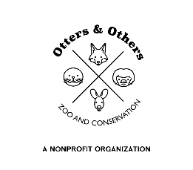

Public Statement 2/14/2025

We are excited to introduce the newest members of the Otters and Others Zoo and Conservation family—Wally and Eve, our White Tree Frogs! As we venture into the world of amphibians for the first time, our team has already fallen in love with these fascinating creatures. We look forward to the impact they will have on our educational programs and the experiences of our visitors. Be sure to stop by and say hello to Wally and Eve on your next visit!