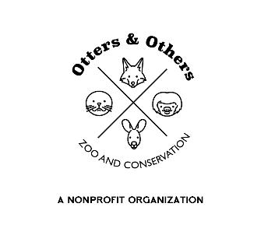

Public Statement 5/5/2025

We are thrilled to announce the birth of a baby chinchilla—also known as a kit—here at Otters and Others Zoo and Conservation! This tiny new arrival marks a joyful milestone for our animal care team and an important step forward in chinchilla conservation.

Chinchillas are an endangered species, and we are proud to be part of the Association of Zoos and Aquariums’ S.A.F.E. (Saving Animals From Extinction) program. Through this collaborative initiative, we can contribute to the recovery and long-term protection of chinchillas in the wild by sharing knowledge, resources, and conservation strategies with partners across the globe.

We’re happy to report that both mother and kit are healthy and doing wonderfully under the attentive care of our expert staff. While they’re currently bonding behind the scenes, guests can look forward to seeing them on exhibit in just a few short weeks.

Stay tuned for more updates as we celebrate this precious new addition and continue our work to ensure a future for Chinchillas both here and in the wild.