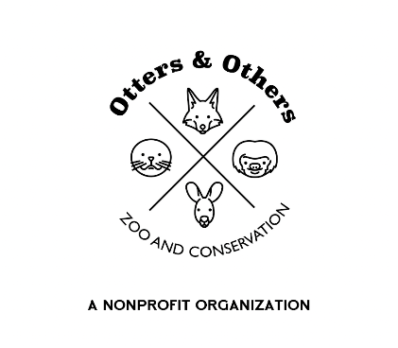

Meet Our New Arrival: A Rare White Mink

We’re excited to introduce the newest member of our zoo family—a rare white mink who has joined us from DeYoung Zoo in Michigan!

In the wild, American mink typically have a rich brown coat with lighter patches on their chin, throat, and belly. But our newest resident is a striking exception. White or albino mink, characterized by their snowy coats and pink noses, are extremely rare in nature.

Though mink are currently listed as a species of Least Concern by the International Union for Conservation of Nature (IUCN), they still face serious threats—particularly from the fur industry. Mink are commonly farmed for their pelts, and fur farming remains legal in many parts of the world, including the United States.

By welcoming this unique mink into our care, we aim to spark meaningful conversations about wildlife, ethical consumerism, and the true cost of fashion. We hope our guests leave not only inspired by this beautiful animal, but also more aware of how everyday choices—like how we shop—can impact animals and ecosystems worldwide.

This rare mink is also looking for a sponsor! Your support helps us provide top-quality care, enrichment, and education programs that make a difference. Sponsorship is a powerful way to connect with conservation and directly support the animals you love.

Let’s continue learning, growing, and making compassionate choices—together.