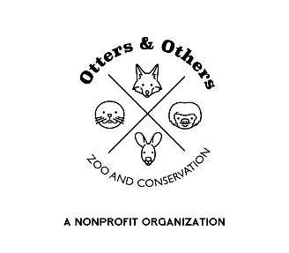

Public Statement from Otters and Others Zoo and Conservation 9/6/2025

In the name of transparency, we want to share important information with our supporters and community. Otters and Others Zoo and Conservation, along with the landowner, is currently facing a lawsuit filed in April 2025 by the Town of Stockton.

As an educational facility that strives to serve our community, bring awareness, and generate positive revenue for our small town, we are deeply concerned by this action. For years, our legal team has worked closely with Stockton’s attorney, Dallin Littlefield, to meet the requirements set forth by the town and to demonstrate the value our organization brings. Despite fulfilling those requirements, personal bias has remained, and the Town of Stockton has now sought representation from a private law firm in pursuit of a different outcome.

Our love for Stockton and Tooele County runs deep. We care about our neighbors, our visitors, and the growth of this community. Our zoo has welcomed guests from across the nation—and even from as far away as Australia and France—helping put Stockton, Utah, on the map as a place people want to visit and support.

This lawsuit is not only a financial burden on our nonprofit organization but also on the residents of Stockton. While the town considers raising taxes and denying support to local businesses and nonprofits, we cannot help but question the use of mismanaged funds.

We remain committed to our mission of conservation, education, and community engagement. We ask that you stand united with us by supporting Stockton and Tooele County in positive ways—shop local, eat local, and be part of building a thriving community together.

With gratitude,

Otters and Others Zoo and Conservation