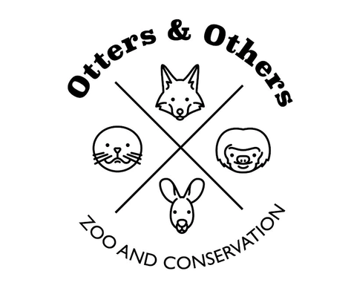
Public Statement 3/26/2026

We are excited to announce the arrival of four BLM wild burros (jennys) here at Otters and Others Zoo and Conservation.
These incredible animals represent a true piece of the American West—resilient, intelligent, and deeply rooted in our history. Wild burros are protected and managed by the Bureau of Land Management (BLM), which works to maintain healthy populations on public lands across the United States.

Our Mission with These Jennys
These burros are part of a much bigger purpose. Our goal is to:
• Gently halter break and build trust with them
• Provide consistent, compassionate handling and care
• Prepare them for successful placement in adoptive homes
Once they are ready, these jennys will be adopted out, allowing us to bring in more burros in need and continue this important cycle of care, training, and placement.

Did You Know?
• Wild burros are descendants of animals brought to North America by Spanish explorers in the 1500s
• They are incredibly hardy and can survive in harsh desert environments with minimal water
• Burros form strong bonds and are known for their intelligence and cautious nature
• Unlike horses, burros will often stop and assess danger rather than flee—making trust-building essential
• The BLM protects and manages wild burros under the Wild Free-Roaming Horses and Burros Act of 1971
At Otters and Others Zoo and Conservation, we are proud to support both education and conservation by giving these animals a second chance while helping connect our community to the legacy of the Wild West.
This is more than an addition to the zoo— it’s a commitment to making a difference.

