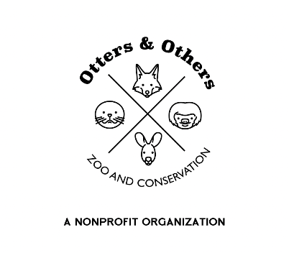

Public Statement 6/17/2025

🐺 New Arrival at Otters and Others Zoo & Conservation 🐺

We’re thrilled to introduce the newest member of our zoo family—a young, 10-week-old Grey Wolf joining us all the way from Wisconsin! What makes this pup extra special is his impressive lineage, with bloodlines that trace directly back to the iconic wolf packs of Yellowstone National Park.

As he begins her journey here, you may notice a period of transition for Lucky, Esme’s loyal companion dog. While Lucky will no longer be on public display, she will remain at the zoo, enjoying a well-earned retirement behind the scenes.

We are incredibly grateful for the opportunity to continue educating and advocating for this vital species. Grey wolves are keystone predators—a foundational part of a healthy ecosystem. Their presence influences prey behavior, boosts biodiversity, and even shapes the very landscapes they inhabit.

And now, a fun question for our Twilight fans… with our pack growing, we have to ask:  
Are you Team Edward, Team Jacob, or Team Jasper Cullins? 🐾

Come visit and help us welcome our little wolf to her new home!