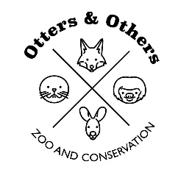

Public Statement 8/19/2025

**Exciting News from the Zoo!** 🐾

We are thrilled to announce the arrival of **three baby Patagonian Cavies**! 🎉 Bingo, our devoted female Cavy, is doing wonderfully and has already proven to be an amazing mother.

For now, the little ones will remain **off exhibit** while they grow a bit stronger, but before long, they’ll be ready to meet all of you! We can’t wait for our community to help welcome these new additions to the zoo family. 💚

Stay tuned for updates and adorable photos as they grow!