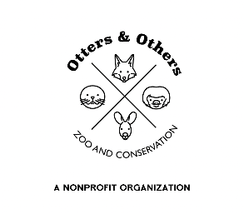
Public Statement 12/9/2025
Otters and Others Zoo & Conservation is thrilled to welcome three incredible new ambassador parrots to our ever-growing feathered family!
Rui – Yellow-Naped Amazon
Rui is our brilliantly green Yellow-Naped Amazon, a species celebrated for remarkable vocal ability and sadly listed as Critically Endangered. These parrots face steep population declines due to extensive habitat loss from agriculture and widespread poaching for the illegal pet trade, driven by demand for “talking birds.”
Rui himself lives up to her species’ reputation—she already knows over 30 phrases, noises, and songs and loves to show off!
Piccalo – White-Bellied Caique
Next in our new flock is Piccalo, a lively and energetic White-Bellied Caique. Across their South American range, these parrots face pressures from deforestation, hunting, and illegal wildlife trade. Several subspecies are listed as Endangered or Vulnerable, with habitat loss being the biggest threat.
Piccalo may be small, but his personality is huge—and he’s quickly learning that visitors love a good “hello!”
Yami – Mustached Parrot
Rounding out our trio is Yami, our charming male Mustached Parakeet. Classified as Near Threatened, these birds face a shrinking wild population due to habitat destruction and trapping.
Yami is curious, expressive, and already waving to greet our guests.
While Rui takes the crown as the most talkative, Piccalo and Yami are not far behind. When you visit, be sure to ask them to “say hi!”—you might even receive a friendly wave in return.
Each of these parrots plays an important role in our mission to educate, advocate, and conserve. By sharing their stories, we hope to inspire meaningful action to protect parrots worldwide from trafficking, habitat loss, and extinction.
Come welcome our newest ambassadors to their forever flock here at Otters and Others Zoo & Conservation!

