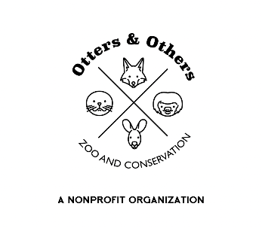

Public Statement 7/11/202503

Exciting Changes Ahead at Otters and Others Zoo and Conservation!

We’re proud to share that we’ve been hard at work behind the scenes making meaningful improvements to enhance both animal and visitors’ safety, while deepening the interactive and educational experiences that make our zoo so special.

As we grow, our visitor experience is evolving too! While we will continue to welcome guests by appointment only, we’re happy to announce that during your visit, you and your group are now free to explore the zoo at your own pace and in any order, you wish—spending as much time as you’d like with our beloved animal residents.

Our keepers and team will still be on-site to assist you, answer questions, and share information, but they’ll also be actively engaged in daily animal care, husbandry, and educational work that you are welcome to observe and learn from.

To best support this transition, our private feeding and interactive experiences will now be limited and available by reservation only.

We are truly excited about this step forward and what it means for our mission and the animals we care for. Thank you for your continued support and understanding as we grow in new and impactful ways!

`