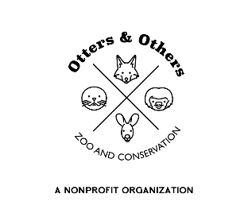

Public Statement 8/22/2025

Exciting New Arrival!

We are thrilled to introduce the newest member of our animal family – Neytiri, a zorse, which is a rare hybrid between a zebra stallion and a horse mare.

Her name was inspired by the beloved character from Avatar – Princess Neytiri – a symbol of strength, courage, and a deep connection to nature. We felt it was a perfect fit for such a unique and remarkable animal.

Hybridization between zebras and horses can occur, but because zebras are native to Africa and wild horses to Europe and Asia, it’s extremely rare in nature. In Neytiri’s case, her existence is a fascinating example of how species can connect across continents.

Neytiri is still settling into her new home. She had never had her feet trimmed before, so our dedicated keepers will be working with her daily to ensure her safety, comfort, and overall welfare. This training period will also help build trust and a strong bond between her and her caretakers.

We can’t wait to share Neytiri’s journey with you as she grows, learns, and becomes part of our conservation story.