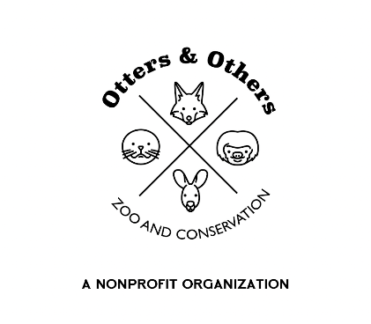

Public Statement 6/18/2025

Otters and Others Zoo and Conservation is excited to welcome a wild new addition to our family — meet *Wylie*, our young Coyote pup!

Wylie is full of curiosity and spirit, and we are thrilled to add him to our *Forest Biome*, where he will serve as an ambassador for native wildlife and the often-misunderstood role of coyotes in our ecosystems. Known for their adaptability and intelligence, coyotes are an important part of our environment, helping to balance populations and maintain healthy landscapes.

As Wylie settles in, you may see him exploring his new habitat, learning the ropes, and getting to know his caretakers. We can’t wait for you to meet him and learn more about these clever canines.

Stay tuned for updates on Wylie’s journey — and don’t forget to say hello during your next visit!